SYSTEM DOCUMENTATION (SD)
SOFTWARE REQUIREMENTS SPECIFICATION (SRS)
AND SOFTWARE DESIGN DOCUMENT (SDD)

AI-POWERED ACADEMIC ADVISORY SYSTEM
FOR UTMSPACE PART-TIME STUDENTS

VERSION: 2.0
DATE: 24 October 2026
PROJECT TEAM: Group 1
LECTURER : Dr. Adila Firdaus Bt Arbain

No. | Project Team Member | Matric Number | Assigned Modules
1 | AISAR AFIQ BIN AHMAD NORZAN | SX220373ECRHS04 | M1 and M2
2 | MUHAMMAD NOR IDHAM BIN RAFIEE | SX220377ECRHS04 | M3 and M4
3 | HARRAZ HAZIQ BIN AZLIM | SX231704ECJHF04 | M5 — Interactive Academic Pathway
4 | MOHD SHARHAN BIN ABDUL GHANI | SX232315ECJHF04 | M0, M6 and M7 — Administration and Forecasting

Revision Page

a. Overview
This System Documentation (SD) sets out the requirements and design for the proposed AI-Powered Academic Advisory System for UTMSPACE Part-Time Students. It includes the SRS and SDD; the System Testing Document (STD) will be prepared separately.

b. Target Audience
- Part-time students and proposed academic consultation stakeholders.
- Project supervisor and academic reviewers.
- System analysts, designers and the four development programmers.
- System administrators and database maintainers.

c. Project Team Members
Member | Role | Primary Responsibilities
Programmer 1 | Developer | M1 Student Profile & Progress; M2 Curriculum and Requirements.
Programmer 2 | Developer | M3 Semester Offering & Eligibility; M4 Subject Recommendation.
Programmer 3 | Developer | M5 Interactive Academic Pathway: talent tree, projected semester planner and what-if comparisons.
Programmer 4 | Developer | M0 Authentication; M6 Academic Coordinator Forecast & Decision Dashboard; M7 System Administrator Dashboard & User Management.

d. Sprint Development Plan
Sprint Cycle | AISAR AFIQ BIN AHMAD NORZAN (M1, M2) | MUHAMMAD NOR IDHAM BIN RAFIEE (M3, M4) | HARRAZ HAZIQ BIN AZLIM (M5) | MOHD SHARHAN BIN ABDUL GHANI (M0, M6, M7)
Sprint 1 — Foundation & Setup | UC03, UC04 — Develop Academic Profile and Academic Subject Records management | UC08 — Develop semester subject offering entry and data structures | UC17 — Develop Interactive Academic Pathway talent tree UI prototype | UC01, UC02 — Implement Clerk registration, login/logout, authentication and access control
Sprint 2 — Core Functionality | UC05, UC06, UC07 — Implement academic progress, curriculum/prerequisites and graduation requirements | UC09, UC10 — Implement subject eligibility validation and semester subject selection | UC13, UC14 — Implement graduation eligibility checking and projected academic pathway scheduling engine | UC20 — Implement academic data validation, demand estimation and class-section optimization
Sprint 3 — Advanced Features | UC04, UC06, UC07 — Refine academic record validation, curriculum dependency rules and configurations | UC11, UC12 — Implement intelligent subject recommendations, ranking, bottleneck warnings and alternatives | UC15, UC16, UC17, UC18, UC19 — Complete what-if simulation, scenario comparison, interactive talent tree, subject exploration and projected roadmap | UC20, UC21, UC22, UC23 — Complete Coordinator Dashboard, Administrator Dashboard, User Management and forecast versioning/comparison
Sprint 4 — Integration & Testing | UC03–UC07 — Integration testing of student records, credit calculations, curriculum and graduation requirements | UC08–UC12 — Integration testing of semester offerings, eligibility, subject selection and recommendations | UC13–UC19 — Validate pathway scheduling rules, simulations, dependencies and timeline synchronization | UC01–UC02, UC20–UC23 — Test authentication, forecasts, decision auditing, user permissions and version lifecycle

e. Use Case Coverage Summary
Programmer | Assigned Modules | Use Cases | Total
P001 — AISAR AFIQ BIN AHMAD NORZAN | M1, M2 | UC03–UC07 | 5
P002 — MUHAMMAD NOR IDHAM BIN RAFIEE | M3, M4 | UC08–UC12 | 5
P003 — HARRAZ HAZIQ BIN AZLIM | M5 | UC13–UC19 | 7
P004 — MOHD SHARHAN BIN ABDUL GHANI | M0, M6, M7 | UC01–UC02, UC20–UC23 | 6
Total | 8 modules | UC01–UC23 | 23

f. Version Control History
Version | Primary Author(s) | Description of Version | Date
1.0 | Project Development Team | Initial SRS + SDD reformatted to approved System Documentation template; M0 Authentication assigned to Programmer 4. | 13/10/2026
1.1 | Project Development Team | M8 redesigned as AI-Powered Academic Assessment & Guided Insights with overall assessment and predefined guided questions. | 17/10/2026
1.2 | Project Development Team | Refined M8 to one structured LLM assessment with four expandable insight sections; removed guided-question calls and free-text chatbot interactions. | 17/10/2026
1.3 | Project Development Team | Revised to seven modules: M5 merges prediction/simulation/roadmap; M6 adds independent Academic Coordinator class offering forecasts from provided data; student AI assessment removed; requirements and ERD extended. | 17/10/2026
1.4 | Project Development Team | Finalized missing and revised UML-style diagram exports; completed coordinator ERD extension and corrected diagram register. | 17/10/2026
1.5 | Project Development Team | Updated Academic Coordinator requirements, use cases, diagrams and data dictionary to specify data provision without prescribing a specific data-submission format. | 18/10/2026
1.6 | Project Development Team | Removed duplicated scope text, restored UC06/UC11/UC14/UC16 normal flows, aligned use-case names and FR traceability, clarified M5 responsibilities and corrected terminology. | 18/10/2026
1.7 | Project Development Team | Added M7 System Administration Dashboard & User Management (UC21–UC22), strengthened existing M6 Coordinator Decision Dashboard, and extended security, design, data model and traceability. | 18/10/2026
1.8 | Project Development Team | Simplified and consolidated wording, clarified distinct requirement responsibilities, corrected module and entity counts, and aligned architecture, use cases and diagram register without changing scope. | 19/10/2026
1.9 | Project Development Team | Expanded M6 with semester-based forecast versioning, refreshed data provision, safe draft reset, historical comparison, lifecycle controls and decision audit logging (UC23). Updated requirements, data dictionary, diagrams and traceability. | 19/10/2026
1.9.1 | Project Development Team | Final editorial cleanup: corrected cover and contents, removed repeated UC23 rules, consolidated overlapping M5 use-case descriptions, and aligned forecast decision editing with finalization safeguards. | 19/10/2026
2.0 | Project Development Team | Inserted individual use case diagrams UC01–UC23; standardized Chapter 4 technical sequence titles and documentation formatting; updated revision labels and diagram checklist. | 24/10/2026

g. Document Status
Design review draft v2.0. The system has eight modules (M0-M7): student academic planning (M1-M5), Academic Coordinator forecasting and decisions (M6), and System Administration (M7). M6 supports dated data snapshots and multiple forecast versions. Forecasts remain advisory and depend on the quality of provided data. Coordinator data is separate from student portal records.

Table of Contents
1.0 Introduction
1.1 Purpose
1.2 Scope
1.3 Definitions, Acronyms and Abbreviations
1.4 References
1.5 Overview
2.0 Specific Requirements
2.1 User Characteristics
2.2 System Features
2.2.1–2.2.23 Detailed Use Cases
2.3 Software System Attributes, Performance and Other Requirements
2.4 Design Constraints
3.0 System Architectural Design
3.1 Architecture Pattern and Rationale
3.2 Technology Architecture and Services
3.3 Academic Scheduling Architecture
4.0 Detailed Description of Components
4.1 Complete Package Diagram
4.2 Detailed Description of Subsystems (P001–P004)
5.0 Data Design
5.1 Data Description
5.2 Data Dictionary
6.0 Requirements Traceability Matrix
6.1 Functional Requirement Traceability
6.2 Visual Paradigm Diagram Register
Document content is organized according to the approved System Documentation reference (Version 3.0). The test case chapter will be prepared in a later development stage.

1.0 Introduction

1.1 Purpose
Students can manage academic records, check prerequisites, receive subject recommendations and explore semester plans through the M5 talent tree and what-if simulator. Academic Coordinators provide independent academic data to forecast class demand and review proposed sections. System Administrators manage application access and view system status. All planning outputs are advisory, not official registration or graduation decisions.
Coordinators review forecasts before any proposed class offering can be treated as an approved decision.

1.2 Scope
The responsive web application initially supports one UTMSPACE degree programme. The selected programme and curriculum version shall be identified in the scope record. Student history is manually entered in this baseline. Additional programme support and SMP PDF import remain deferred unless separately approved. Curriculum and graduation rules are configurable to allow more programmes later.
Included in Initial Scope | Excluded from Initial Scope
Clerk authentication; student profile and manually entered academic history. | Direct integration with official UTMSPACE student information systems.
Curriculum, prerequisites, programme completion requirements and semester configuration. | Automatic or officially authorized subject registration.
Student-reported current-semester offerings, eligibility and plan selection. | Guaranteed future subject offerings or guaranteed graduation dates.
Interactive Academic Pathway (talent tree, what-if simulation and graduation projections); coordinator-provided academic data, demand forecasts, exception reviews, forecast refresh, draft reset and history comparison. | Standalone mobile applications, official registration, direct UTM/SPACE API access, standalone student LLM assessment or claims of verified forecast accuracy from synthetic histories.
System Administrator dashboard, role assignment and controlled user access using Clerk-backed identity. | Self-service privilege elevation, local password storage or automatic publication of institutionally official class offerings.

The planning model uses three semesters per academic year, with Semesters 1 and 2 classified as Normal Semesters and Semester 3 as the Short Semester. Credit limits, subject-count limits, permitted semester types, prerequisites and exceptions shall follow verified rules for the selected programme and curriculum. The configuration shall distinguish ordinary planning limits from higher loads requiring authorization. Pending policy confirmation, ten-credit normal-semester planning, an approval-dependent allowance up to twelve credits and the six-credit short-semester figure remain provisional. Subject semester restrictions shall not be inferred from credit value alone. Lecture and laboratory capacities, minimum enrollment and financial break-even references shall be confirmed for the applicable learning centre and class type before enforcement.

1.3 Definitions, Acronyms and Abbreviations
Term | Definition
SD | System Documentation combining SRS and SDD for this initial review.
SRS | Software Requirements Specification: what the system must do.
SDD | Software Design Document: proposed architecture, components, interfaces and data.
UC | Use Case describing interaction between an actor and the system.
FR / NFR | Functional Requirement / Non-Functional Requirement.
UTMSPACE | The academic context of the intended part-time student users.
API | Application Programming Interface.
Forecast Snapshot | A dated, independently provided coordinator dataset used as the input to a class-offering forecast.
VP | Visual Paradigm software used to construct required UML models.
ERD | Entity Relationship Diagram.
Short Semester | Semester 3, with a maximum of three subjects and six credit hours.
Normal Semester | Semester 1 or 2, normally planned at ten credits; the applicable maximum (including a possible twelve-credit allowance) is programme-configured and subject to verification.
User Access Assignment | Local application authorization record tied to Clerk identity; does not duplicate password authentication.

1.4 References
- Approved reference template: System Documentation Version 3.0 — Visitor Management System (SECJ2203, 22 June 2024).
- Project working specification: AI-Powered Academic Advisory System for UTMSPACE Part-Time Students, consolidated SRDD draft, October 2026.
- Programme curriculum rules and applicable university regulations: to be verified against the selected curriculum before implementation.
- Stakeholder Consultation with Dr Zalmiyah: Discussion with Dr Zalmiyah. Undated internal meeting record covering student academic planning, coordinator class-offering workflows, data availability and provisional planning parameters.
- Initial Proposal Review with Dr Adila: Proposed AD Project with Dr Adila, 17 October 2026. Internal meeting record covering stakeholder consultation, project scope and expectations for measurable system-quality improvements.
- Second Proposal Review with Dr Adila: Discussion with Dr Adila on the Second Proposal, 19 October 2026. Internal meeting record covering coordinator forecasting, system administration, sprint allocation, workflow-quality measurement and preparation of the SRS and SDD.
- Programme Curriculum and Academic Regulations. The applicable programme curriculum, prerequisite requirements, graduation requirements and UTMSPACE academic regulations shall be confirmed before implementation. The final references shall identify each official document’s title, issuing authority, version or effective date, and relevant sections. Until confirmation, academic rules and numerical parameters derived from discussions shall remain provisional.

1.5 Overview
Chapter 2 defines system requirements, 23 use cases and quality attributes. Chapter 3 describes architecture. Chapter 4 describes four development subsystems and their diagrams. Chapter 5 defines the 26-entity database design. Chapter 6 maps requirements to use cases and diagrams.

2.0 Specific Requirements

2.1 User Characteristics
User / Actor | Characteristics and Responsibilities
Part-Time Student | Verified @graduate.utm.my student account; maintains self-reported academic records, checks subject eligibility and recommendations, and explores the Interactive Academic Pathway talent tree, semester planner and hypothetical scenarios.
System Administrator | Trusted administrator manages curricula, semester/capacity rules, user access and role assignments; reviews the administrative dashboard and audit information.
External Service — Clerk | Authenticates users and provides session information; the backend enforces user authorization.
External Data Source — SPACE-provided Academic Data | Periodic data snapshot obtained by Academic Coordinator; not a live API, may be stale or lack complete subject histories. Provided records remain separate from StudentProfile.
Academic Coordinator | Authorized planning user who provides independent external academic data, reviews data quality, generates class offerings, and records exceptional-offering decisions on the M6 Coordinator Decision Dashboard.

2.2 System Features
The system has eight modules (M0–M7) across four programmer-owned subsystems. M0 handles authentication, M1–M5 support student planning, M6 supports coordinator forecasting, review and forecast versions, and M7 manages administration. UC01–UC20 cover core workflows, UC21–UC22 cover administration, and UC23 covers coordinator forecast lifecycle actions.
Figure 2.1(a): Authentication, Profile and Curriculum (UC01–UC07)
Figure 2.1(b): Eligibility, Recommendations and Pathway (UC08–UC14)
Figure 2.1(c): Interactive Pathway and Coordinator Forecast (UC15–UC20)
Figure 2.1(a)–(c): System Use Case Diagrams (UC01–UC20)

Module | System Features | Assigned Developer
M0 | Authentication & Account Management | Programmer 4
M1 | Student Profile & Academic Progress Management | Programmer 1
M2 | Curriculum, Prerequisite & Graduation Requirements Management | Programmer 1
M3 | Semester Offering & Eligibility Management | Programmer 2
M4 | Intelligent Subject Recommendation Engine | Programmer 2
M5 | Interactive Academic Pathway (talent tree, what-if and semester planner) | Programmer 3
M6 | Class Offering Forecast & Optimization (Academic Coordinator) | Programmer 4
M7 | System Administration Dashboard & User Management | Programmer 4

Table 2.1: Description of Modules and System Features

2.2.A0 Functional Requirements — M0 Authentication & Account Management
Index | Functional Requirement | Priority | Use Case
FR-A1 | The system shall allow students to register using Clerk authentication with a verified email address belonging to the @graduate.utm.my domain. | M | UC1
FR-A2 | The system shall allow registered students, authorized Academic Coordinators and System Administrators to securely log in and log out using Clerk authentication, with backend enforcement of assigned roles and application access status. | M | UC2

2.2.A1 Functional Requirements — M1 Student Profile and Academic Progress Management
Index | Functional Requirement | Priority | Use Case
FR-A3 | The system shall allow students to create, view, and update their academic profiles, including employment commitments, weekly working hours, and available study time. | M | UC3
FR-A4 | The system shall allow students to record, view, and update their academic subject statuses, including completed, exempted, failed, and withdrawn subjects. | M | UC4
FR-A5 | The system shall calculate accumulated and remaining credit hours, distinguish exemptions with recognized credits from exemptions without awarded credits, and display academic progress towards programme completion. | M | UC5

2.2.A2 Functional Requirements — M2 Curriculum, Prerequisite and Graduation Requirements Management
Index | Functional Requirement | Priority | Use Case
FR-B1 | The system shall allow authorized administrators to create, view, update, and manage curriculum information, including subject codes, subject names, credit hours, and subject classifications. | M | UC6
FR-B2 | The system shall allow administrators to define and manage official prerequisite, co-requisite, and concurrent enrollment requirements between subjects. | M | UC6
FR-B3 | The system shall allow administrators to configure programme- and curriculum-specific graduation requirements, including required credit hours, compulsory subjects, elective requirements, Final Year Project 1, Final Year Project 2, and Industrial Training where applicable. | M | UC7
FR-B4 | The system shall support recommended prior knowledge relationships between subjects and distinguish these advisory relationships from mandatory prerequisites. | S | UC6
FR-B5 | The system shall validate curriculum dependency information to prevent invalid prerequisite relationships, including cyclic prerequisite dependencies. | M | UC6
FR-B6 | The system shall allow authorized administrators to configure the three-semester academic-year structure and programme-specific limits: Semesters 1 and 2 as Normal Semesters (three subjects and a configured normal-semester credit cap) and Semester 3 as the Short Semester (three subjects, six credits). | M | UC7
FR-B7 | The system shall allow administrators to configure subject-specific permitted semester types, including the Short-Semester-only rule for two-credit subjects and the exception for Final Year Project 1, as well as the English 1 to English 2 to English 3 prerequisite sequence. | M | UC6

2.2.A3 Functional Requirements — M3 Semester Offering and Eligibility Management
Index | Functional Requirement | Priority | Use Case
FR-C1 | The system shall allow students to identify and select subjects offered by UTMSPACE during the current semester registration period from the available curriculum subject list. | M | UC8
FR-C2 | The system shall evaluate students' eligibility to register for offered subjects based on completed subjects, recognized exemptions, prerequisites, and applicable academic requirements. | M | UC9
FR-C3 | The system shall validate proposed selections according to semester type: no more than three subjects and a configured normal-semester credit cap in Semester 1 or 2, and no more than three subjects and a configured short-semester credit cap in Semester 3, unless a configured programme exception applies. | M | UC10
FR-C4 | The system shall allow students to create and modify a proposed semester subject selection using eligible subjects from the current semester offering list. | M | UC10
FR-C5 | The system shall enforce subject eligibility by semester type, restricting two-credit subjects to Semester 3 except for configured exemptions such as Final Year Project 1 and validating applicable sequential prerequisites. | M | UC9

2.2.A4 Functional Requirements — M4 Intelligent Subject Recommendation Engine
Index | Functional Requirement | Priority | Use Case
FR-D1 | The system shall generate valid subject combinations from the current semester offering list based on academic eligibility, remaining programme requirements, and semester registration limits. | M | UC11
FR-D2 | The system shall prioritize subject combinations that support efficient academic progression by considering prerequisite dependencies, remaining academic requirements, and projected graduation pathways. | M | UC11
FR-D3 | The system shall identify potential academic bottlenecks and generate warnings when postponing an available prerequisite subject may affect subsequent academic progression. | M | UC12
FR-D4 | The system shall provide alternative recommended subject combinations with explanations of their academic progression advantages and potential limitations. | M | UC12
FR-D5 | The system shall consider student-reported employment commitments, available study time, and workload preferences when evaluating suitable subject combinations, where sufficient information is available. | S | UC11
FR-D6 | The system shall generate recommendations using semester-specific subject and credit limits, eligible semester types, and the effect of Short-Semester-only prerequisite sequences on future progression. | M | UC11

2.2.A5 Functional Requirements — M5 Interactive Academic Pathway (Graduation and Scheduling)
Index | Functional Requirement | Priority | Use Case
FR-E1 | The system shall check graduation eligibility against the student's curriculum requirements, including required credits, compulsory and elective subjects, Final Year Projects, Industrial Training, and recognized transfers or exemptions. | M | UC13
FR-E2 | The system shall calculate a theoretical minimum number of remaining semesters using credit limits and mandatory prerequisite chains. | M | UC14
FR-E3 | The system shall generate a feasible semester-by-semester plan and estimate the earliest theoretical completion semester using configured rules and stated offering assumptions. | M | UC14
FR-E4 | The system shall show assumptions and limitations when future subject offerings are not confirmed. | M | UC14
FR-E5 | The system shall produce semester assignments and outstanding requirements for display in the M5 timeline and talent tree. | M | UC14
FR-E6 | The system shall apply the academic-year sequence (Normal Semesters 1 and 2; Short Semester 3), credit and subject limits, semester-type restrictions, exceptions and prerequisites to every proposed pathway. | M | UC14

2.2.A6 Functional Requirements — M5 Interactive Academic Pathway (What-If Planning)
Index | Functional Requirement | Priority | Use Case
FR-F1 | The system shall let students simulate changes to planned subjects, including postponement, withdrawal and assumed failure. | M | UC15
FR-F2 | The system shall recalculate prerequisite eligibility, academic progress and projected completion dates for each simulated scenario. | M | UC15
FR-F3 | The system shall compare the baseline plan with a simulated plan and calculate changes to subjects, requirements and projected completion semester. | M | UC16
FR-F4 | The system shall let students reset a simulation without changing their actual academic records. | M | UC16
FR-F5 | The system shall enforce prerequisite links, semester sequencing, credit and subject limits, two-credit subject rules and configured exceptions in every simulation. | M | UC15

2.2.A7 Functional Requirements — M5 Interactive Academic Pathway (Talent Tree and Timeline)
Index | Functional Requirement | Priority | Use Case
FR-G1 | The system shall show an interactive talent tree with completed, exempted, in-progress, eligible, locked, recommended and remaining subjects, without changing actual records. | M | UC17
FR-G2 | The system shall connect subject nodes using curriculum-specific prerequisites and distinguish required links from recommendations. | M | UC17
FR-G3 | The system shall let students inspect subject details, prerequisites and credits and test hypothetical semester placement subject to academic rules. | M | UC18
FR-G4 | The system shall display the same planning results in a synchronized talent tree and semester timeline, including simulation changes and uncertain future offerings. | M | UC19

2.2.A8 Functional Requirements — M6 Class Offering Forecast & Optimization
Index | Functional Requirement | Priority | Use Case
FR-H1 | The system shall allow authorized Academic Coordinators to provide student academic data for next-semester class forecasts, with a source date, learning centre and target semester. | M | UC20
FR-H2 | The system shall validate provided academic data against the subject and curriculum catalogue and report missing fields, duplicate records, invalid identifiers and unmatched subject codes. | M | UC20
FR-H3 | The system shall store coordinator-provided snapshots separately from student academic records and show data freshness, history coverage and forecasting assumptions. | M | UC20
FR-H4 | The system shall estimate subject demand from supported eligibility, prerequisite and remaining-requirement data. Incomplete histories shall not count as verified eligibility. | M | UC20
FR-H5 | The system shall exclude configured non-classroom subjects, such as FYP1, FYP2 and Industrial Training, from class-section recommendations but retain them for graduation calculations. | M | UC20
FR-H6 | The system shall recommend class sections using configured minimum enrollment, break-even references, lecture/lab capacities and approved exceptions. | M | UC20
FR-H7 | The system shall flag below-minimum offerings for coordinator review and allow justified graduation-critical exceptions. It shall not cancel or publish offerings automatically. | M | UC20
FR-H8 | The system shall show demand, data coverage, high- and low-demand subjects, capacity shortages, proposed sections, pending reviews and verified graduation-critical cases on the Coordinator Dashboard. | M | UC20
FR-H9 | The system shall allow coordinators to record and revise offering decisions while a forecast is Draft or Under Review. Each decision shall retain its reason, status, source snapshot, assumptions, applied rules, reviewer and timestamp. | M | UC20
FR-H10 | The system shall create numbered forecast versions for each learning centre and target semester, linking each version to its source data, assumptions, applied rules and previous version. | M | UC23
FR-H11 | The system shall allow coordinators to provide updated data or change assumptions and generate a new forecast version without overwriting existing versions. | M | UC23
FR-H12 | The system shall allow coordinators to reset unsaved draft adjustments to the last saved baseline without deleting data snapshots, saved forecasts or recorded decisions. | M | UC23
FR-H13 | The system shall compare two forecast versions for the same learning centre and semester, showing changes in source date, data coverage, subject demand, proposed sections and review flags. | M | UC23
FR-H14 | The system shall manage Draft, Under Review, Finalized, Superseded and Archived forecast statuses. Finalized results and decisions shall be read-only. Authorized users may update status metadata, and decision changes shall be logged. | M | UC23

2.2.A9 Functional Requirements — M7 System Administration Dashboard & User Management
Index | Functional Requirement | Priority | Use Case
FR-I1 | The system shall show account roles, access status and system warnings on the Administrator Dashboard without displaying identifiable student records by default. | M | UC21
FR-I2 | The system shall let authorized System Administrators search and view role and access status for students, coordinators and administrators. | M | UC22
FR-I3 | The system shall let authorized administrators invite or authorize Clerk-linked accounts, assign approved roles, and suspend or reactivate application access. It shall not store passwords locally. | M | UC22
FR-I4 | The system shall reject self-assigned privileges, unauthorized role elevation and deactivation of the last active System Administrator. | M | UC22
FR-I5 | The system shall record each access change with its administrator, target account, old and new values, timestamp and optional reason. | M | UC22
FR-I6 | The system shall permit access to M7 dashboards and user management only after backend verification of System Administrator permissions. | M | UC21, UC22

2.2.B List of Use Cases
UC | Use Case Name | Related FR
UC1 | Register Account | FR-A1
UC2 | Login / Logout | FR-A2
UC3 | Manage Academic Profile | FR-A3
UC4 | Manage Academic Subject Records | FR-A4
UC5 | View Academic Progress | FR-A5
UC6 | Manage Curriculum and Prerequisites | FR-B1, FR-B2, FR-B4, FR-B5, FR-B7
UC7 | Manage Graduation Requirements | FR-B3, FR-B6
UC8 | Enter Semester Subject Offerings | FR-C1
UC9 | Check Subject Eligibility | FR-C2, FR-C5
UC10 | Manage Semester Subject Selection | FR-C3, FR-C4
UC11 | Generate Intelligent Subject Recommendations | FR-D1, FR-D2, FR-D5, FR-D6
UC12 | View Academic Bottlenecks and Alternative Recommendations | FR-D3, FR-D4
UC13 | Check Graduation Eligibility | FR-E1
UC14 | Generate Projected Academic Pathway | FR-E2, FR-E3, FR-E4, FR-E5, FR-E6
UC15 | Simulate Subject Choices in Interactive Pathway | FR-F1, FR-F2, FR-F5
UC16 | Compare and Reset Pathway Scenarios | FR-F3, FR-F4
UC17 | View Interactive Academic Pathway | FR-G1, FR-G2
UC18 | Explore Subject Dependencies | FR-G3
UC19 | View Projected Semester Roadmap | FR-G4
UC20 | Provide Academic Data and Generate Class Offering Forecast | FR-H1, FR-H2, FR-H3, FR-H4, FR-H5, FR-H6, FR-H7, FR-H8, FR-H9
UC21 | View System Administration Dashboard | FR-I1, FR-I6
UC22 | Manage User Access and Roles | FR-I2, FR-I3, FR-I4, FR-I5, FR-I6
UC23 | Manage and Compare Forecast Versions | FR-H10, FR-H11, FR-H12, FR-H13, FR-H14

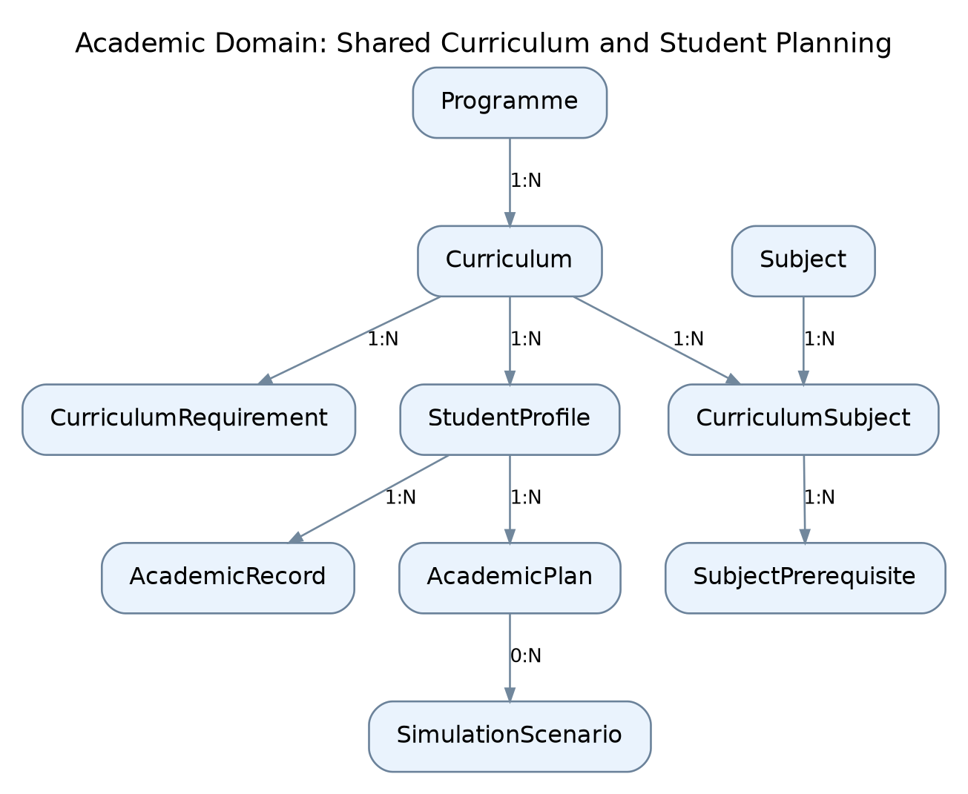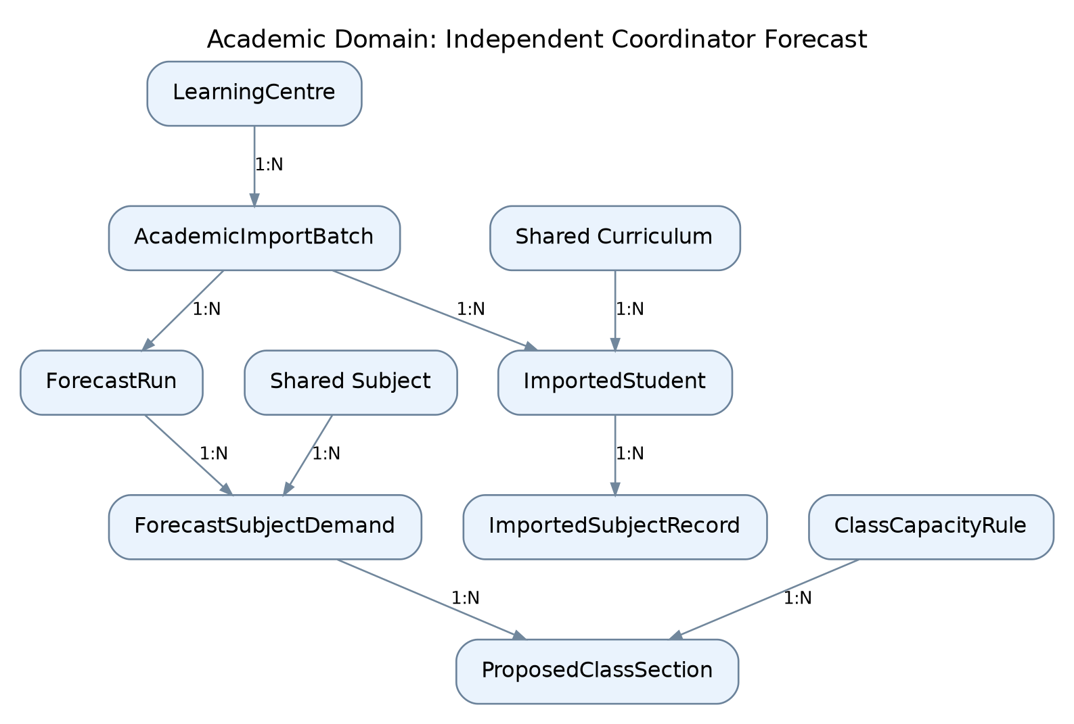
Figure 2.2: Academic Domain Model

2.2.1 UC01: Use Case Register Account
Field | Description
Use case ID | UC01
Use Case Name | Register Account
Actor | Part-Time Student, Clerk Authentication Service
Brief Description | Allows new students to register for the system using Clerk authentication with a verified institutional email address belonging to the @graduate.utm.my domain.
Includes | Email verification, domain validation, Clerk authentication, student profile initialization.
Extension Points | Additional academic profile information may be collected after successful registration.
Pre-condition | 1. The student has not registered an account in the system.  2. The student possesses an accessible institutional email address ending with @graduate.utm.my.  3. An internet connection is available.
Normal Flow | 1. Student accesses the registration page.  2. Student clicks the Register button.  3. System displays the Clerk registration interface.  4. Student enters their institutional email address and completes the required registration information.  5. Clerk initiates email verification.  6. Student completes the verification process.  7. System verifies the authenticated account and permitted institutional email domain.  8. System associates the student with a unique Clerk User ID and creates an initial student profile in Neon PostgreSQL.  9. Student is directed to mandatory academic profile setup. StudentProfile is created with the selected valid curriculum when setup succeeds..
Exception Flow | 1. If the email domain is not @graduate.utm.my, student access is rejected.  2. If email verification fails or is incomplete, access to protected features is denied.  3. If the account already exists, the student is directed to log in.  4. If the authentication service is unavailable, the system displays an appropriate error message.
Postcondition | A student account is registered and its institutional email is verified. Academic profile setup must be completed before planning functions become available.
Business Rules | 1. Student accounts must use a verified institutional email address.  2. Each academic profile must be associated with a unique Clerk User ID.  3. Students cannot modify their registered institutional email addresses through the application.  4. Access restrictions must be enforced by the backend.

UC01 | INDIVIDUAL USE CASE DIAGRAM
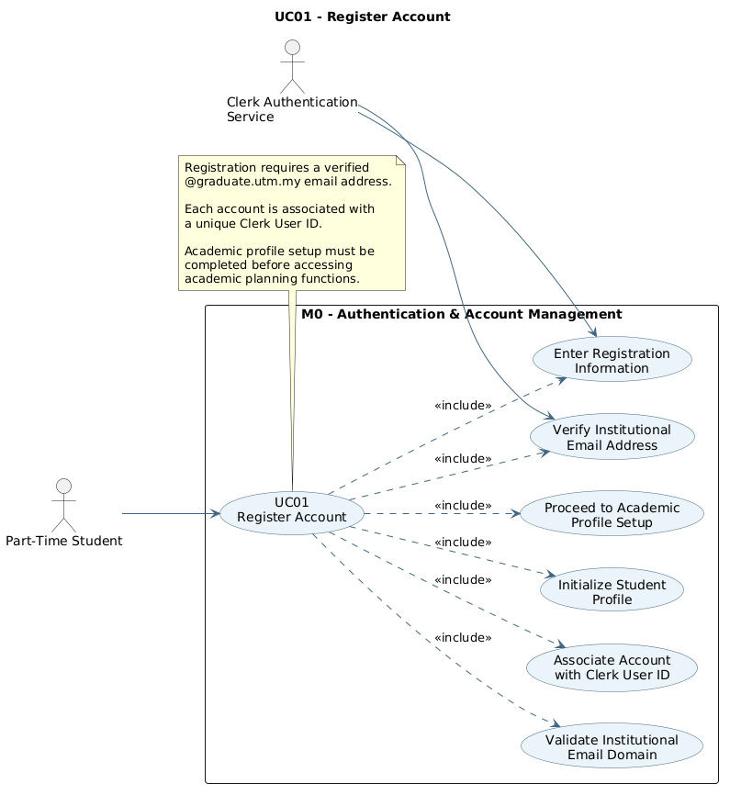
Register Account

2.2.1.1 Activity Diagram — Register Account
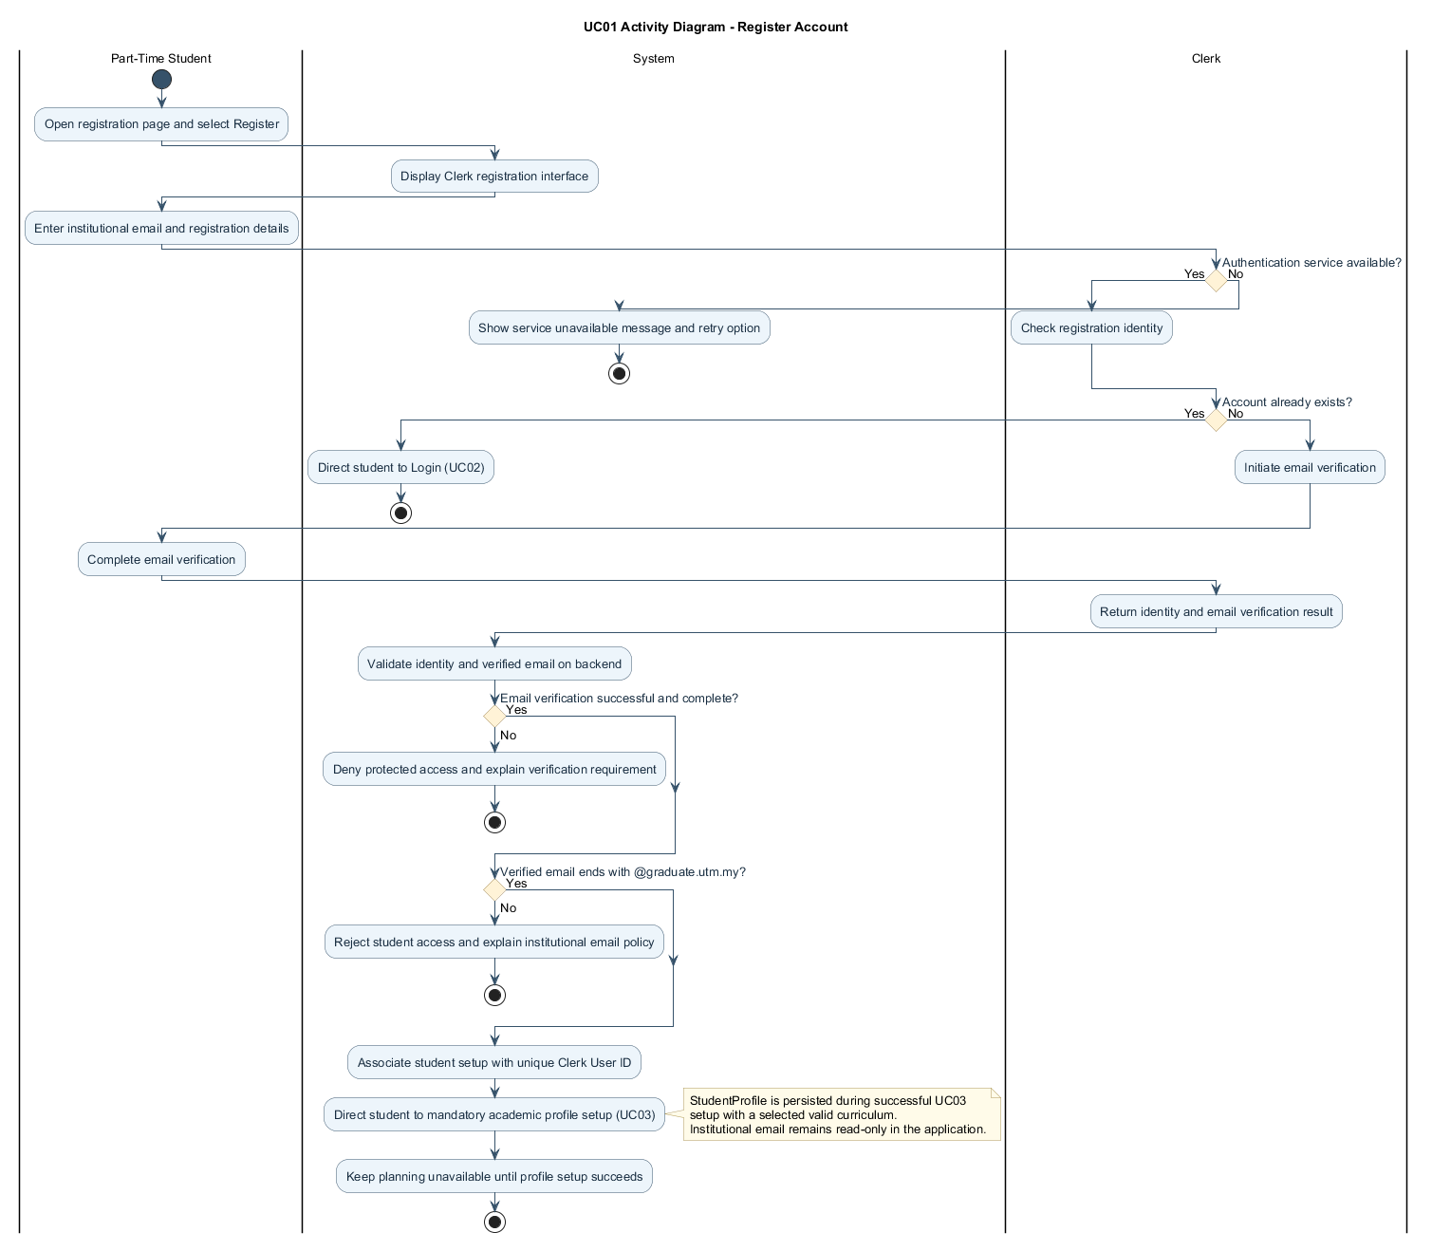
Figure 2.1: Activity Diagram for Register Account

2.2.1.2 Sequence Diagram — Register Account
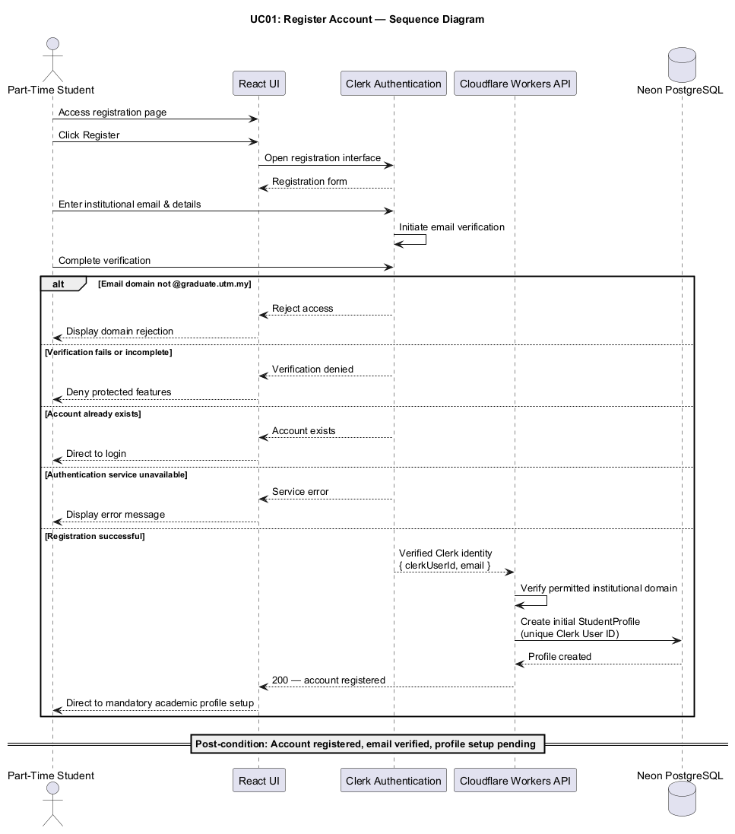

2.2.2 UC02: Use Case Login / Logout
Field | Description
Use case ID | UC02
Use Case Name | Login / Logout
Actor | Part-Time Student, System Administrator, Academic Coordinator, Clerk Authentication Service
Brief Description | Allows authorized students, system administrators and Academic Coordinators to securely log in and log out through Clerk, with backend-enforced role access.
Includes | Authentication, session validation, role-based authorization, logout.
Extension Points | Password recovery or other authentication recovery mechanisms supported by Clerk.
Pre-condition | The user has an existing authorized account.
Normal Flow | 1. User accesses the system login page.  2. User enters their credentials using the Clerk authentication interface.  3. Clerk authenticates the user.  4. The backend validates the authenticated session and checks the user's permitted role and account eligibility.  5. The system retrieves the user's associated profile.  6. The user is redirected to the student, coordinator or System Administrator dashboard permitted by the validated application role..  7. When finished, the user selects Logout.  8. Clerk terminates the user session and the system returns to the login page.
Exception Flow | 1. If authentication fails, the system displays an error and allows another attempt.  2. If the student's institutional email does not satisfy the verified-domain policy, access is denied.  3. If an administrator does not have the required role, access to administrative functions is denied.  4. If the session expires, the system requires reauthentication.  5. If Clerk is unavailable, the system informs the user that authentication cannot be completed.
Postcondition | The user successfully enters the appropriate dashboard or securely logs out of the application.
Business Rules | 1. Users must authenticate before accessing protected system functions.  2. Student accounts must satisfy the verified institutional email policy.  3. Administrator privileges must be explicitly assigned.  4. Users may only access functions permitted by their assigned roles.

UC02 | INDIVIDUAL USE CASE DIAGRAM
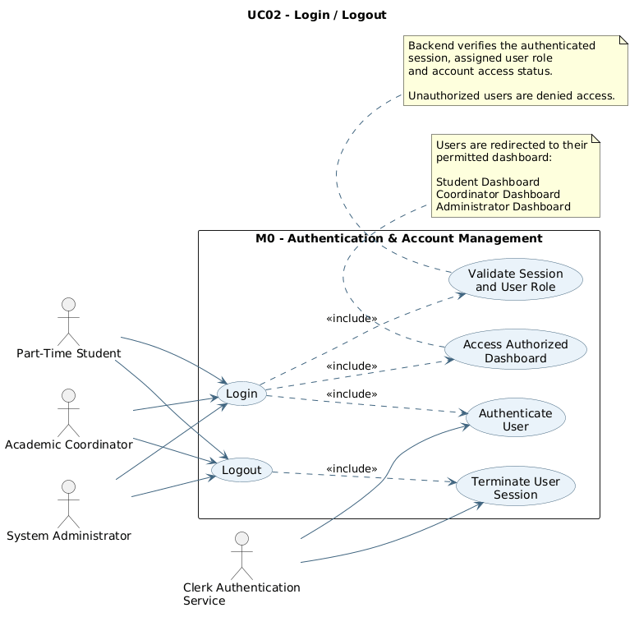
Login / Logout

2.2.2.1 Activity Diagram — Login / Logout
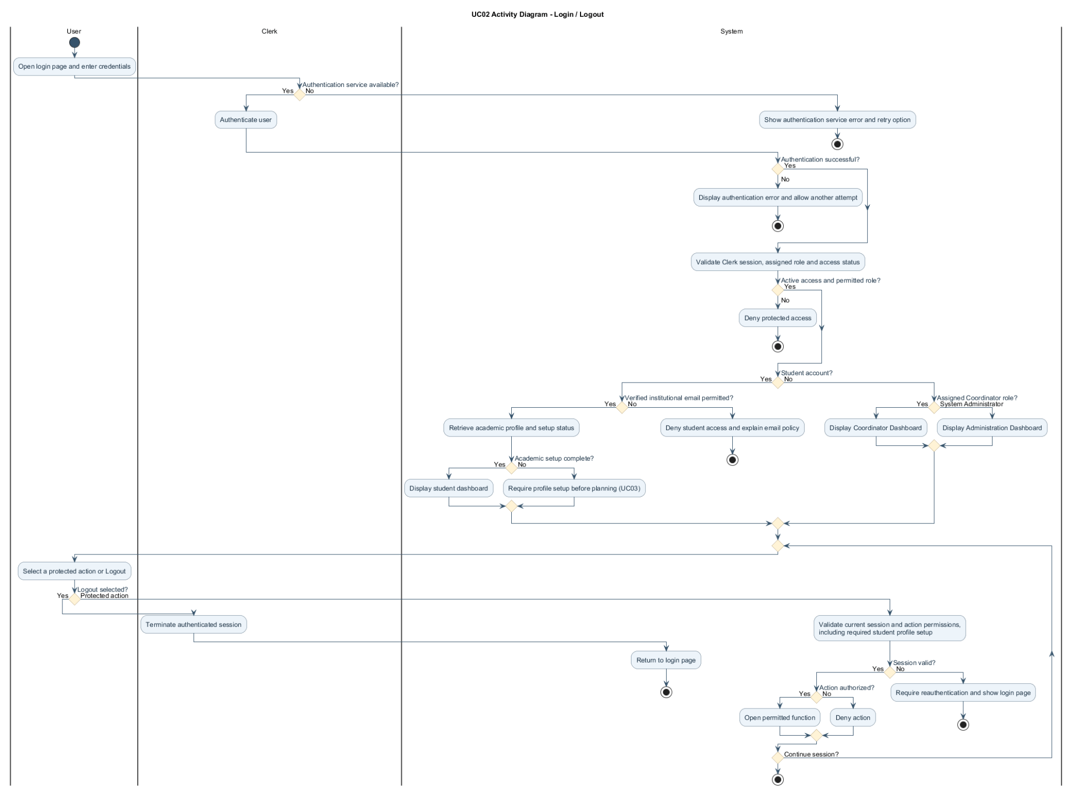

2.2.2.2 Sequence Diagram — Login / Logout
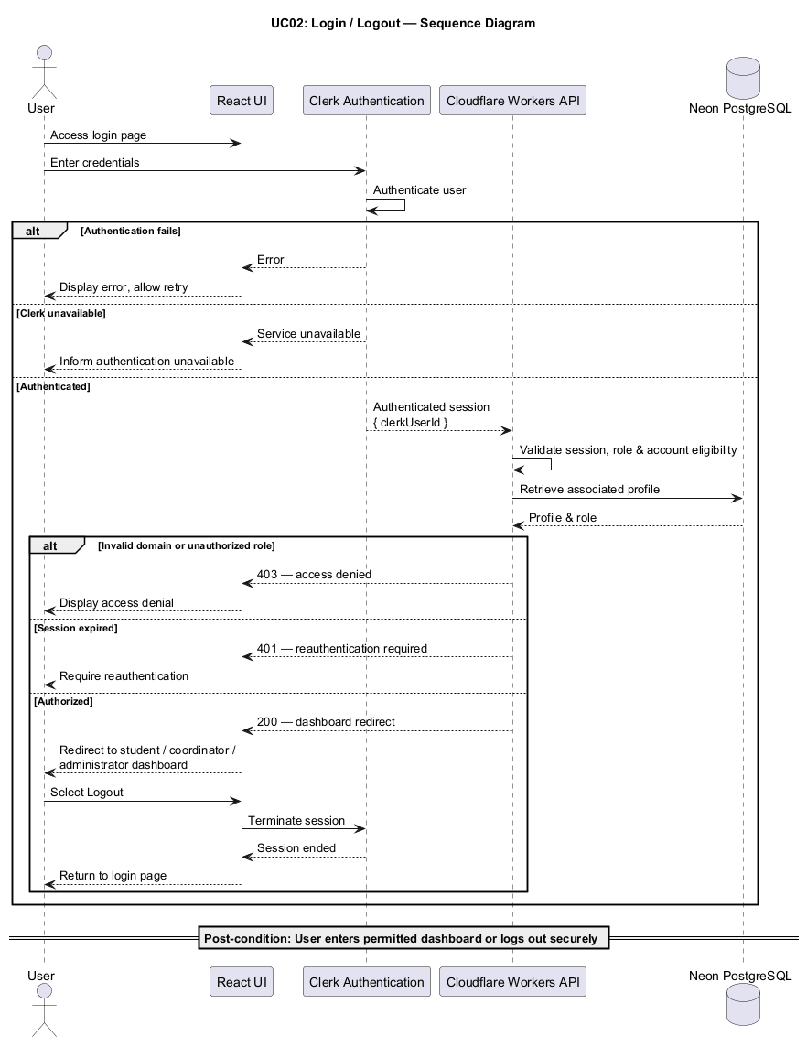

2.2.3 UC03: Use Case Manage Academic Profile
Field | Description
Use case ID | UC03
Use Case Name | Manage Academic Profile
Actor | Part-Time Student
Brief Description | Allows students to create, view, and update their academic profiles and employment-related information for personalized academic planning.
Includes | Profile data entry, input validation, database update.
Extension Points | Additional planning preferences, such as preferred academic workload, may be configured.
Pre-condition | Student must be authenticated and have an existing system account.
Normal Flow | 1. Student logs in to the system.  2. Student navigates to the Academic Profile page.  3. System displays available profile information.  4. Student enters or updates academic information, including the selected programme and applicable curriculum.  5. Student enters employment commitments, weekly working hours, and available study time.  6. Student clicks Save Profile.  7. System validates the information and stores the updated profile in Neon PostgreSQL.  8. System displays a successful update message.
Exception Flow | 1. If required information is missing, the system displays a validation message.  2. If entered values are invalid, the system requests corrections.  3. If the database operation fails, the system displays an error and allows the student to retry.  4. If the student cancels the update, the existing profile information remains unchanged.
Postcondition | The student's academic profile and planning preferences are successfully stored or updated.
Business Rules | 1. Each profile must be associated with the authenticated student's Clerk User ID.  2. Weekly employment hours and available study hours must contain valid non-negative values.  3. Students may only modify their own academic profiles.  4. Institutional email addresses cannot be modified through the academic profile interface.

UC03 | INDIVIDUAL USE CASE DIAGRAM
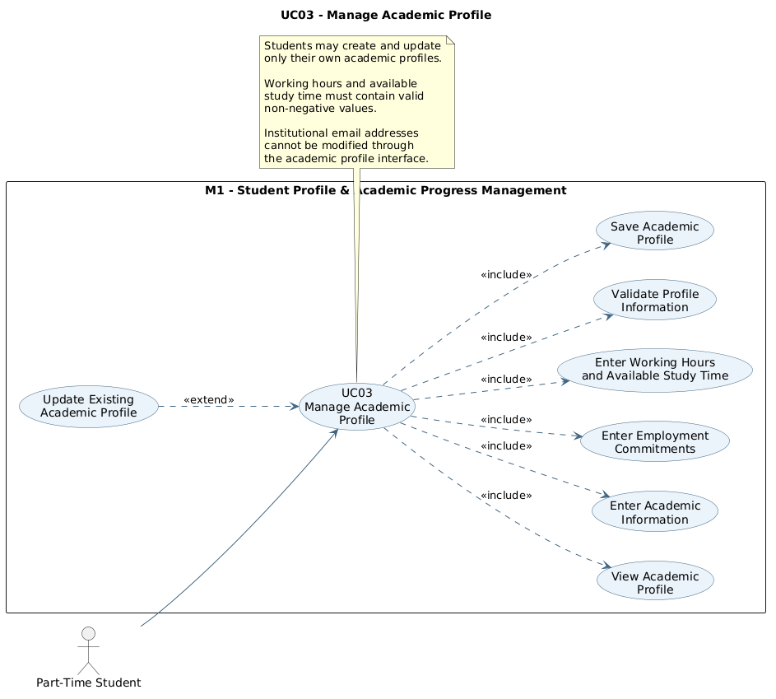
Manage Academic Profile

2.2.3.1 Activity Diagram — Manage Academic Profile
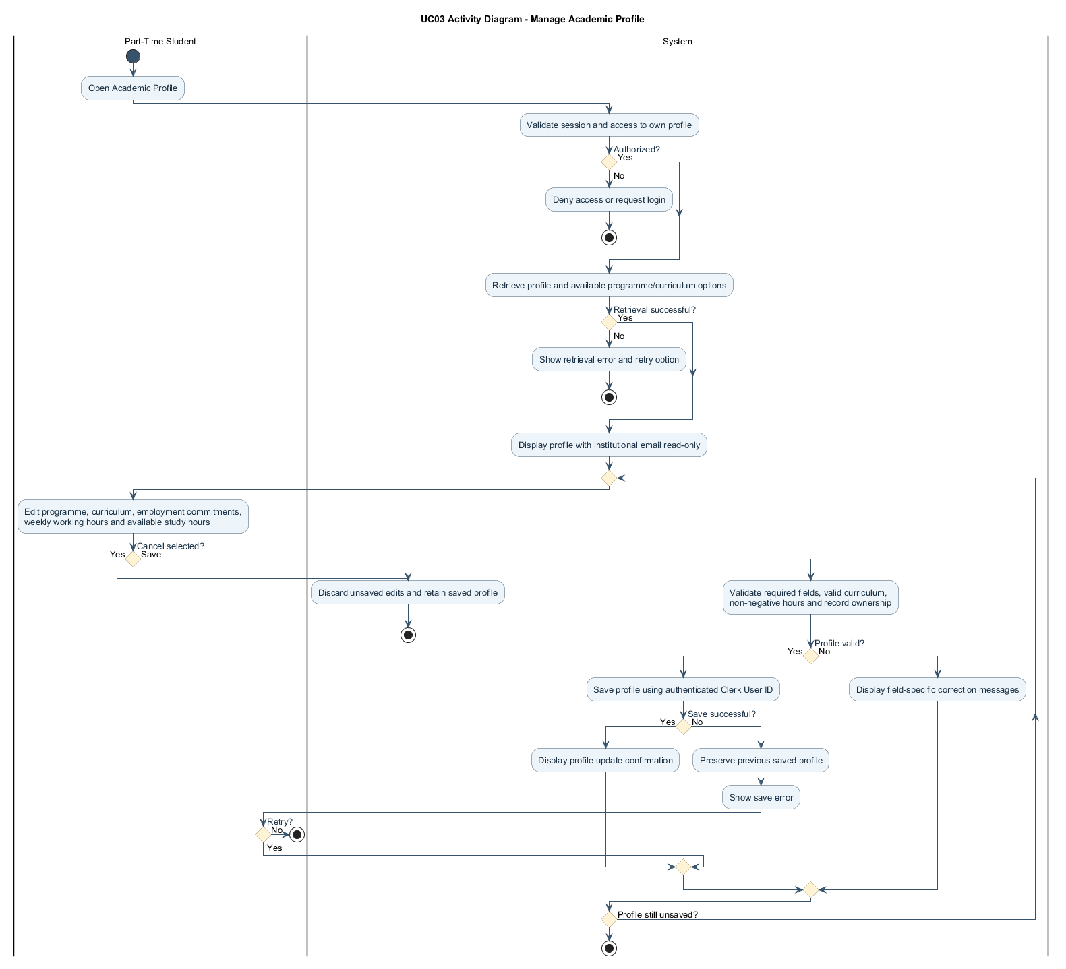

2.2.3.2 Sequence Diagram — Manage Academic Profile
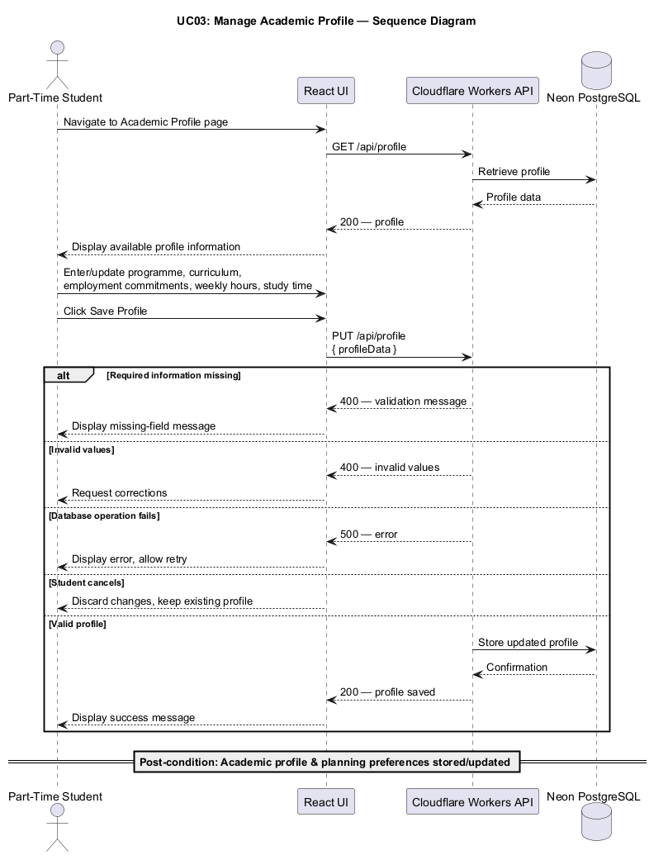

2.2.4 UC04: Use Case Manage Academic Subject Records
Field | Description
Use case ID | UC04
Use Case Name | Manage Academic Subject Records
Actor | Part-Time Student
Brief Description | Allows students to maintain their academic subject history by recording completed, exempted, failed, and withdrawn subjects.
Includes | Subject selection, academic status management, exemption recording, input validation, database update.
Extension Points | Recording additional academic details such as course attempts or grades where supported.
Pre-condition | 1. Student must be authenticated.  2. The student's academic profile must be initialized.  3. The relevant curriculum subject list must be available.
Normal Flow | 1. Student accesses the Academic Subject Records page.  2. System retrieves the applicable curriculum subject list.  3. Student selects a subject from the list.  4. Student assigns the appropriate academic status: Completed, Exempted, Failed, or Withdrawn.  5. For exempted subjects, the student provides the relevant exemption or credit recognition details.  6. Student saves the academic record.  7. System validates and stores the information.  8. System updates the student's academic progression data.  9. Student can review or update previously entered subject records.
Exception Flow | 1. If the selected subject does not belong to the applicable curriculum, the system rejects the entry.  2. If exemption information is incomplete, the system requests the required details.  3. If conflicting subject statuses are entered, the system requests correction.  4. If the student cancels the operation, no changes are saved.  5. If a database error occurs, the system displays an appropriate message.
Postcondition | The student's academic subject records are stored or updated and become available for academic progression analysis.
Business Rules | 1. Students may only manage their own academic records.  2. Successfully completed subjects shall contribute the applicable credit hours.  3. Approved exemptions shall satisfy the relevant subject requirements.  4. Only recognized credit transfers or credit-bearing exemptions shall contribute to accumulated credits.  5. Failed and withdrawn subjects shall not contribute completed graduation credits.  6. Duplicate subject records shall not result in double-counted credits.

UC04 | INDIVIDUAL USE CASE DIAGRAM
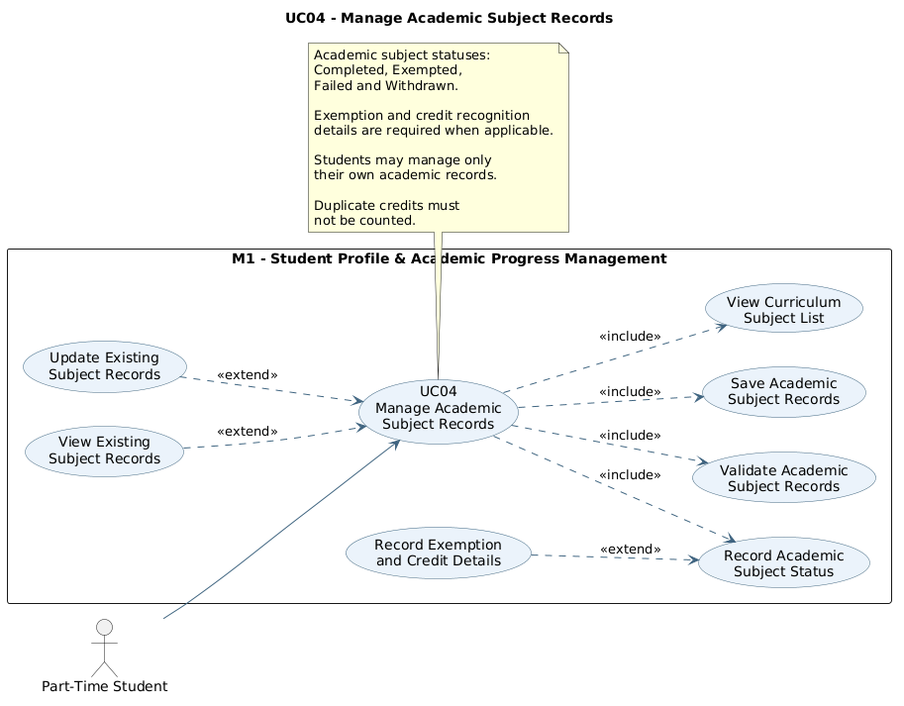
Manage Academic Subject Records

2.2.4.1 Activity Diagram — Manage Academic Subject Records

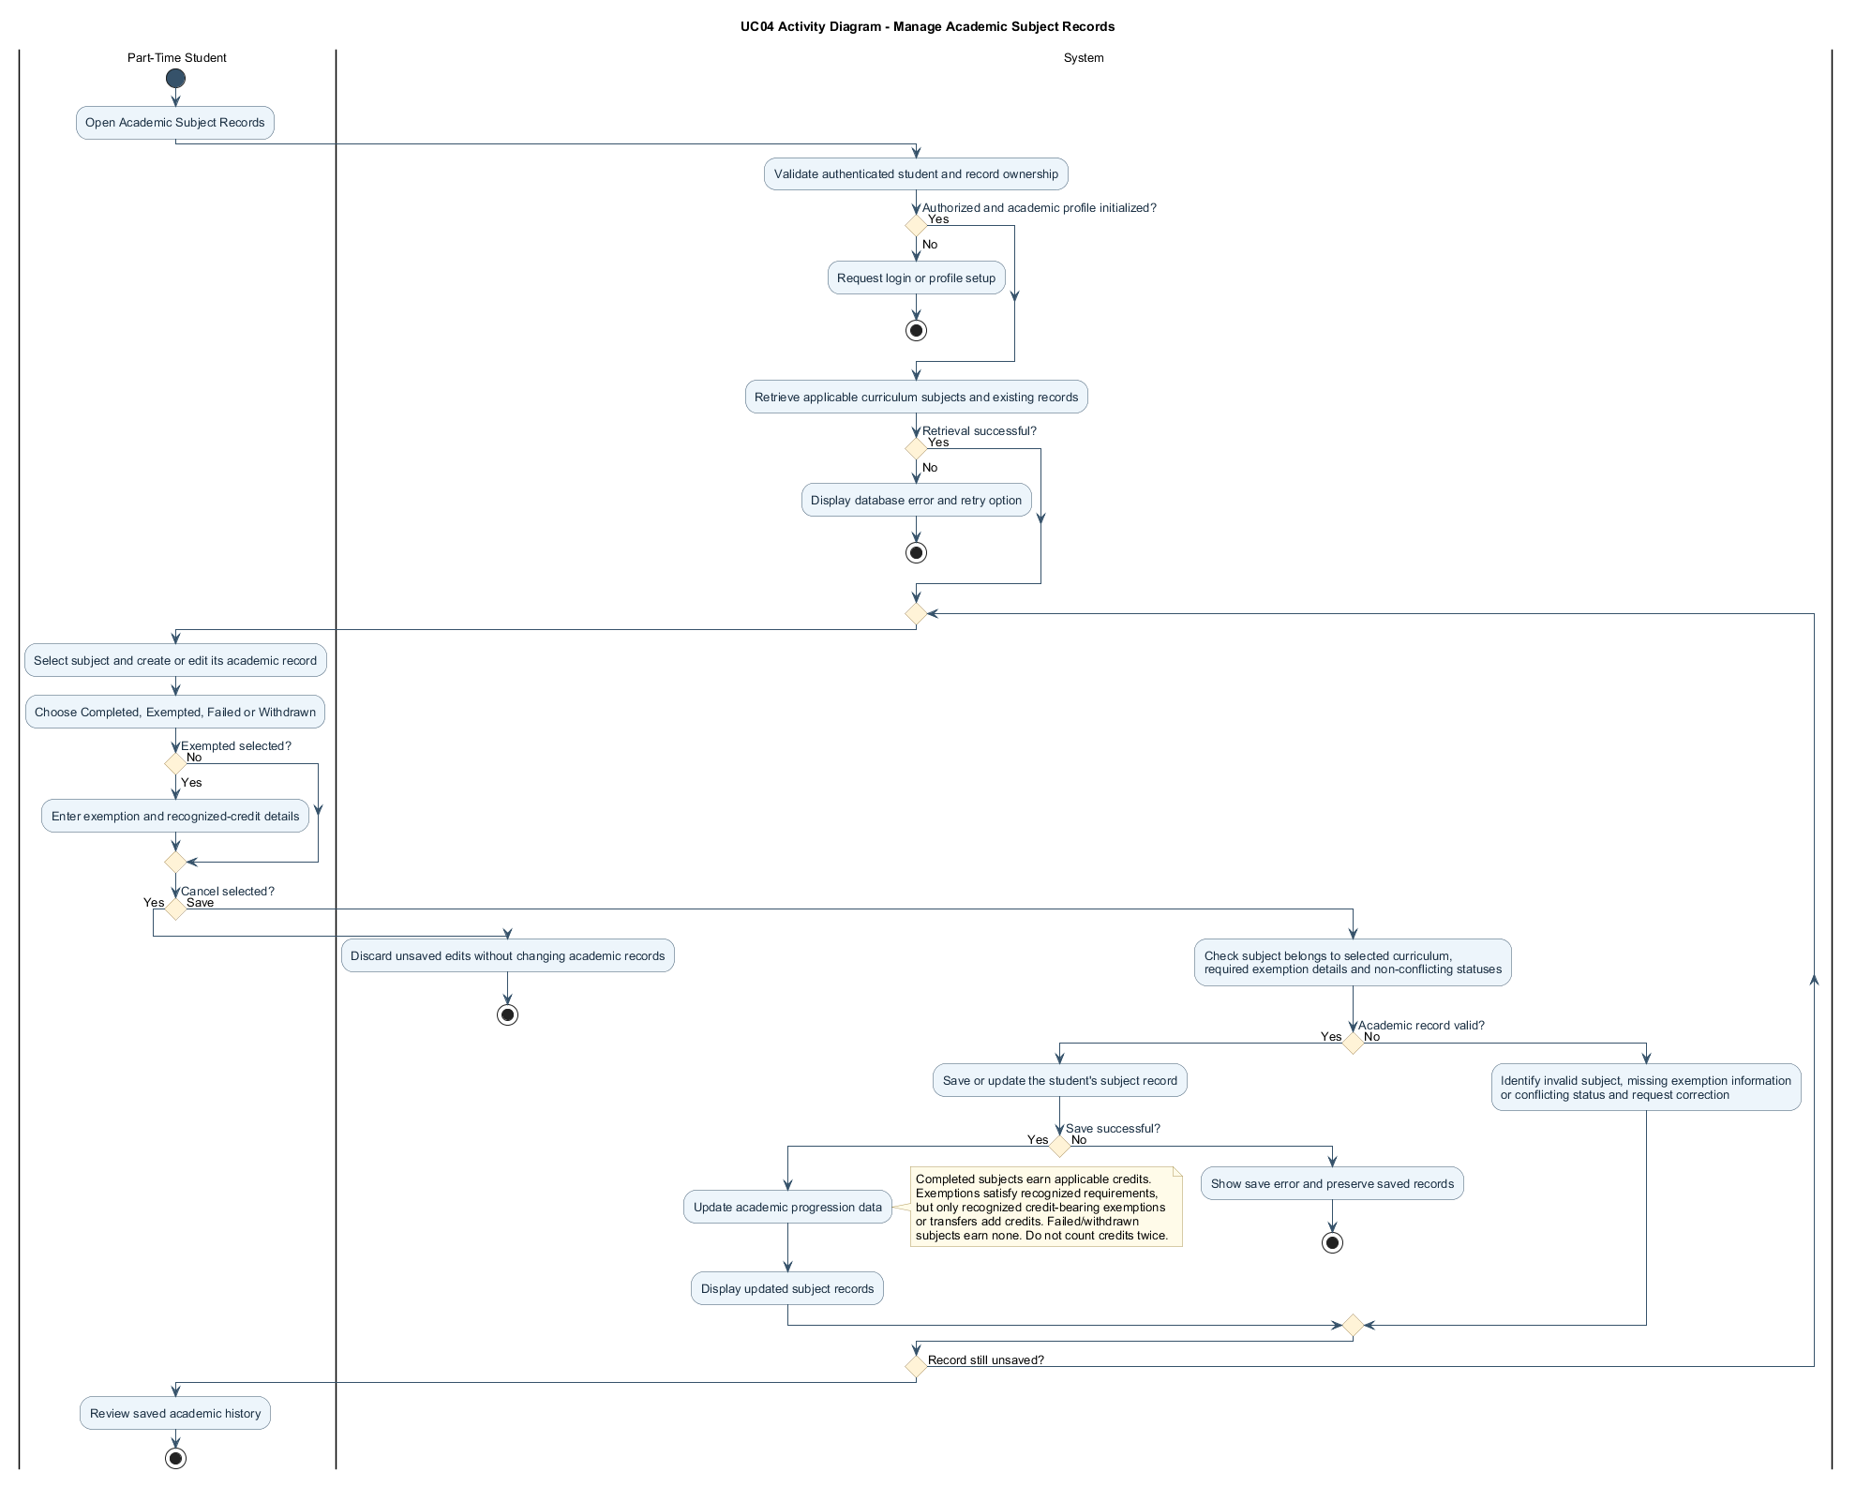
Figure 2.3: Activity Diagram for Manage Academic Subject Records

2.2.4.2 Sequence Diagram — Manage Academic Subject Records
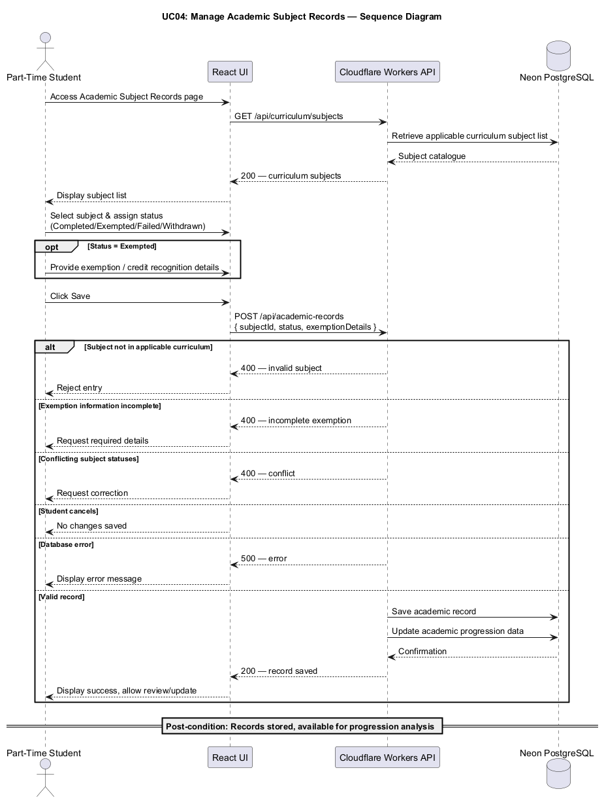
Figure 2.4: Sequence Diagram for Manage Academic Subject Records

2.2.5 UC05: Use Case View Academic Progress
Field | Description
Use case ID | UC05
Use Case Name | View Academic Progress
Actor | Part-Time Student
Brief Description | Allows students to view accumulated credits, remaining credits, recognized exemptions, and overall academic progress towards graduation.
Includes | Academic record retrieval, credit calculation, outstanding subject identification, progress visualization.
Extension Points | Academic progress charts and additional subject completion statistics.
Pre-condition | 1. Student must be authenticated.  2. The programme curriculum and graduation requirements must be configured.  3. The student must have an initialized academic profile.
Normal Flow | 1. Student accesses the Academic Progress dashboard.  2. System retrieves the student's recorded academic subject information.  3. System retrieves the applicable curriculum and credit requirements.  4. System calculates accumulated credits, including successfully completed subjects and recognized credit-bearing exemptions or transfers.  5. System identifies remaining prescribed subjects and outstanding academic requirements.  6. System calculates academic progress against the total credit hours required by the student's selected degree programme and applicable curriculum version.  7. System displays a progress summary, including completed subjects, exempted subjects, accumulated credits, and remaining credits.
Exception Flow | 1. If the student has not entered academic records, the system displays the initial progress state and prompts the student to enter their academic history.  2. If curriculum information is incomplete, the system indicates that the progress calculation cannot be finalized.  3. If exemption credit details are missing, the system identifies the incomplete information.  4. If the database cannot be accessed, the system displays an appropriate error message.
Postcondition | The student's academic progression summary is displayed using the latest recorded academic information.
Business Rules | 1. Academic progress shall be calculated against the applicable programme requirements.  2. Completed credits and recognized transferred credits shall be distinguished in the academic record.  3. Credits from failed and withdrawn subjects shall not be counted as earned credits.  4. Academic progress shall not count the same credit entitlement more than once.  5. The system shall distinguish overall credit completion from completion of all prescribed curriculum components.

UC05 | INDIVIDUAL USE CASE DIAGRAM
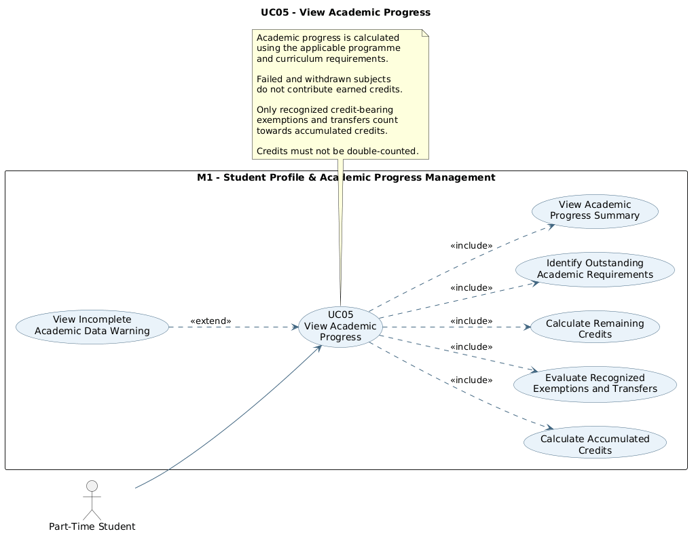
View Academic Progress

2.2.5.1 Activity Diagram — View Academic Progress
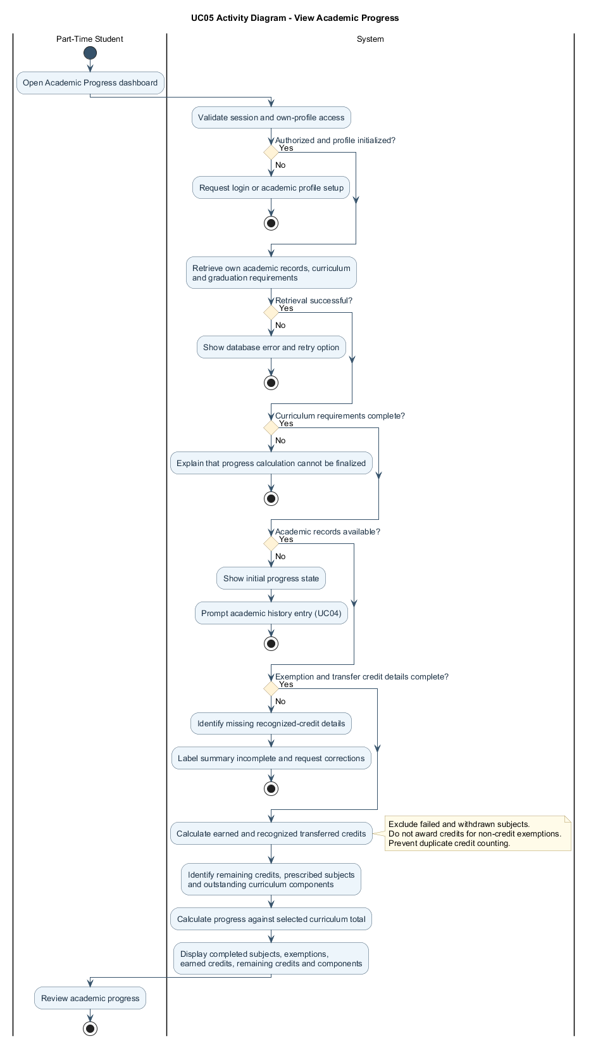

2.2.5.2 Sequence Diagram — View Academic Progress
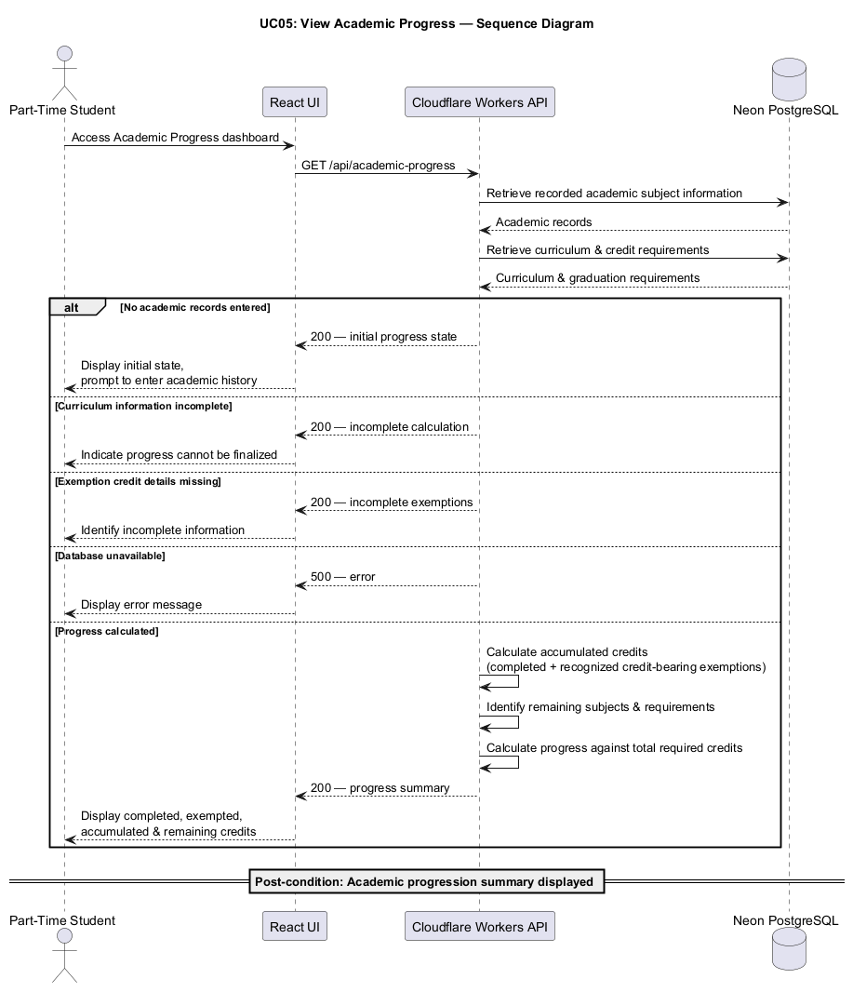

2.2.6 UC06: Use Case Manage Curriculum and Prerequisites
Field | Description
Use case ID | UC06
Use Case Name | Manage Curriculum and Prerequisites
Actor | System Administrator
Brief Description | Allows system administrators to maintain curriculum subject information, official prerequisite relationships, co-requisites, and recommended prior knowledge required by the academic planning engine.
Includes | Curriculum management, subject management, prerequisite validation, dependency graph management.
Extension Points | Curriculum version management, importing curriculum data from structured files.
Pre-condition | 1. Administrator must be authenticated.  2. Administrator must possess the appropriate management permissions.  3. An applicable academic programme and curriculum must exist in the system.
Normal Flow | 1. Administrator opens Curriculum Management and selects the relevant programme and curriculum version.  2. System loads the current subject catalogue, prerequisite rules and semester restrictions.  3. Administrator creates or edits subject details and curriculum mappings.  4. Administrator configures mandatory prerequisites, co-requisites and advisory prior-knowledge links separately.  5. Administrator sets subject-specific permitted semester types and documented exceptions.  6. System checks required fields, duplicate subject mappings and cyclic prerequisite dependencies.  7. Administrator reviews the changes and confirms Save.  8. System persists validated curriculum rules and makes them available to academic engines.
Exception Flow | 1. If a duplicate subject code is entered within the applicable curriculum, the system rejects the entry.  2. If an invalid prerequisite cycle is detected, the system displays an error and prevents the invalid relationship from being saved.  3. If required subject information is missing, the system requests corrections.  4. If the administrator lacks the required permissions, access is denied.  5. If the database update fails, the system displays an error message.
Postcondition | The curriculum subject information and dependency relationships are successfully created or updated.
Business Rules | 1. Each subject must have a unique code within the applicable curriculum.  2. Subject information must include valid credit hours and classifications.  3. Official prerequisite relationships must follow the programme's academic regulations.  4. The mandatory prerequisite graph must not contain invalid cyclic dependencies.  5. Co-requisites and concurrent enrollment rules must be managed separately from strictly sequential prerequisites.  6. Recommended prior knowledge shall not automatically prevent subject registration.  7. Only authorized administrators may modify curriculum information.  8. Two-credit subjects shall normally be restricted to Semester 3 unless a subject-specific exception is configured.  9. Final Year Project 1, a two-credit subject, shall be exempt from the default Short-Semester-only rule.  10. English 1, English 2, and English 3 shall form a mandatory sequential prerequisite chain.

UC06 | INDIVIDUAL USE CASE DIAGRAM
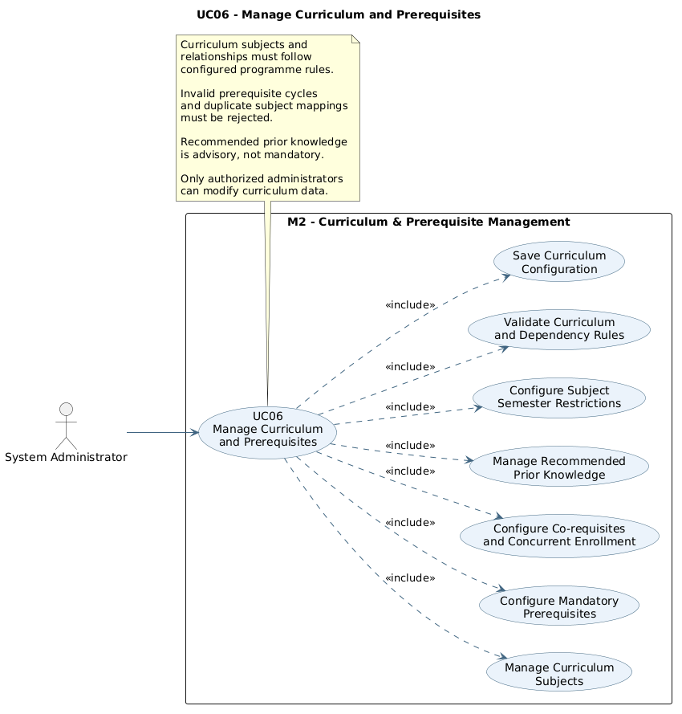
Manage Curriculum and Prerequisites

2.2.6.1 Activity Diagram — Manage Curriculum and Prerequisites
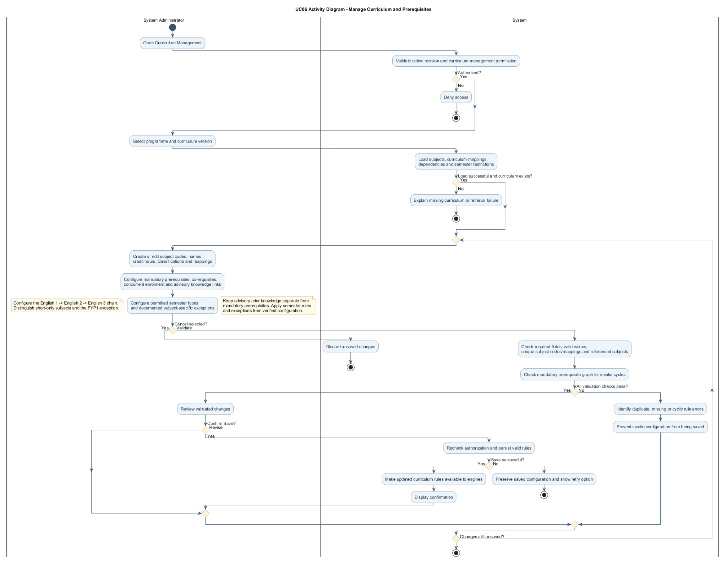

2.2.6.2 Sequence Diagram — Manage Curriculum and Prerequisites
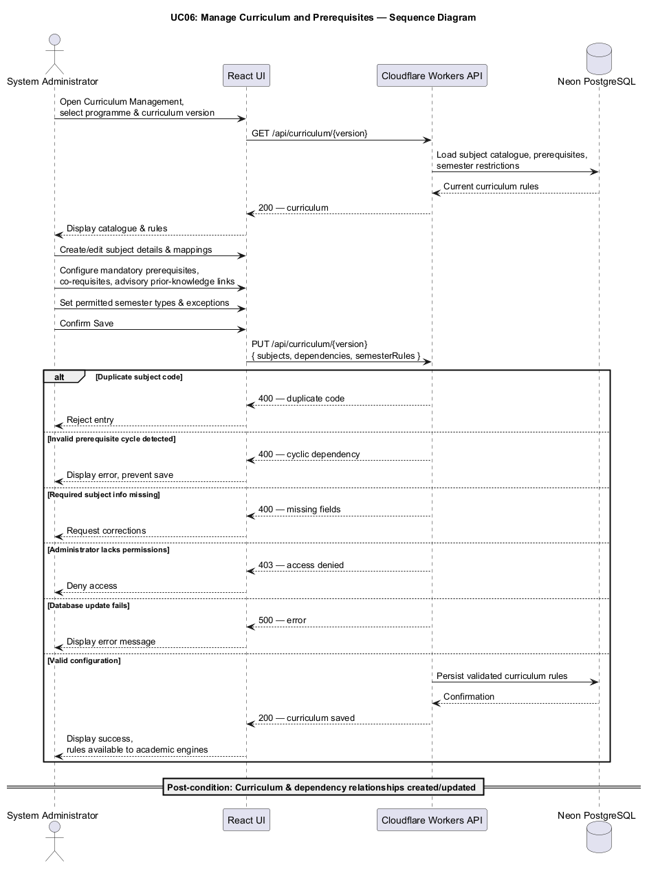

2.2.7 UC07: Use Case Manage Graduation Requirements
Field | Description
Use case ID | UC07
Use Case Name | Manage Graduation Requirements
Actor | System Administrator
Brief Description | Allows administrators to configure the credit, subject and curriculum rules used to assess degree completion.
Includes | Graduation credit configuration, compulsory requirement management, elective requirement configuration, validation of graduation rules.
Extension Points | Support for multiple curriculum versions and additional programme-specific graduation requirements.
Pre-condition | 1. Administrator must be authenticated and authorized.  2. The relevant academic programme and curriculum must exist.  3. Subject information must be available for graduation requirement configuration.
Normal Flow | 1. Administrator opens Graduation Requirements Management and selects the applicable programme and curriculum version.  2. System displays the existing graduation requirements and academic semester configuration.  3. Administrator configures the total credit hours required for graduation and the compulsory subject and elective requirements.  4. Administrator identifies Final Year Project 1, Final Year Project 2, Industrial Training, and any other required components and relevant completion conditions.  5. Administrator configures the three-semester academic year: Semesters 1 and 2 are Normal Semesters with up to three subjects and the configured normal-semester credit cap; Semester 3 is the Short Semester with up to three subjects and six credits.  6. System validates the completeness and consistency of graduation requirements and semester registration rules.  7. Administrator reviews and saves the configuration.  8. System stores the updated requirements and makes them available for progress assessment, eligibility checking, and graduation pathway generation.
Exception Flow | 1. If the required credit hours are invalid, the system requests correction.  2. If a compulsory curriculum component is missing or incorrectly configured, the system displays a validation warning.  3. If the configuration contains inconsistent requirements, the system prevents or flags the invalid configuration.  4. If the administrator cancels the changes, the existing configuration remains unchanged.  5. If the database operation fails, the system displays an error message.
Postcondition | Graduation requirements are successfully configured and available for academic progress and graduation prediction calculations.
Business Rules | 1. The programme's required credit hours shall be defined according to the applicable curriculum.  2. The prescribed graduation credits shall comprise the compulsory subjects, elective requirements, Final Year Projects, Industrial Training, and other curriculum components applicable to the selected programme and curriculum version.  3. These components shall contribute towards the prescribed total and shall not be treated as additional credits beyond the programme requirement.  4. Graduation eligibility shall require completion of the prescribed curriculum components and applicable credit requirements.  5. Any prerequisite or enrollment restrictions associated with mandatory components shall be enforced according to configured academic rules.  6. Only authorized administrators shall be permitted to modify graduation requirements.  7. The academic-year model shall contain exactly three chronological semesters, with Semester 3 always classified as Short Semester.  8. Each semester shall allow no more than three subjects, with limits of ten credits for Semesters 1 and 2 and six credits for Semester 3, unless a configured programme exception applies.

UC07 | INDIVIDUAL USE CASE DIAGRAM
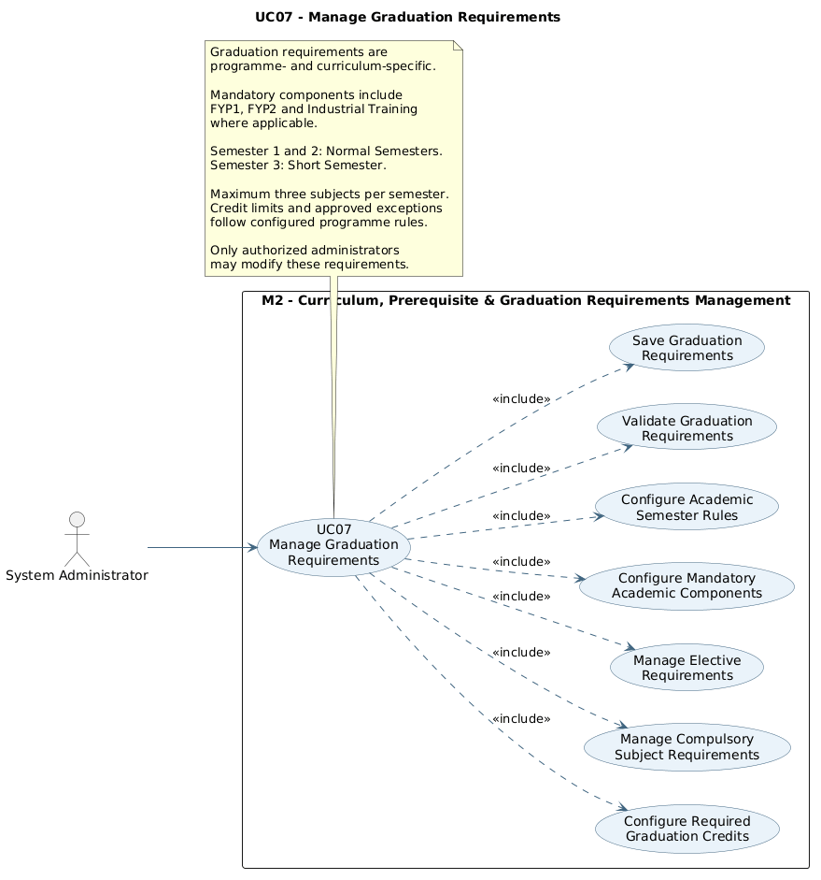
Manage Graduation Requirements

2.2.7.1 Activity Diagram — Manage Graduation Requirements
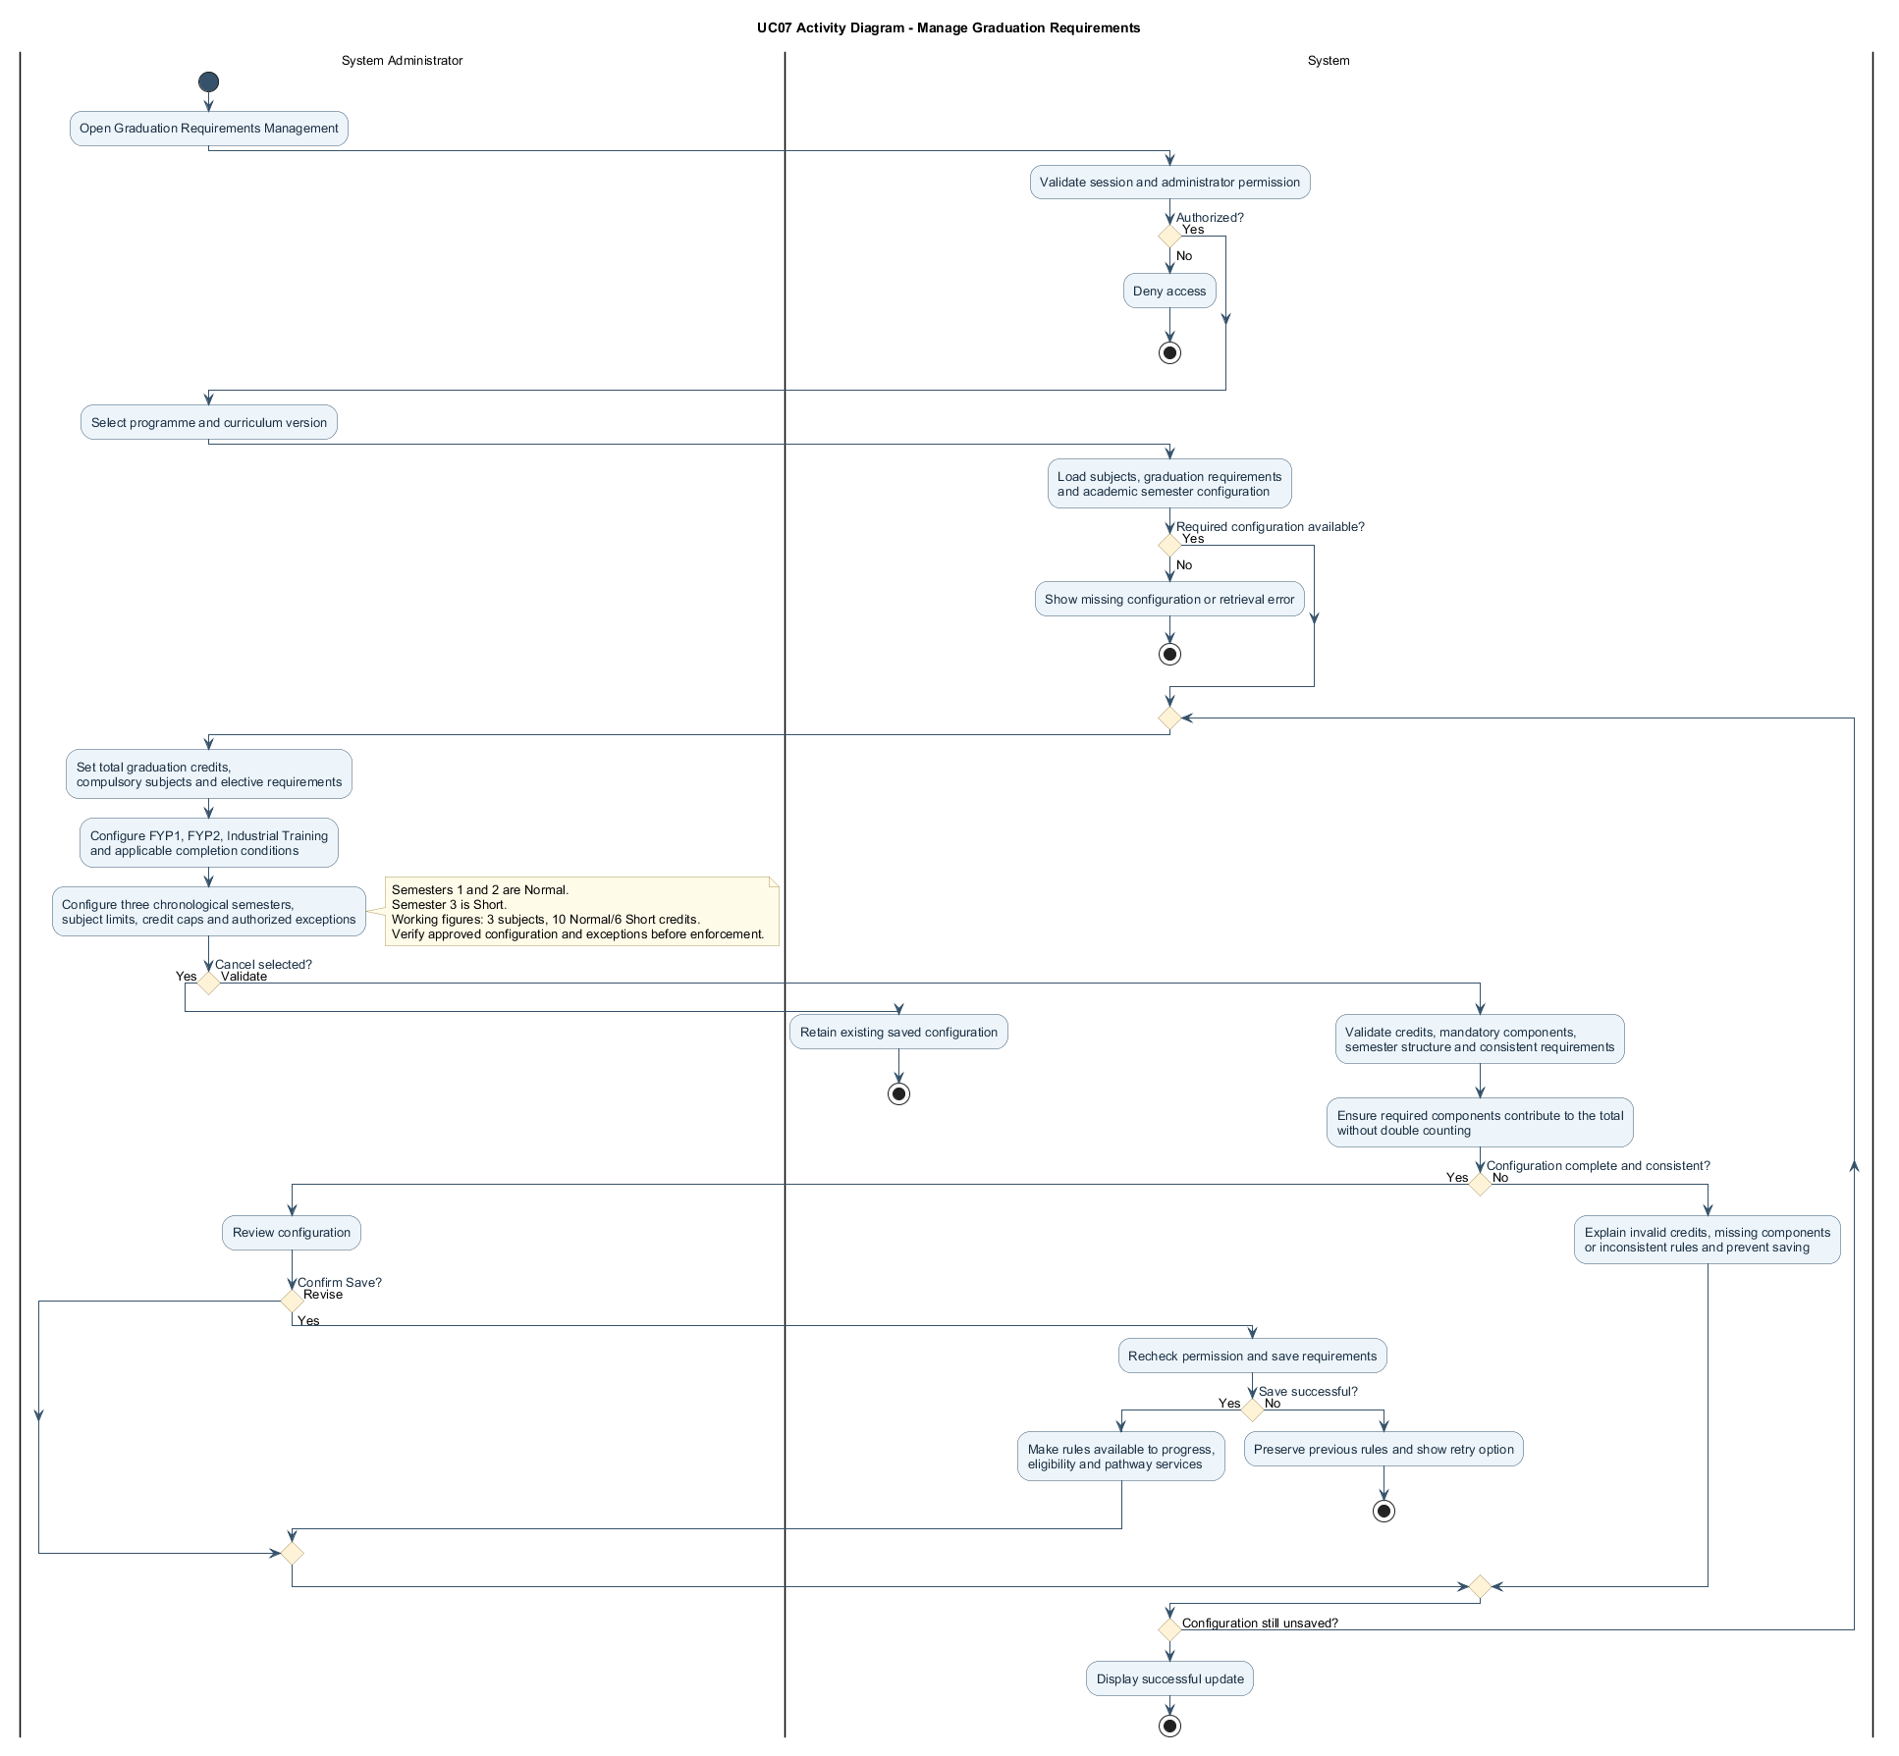

2.2.7.2 Sequence Diagram — Manage Graduation Requirements
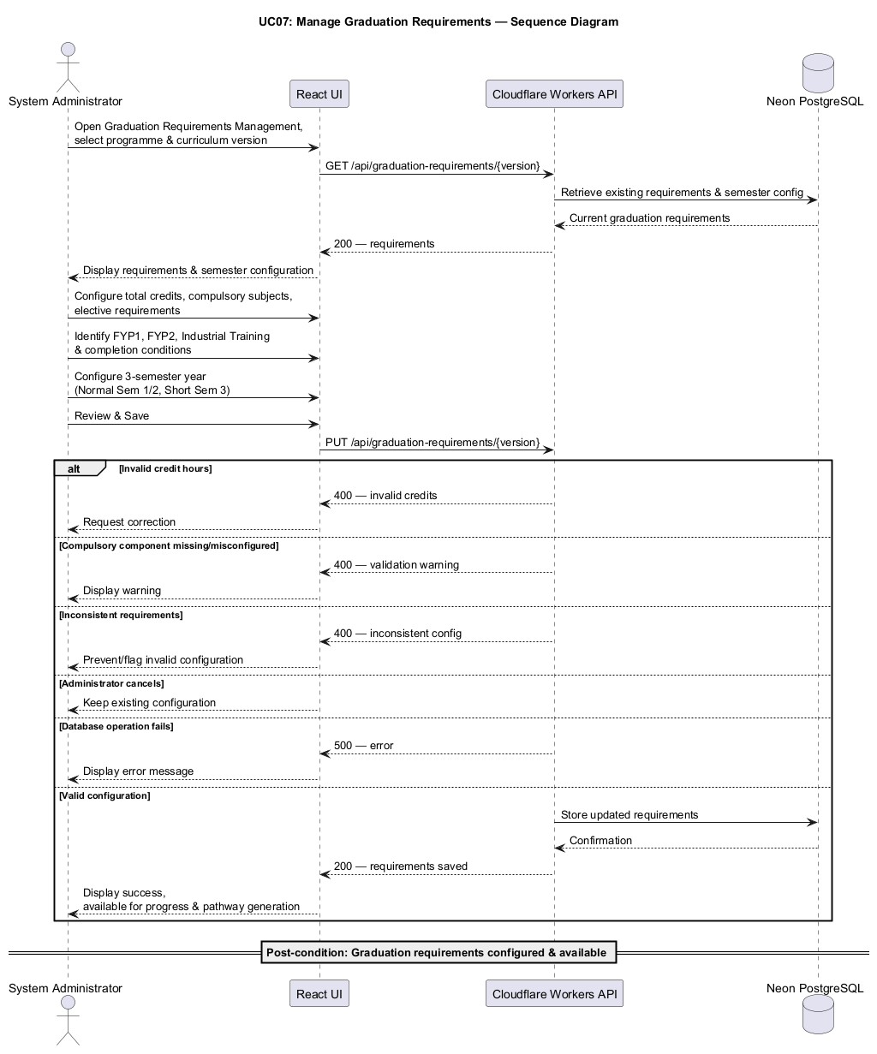

2.2.8 UC08: Use Case Enter Semester Subject Offerings
Field | Description
Use case ID | UC08
Use Case Name | Enter Semester Subject Offerings
Actor | Part-Time Student
Brief Description | Allows students to identify and select subjects offered by UTMSPACE during the current semester registration period. The selected subjects will be used by the system to evaluate academic eligibility and generate personalized subject recommendations.
Includes | Curriculum subject retrieval, subject selection, input validation, semester offering management.
Extension Points | Future integration with official semester subject offering information, where available.
Pre-condition | 1. Student must be authenticated.  2. The student's academic profile must be initialized.  3. The relevant programme curriculum and subject list must be available.
Normal Flow | 1. Student opens the Semester Subject Offerings page.  2. System identifies the selected academic year and semester; Semester 3 is automatically designated the Short Semester.  3. System displays the subject catalogue for the student's selected programme and curriculum.  4. Student refers to UTMSPACE registration information and selects the subjects reported as offered during the current semester.  5. System validates the selected subjects against the applicable curriculum and checks for duplicate entries.  6. Student reviews and confirms the student-reported offering list.  7. System saves the offering list against the selected academic year and semester.  8. System displays the recorded offerings for subsequent eligibility checking and recommendation generation.
Exception Flow | 1. If no subjects are selected, the system prompts the student to select at least one offered subject before generating recommendations.  2. If a selected subject does not belong to the applicable curriculum, the system rejects the invalid selection.  3. If the student selects the wrong subject, the system allows the selection to be removed or corrected.  4. If the student cancels the operation, the current unsaved changes are discarded.  5. If the database operation fails, the system displays an appropriate error message.
Postcondition | The student-reported semester subject offering list is successfully recorded and becomes available for academic eligibility validation and subject recommendation processing.
Business Rules | 1. Students shall select subjects only from the curriculum associated with their academic profile.  2. Subject offerings shall be identified by students based on information published during the current registration period.  3. The selected offering list shall be associated with the relevant academic semester.  4. Duplicate subject selections shall not be permitted.  5. Students shall be able to update the offering list before finalizing their academic plan.  6. Student-reported offerings shall not be presented as officially verified university information.  7. Offering lists shall be associated with a specific academic year and semester (1, 2, or 3); semester type is derived from the semester number.  8. Subjects entered as offered shall remain student-reported, even when the course is normally permitted in that semester type.

UC08 | INDIVIDUAL USE CASE DIAGRAM
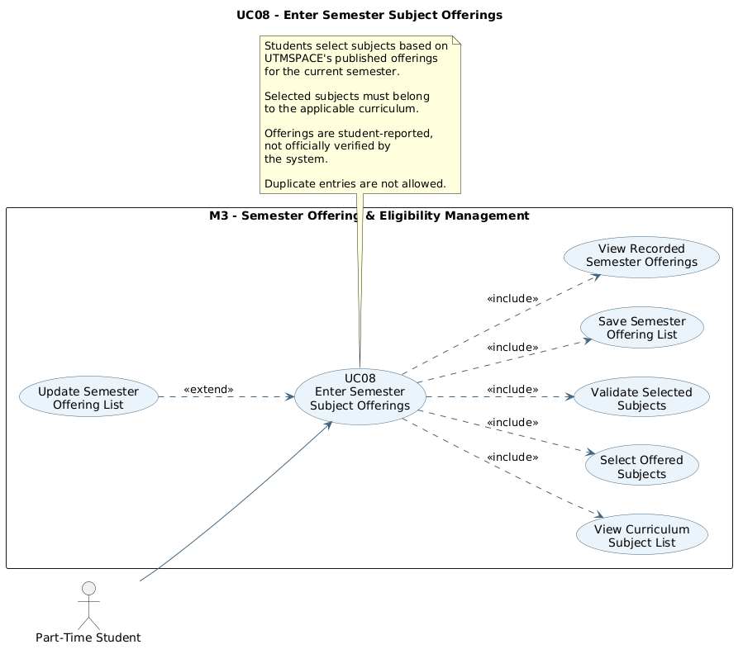
Enter Semester Subject Offerings

2.2.8.1 Activity Diagram — Enter Semester Subject Offerings

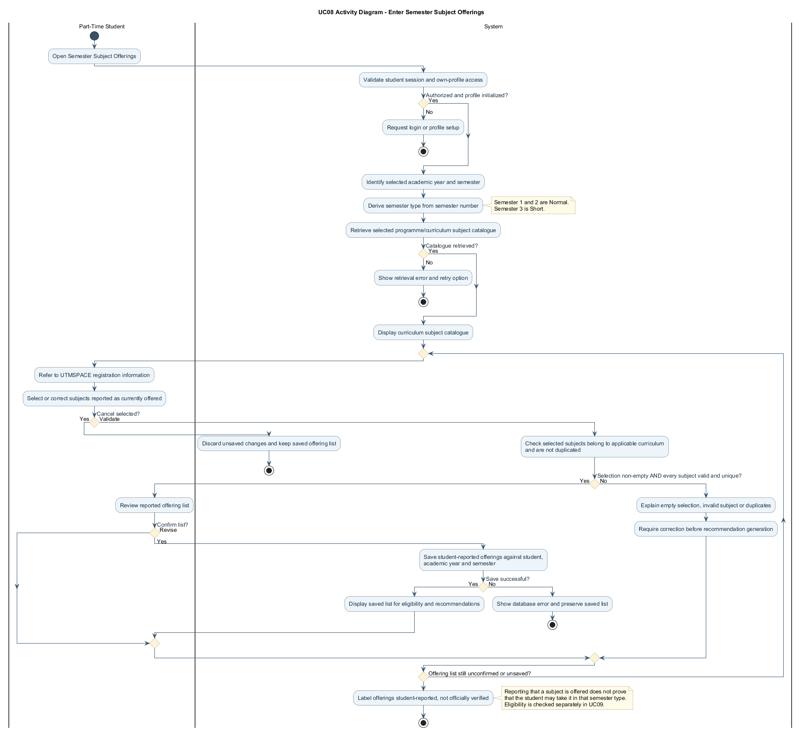
Figure 2.5: Activity Diagram for Enter Semester Subject Offerings

2.2.8.2 Sequence Diagram — Enter Semester Subject Offerings
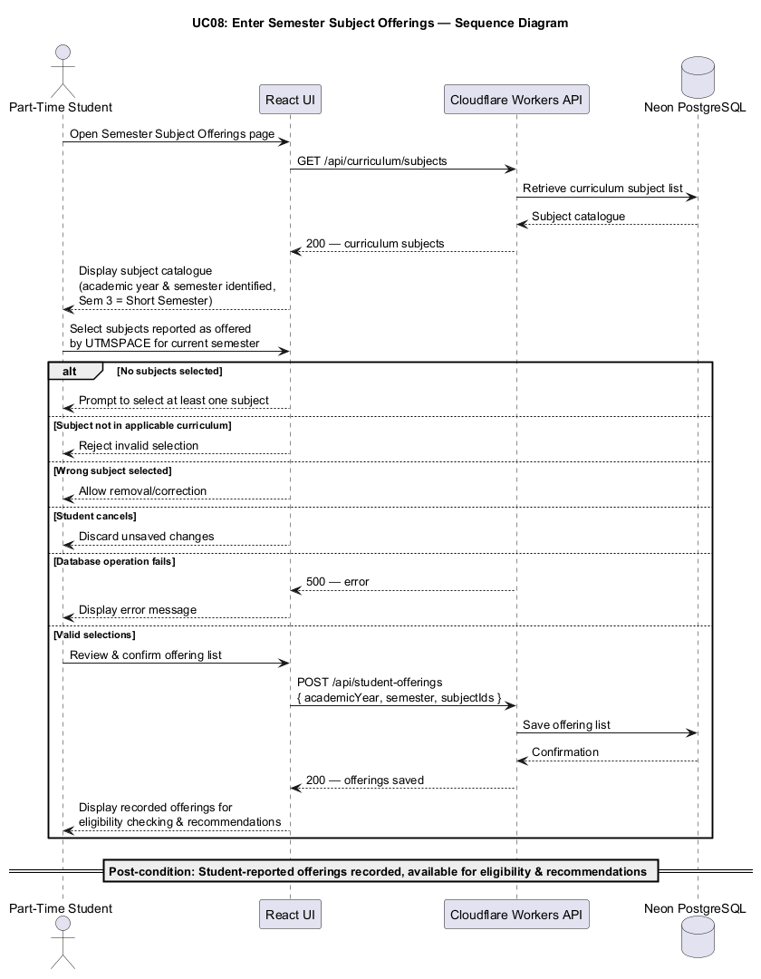
Figure 2.6: Sequence Diagram for Enter Semester Subject Offerings

2.2.9 UC09: Use Case Check Subject Eligibility
Field | Description
Use case ID | UC09
Use Case Name | Check Subject Eligibility
Actor | Part-Time Student
Brief Description | Allows students to identify which subjects from the current semester offering list are eligible for registration based on completed subjects, recognized exemptions, prerequisite relationships, and applicable academic requirements.
Includes | Academic record retrieval, prerequisite validation, exemption recognition, subject eligibility calculation.
Extension Points | Additional programme-specific enrollment restrictions or special academic eligibility rules.
Pre-condition | 1. Student must be authenticated.  2. Student academic records must be available.  3. The applicable curriculum and prerequisite relationships must be configured.  4. The current semester subject offering list must be available.
Normal Flow | 1. Student opens Subject Eligibility after entering the current semester offering list.  2. System retrieves the student's recorded completed, exempted, failed, and withdrawn subjects and the relevant academic rules.  3. System identifies the academic year and semester type, including the Short Semester designation for Semester 3.  4. For each offered subject, the system checks mandatory prerequisites, recognized exemptions, co-requisites, and concurrent enrollment conditions.  5. System enforces configured prerequisite sequences, including English 1 before English 2 and English 2 before English 3 where required.  6. System verifies subject-specific permitted semester types, including the Short-Semester-only rule for standard two-credit subjects and configured exceptions such as Final Year Project 1.  7. System identifies subjects already completed or satisfied through exemptions and applies any configured repeat-registration rules.  8. System classifies offered subjects as eligible, conditionally eligible, or ineligible based on the complete set of rules.  9. System displays the eligibility results and explains any unmet prerequisites or semester-type restrictions.
Exception Flow | 1. If the student has not completed the required academic record setup, the system prompts the student to update their academic history.  2. If a mandatory prerequisite has not been satisfied, the subject is marked as ineligible.  3. If a subject has a co-requisite requirement, the system identifies the required concurrent subject or enrollment condition.  4. If a subject has already been completed or satisfied through an approved exemption, the system excludes it from ordinary repeat recommendations unless repeat enrollment is permitted.  5. If prerequisite information is missing or incomplete, the system indicates that eligibility cannot be determined reliably.  6. If a two-credit subject other than a configured exception is selected during Semester 1 or 2, the system marks it ineligible and explains the Short-Semester restriction.
Postcondition | The system displays validated subject eligibility information and identifies subjects that may be considered for semester planning and recommendations.
Business Rules | 1. Subject eligibility shall be determined using the official prerequisite and enrollment rules configured in the system.  2. Successfully completed subjects shall satisfy applicable prerequisites according to configured passing requirements.  3. Approved subject exemptions shall satisfy the relevant prerequisite requirements where permitted by the curriculum.  4. Failed and withdrawn subjects shall not be treated as completed prerequisites.  5. Mandatory prerequisites shall be distinguished from recommended prior knowledge.  6. Recommended prior knowledge shall not automatically prevent subject registration.  7. Co-requisite and concurrent enrollment requirements shall be evaluated according to the proposed subject combination where applicable.  8. The system shall not permit an ineligible subject to be included in a final recommended combination.  9. Semester 3 shall be the only permitted semester for standard two-credit subjects; Final Year Project 1 may be eligible in a Normal Semester if offered and its prerequisites are satisfied.  10. English 2 requires completed English 1, and English 3 requires completed English 2; they cannot be taken as substitutes for sequential completion.

UC09 | INDIVIDUAL USE CASE DIAGRAM
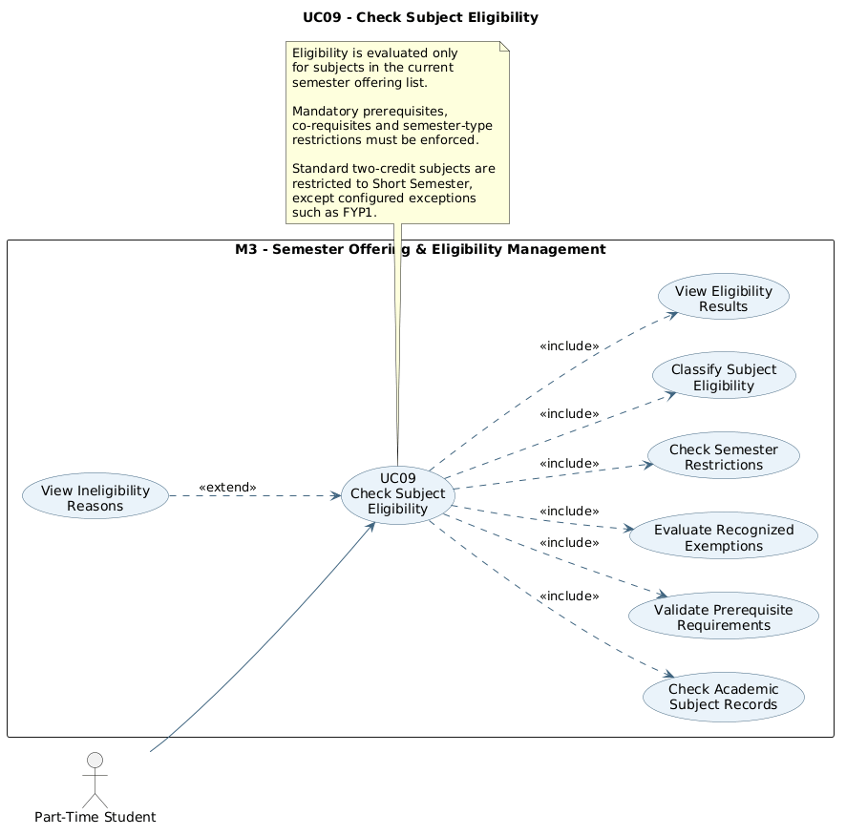
Check Subject Eligibility

2.2.9.1 Activity Diagram — Check Subject Eligibility

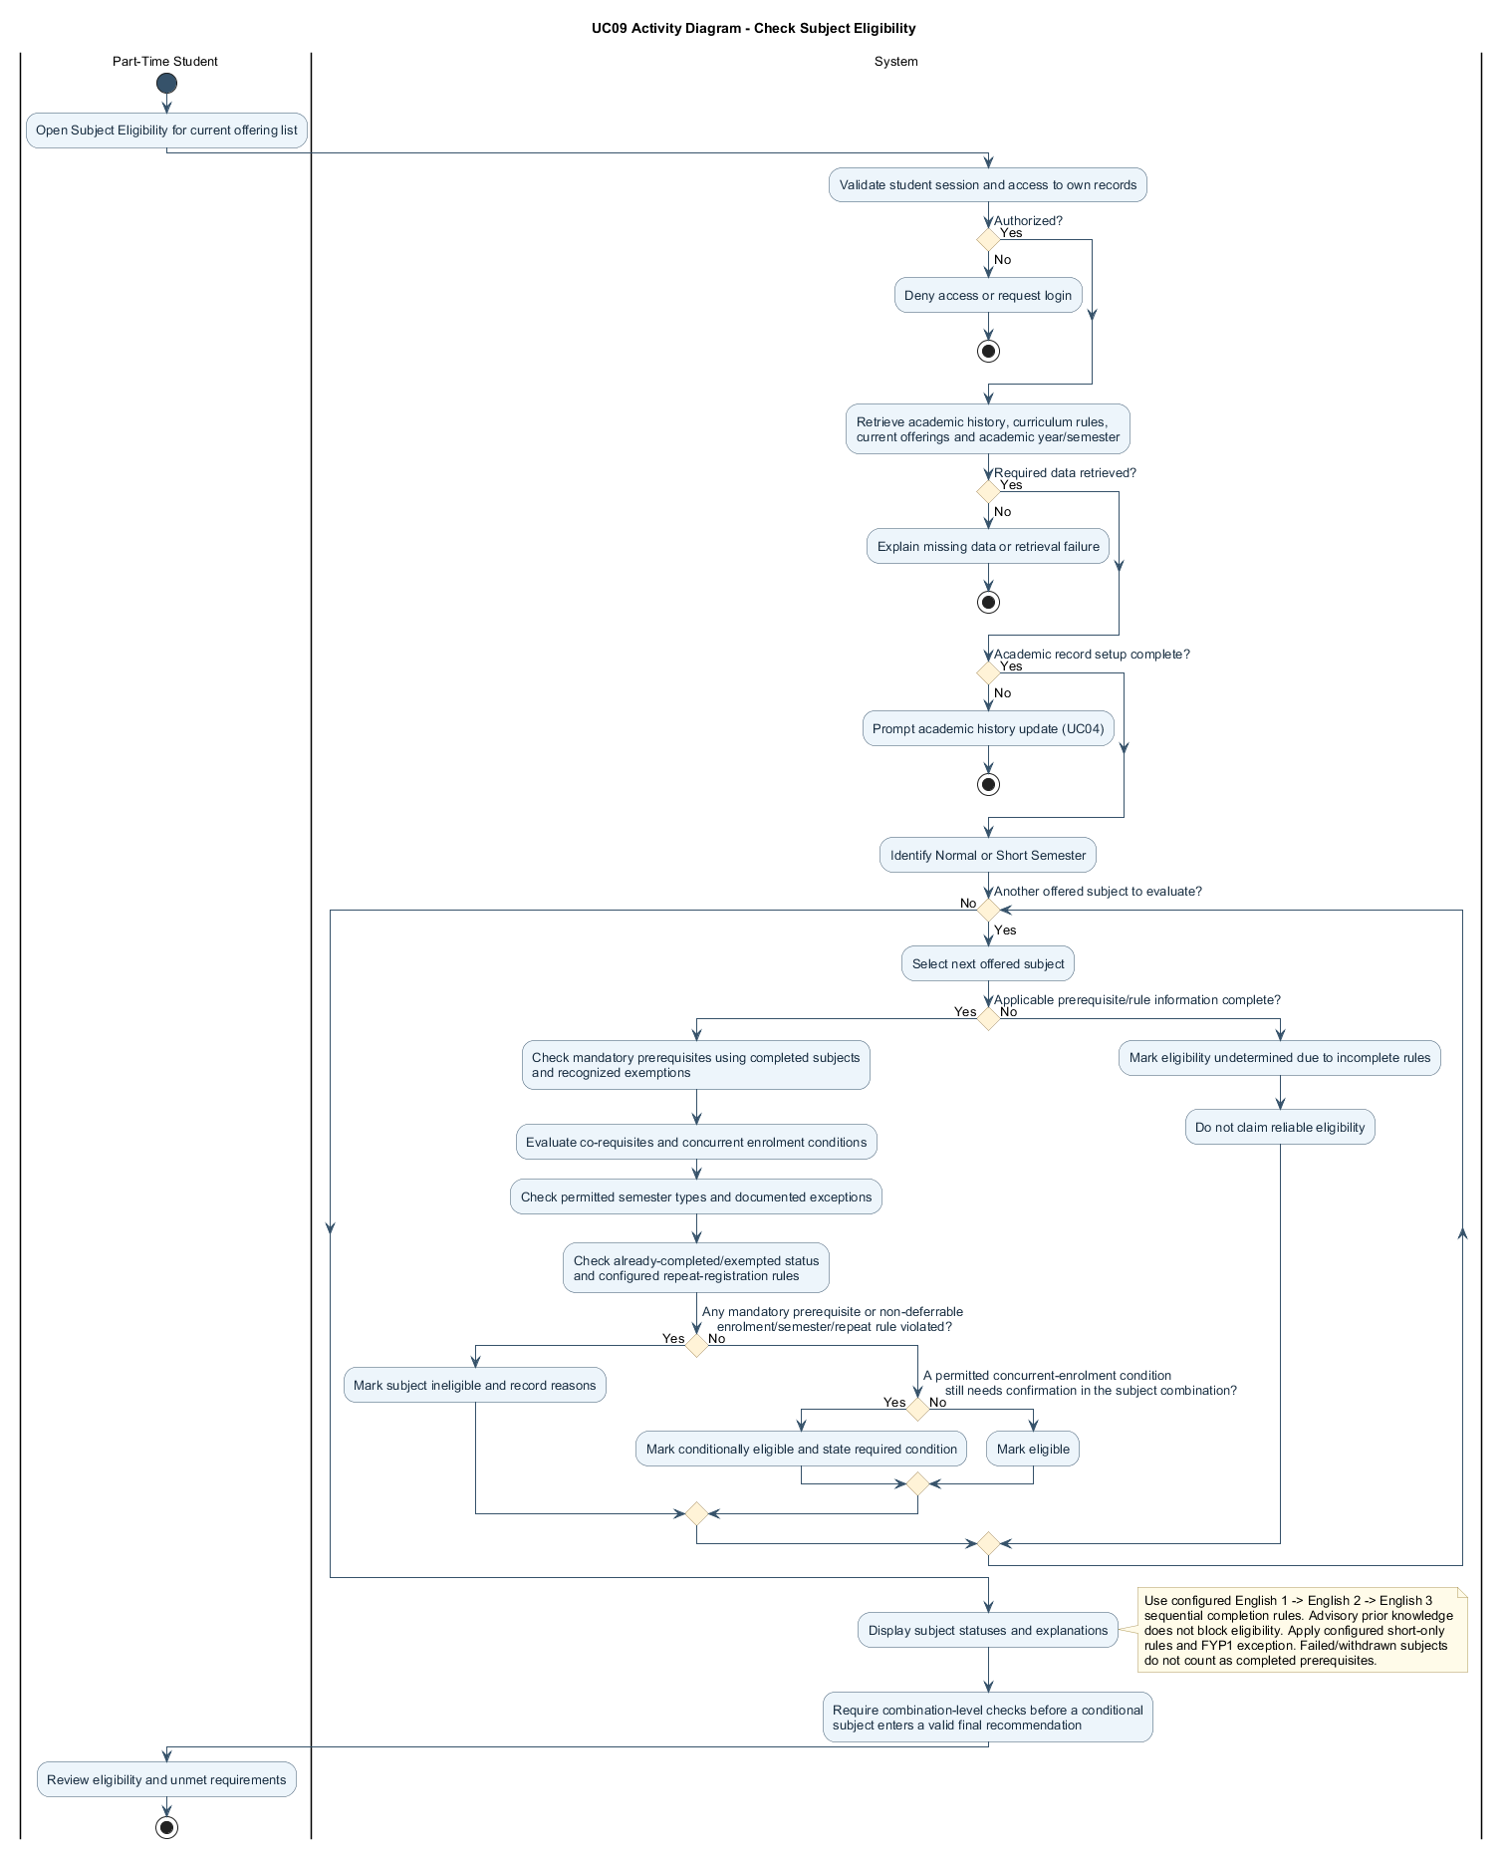
Figure 2.7: Activity Diagram for Check Subject Eligibility

2.2.9.2 Sequence Diagram — Check Subject Eligibility
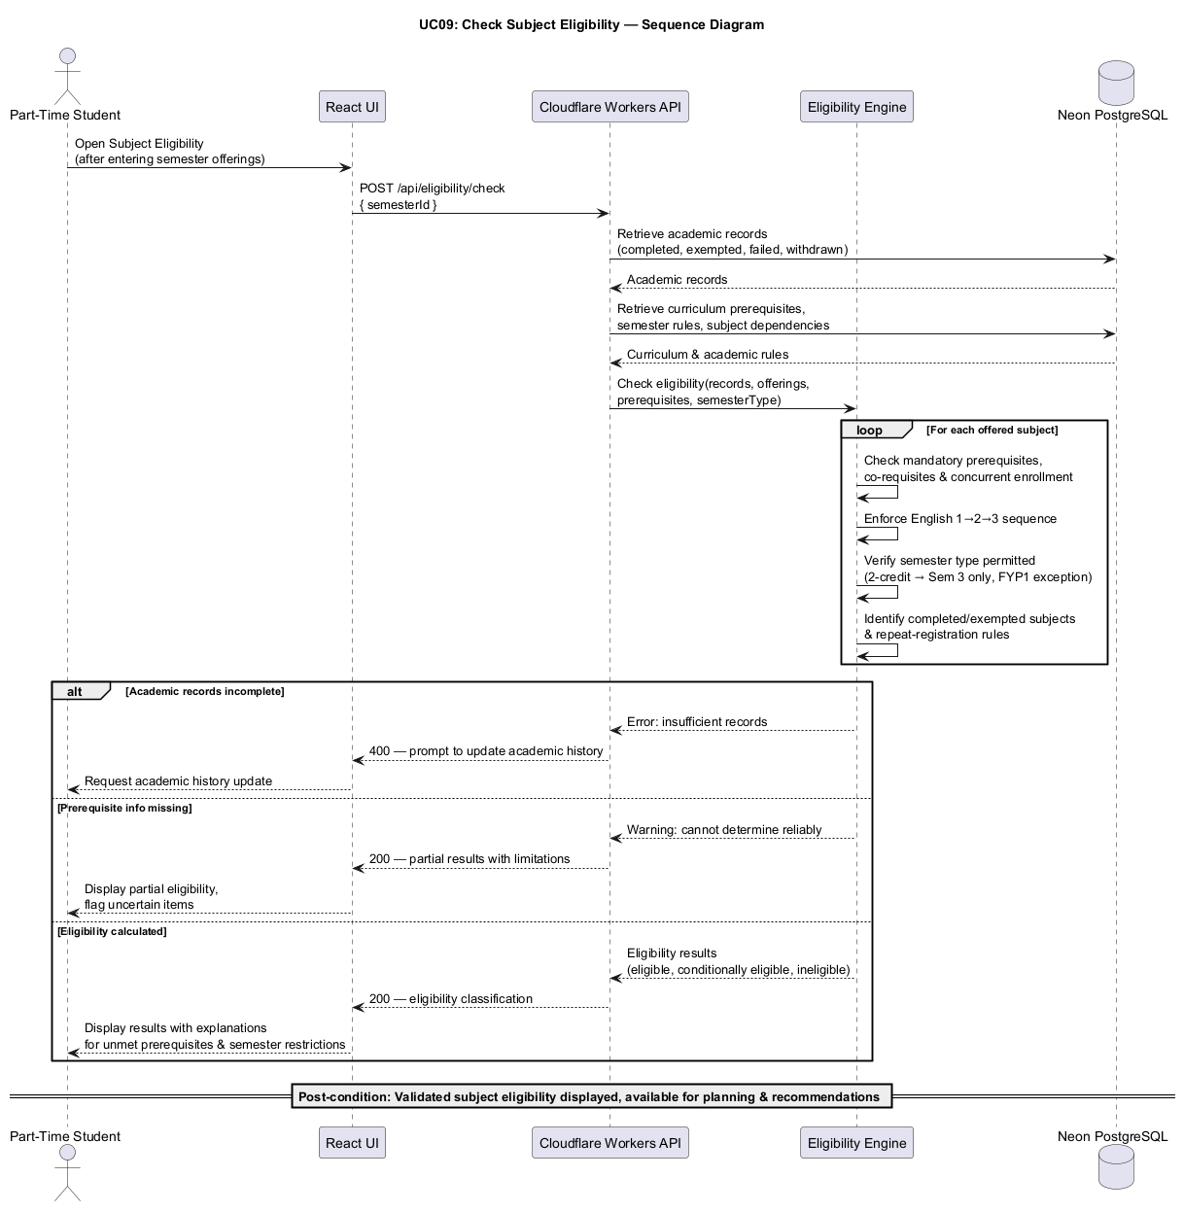
Figure 2.8: Sequence Diagram for Check Subject Eligibility

2.2.10 UC10: Use Case Manage Semester Subject Selection
Field | Description
Use case ID | UC10
Use Case Name | Manage Semester Subject Selection
Actor | Part-Time Student
Brief Description | Allows students to create, review, and modify proposed semester subject combinations using subjects available during the current registration period while ensuring compliance with applicable subject and credit-hour limits.
Includes | Subject selection, eligibility validation, credit-hour calculation, subject-count validation, semester plan management.
Extension Points | Comparison with intelligent subject recommendations and alternative semester plans.
Pre-condition | 1. Student must be authenticated.  2. The current semester offering list must be available.  3. Subject eligibility information must be available.  4. The programme's semester registration limits must be configured.
Normal Flow | 1. Student accesses the Semester Subject Selection page.  2. System identifies the selected academic year and semester and retrieves the relevant subject registration limits.  3. System displays the currently offered subjects, eligibility indicators, credit hours, and applicable semester-type restrictions.  4. Student selects subjects for a proposed semester plan.  5. System calculates the subject count and total selected credit hours.  6. System validates the three-subject maximum and the applicable credit cap: ten credits in Semester 1 or 2, or six credits in Semester 3, unless a configured exception applies.  7. System checks mandatory prerequisites, co-requisites, and permitted semester types, including two-credit subject restrictions and exceptions.  8. Student reviews the validated combination and may add or remove subjects; the system recalculates and revalidates the selection when changes are made.  9. Student saves the proposed semester plan.  10. System stores the validated plan and makes it available for recommendation and graduation pathway analysis.
Exception Flow | 1. If the student selects more than three subjects, the system displays a limit warning and prevents the invalid plan from being finalized.  2. If the selected subjects exceed the credit limit applicable to the selected semester (ten credits in Semester 1/2 or six credits in Semester 3), the system displays a credit-limit warning.  3. If a subject has an unmet prerequisite, the system identifies the requirement and prevents the subject from being included in a valid plan.  4. If a required co-requisite is missing, the system prompts the student to include the required subject or revise the plan.  5. If the student removes a subject, the system recalculates the subject count and total credit hours.  6. If saving fails, the system displays an error message without modifying the previously saved plan.  7. If the proposed Semester 3 plan exceeds six credits, the system prevents finalization.  8. If an ineligible two-credit subject is selected in a Normal Semester, the system displays the semester restriction and any configured exception.
Postcondition | A valid proposed semester subject combination is saved and available for further academic planning analysis.
Business Rules | 1. Students shall select subjects from the current semester offering list.  2. Proposed subject combinations shall satisfy all applicable mandatory prerequisites and enrollment conditions.  3. The maximum number of subjects shall be three per semester unless the configured programme rules permit an exception.  4. Semester 1 and 2 selections shall not exceed ten credits; Semester 3 selections shall not exceed six credits, unless an applicable programme exception is configured.  5. Students may select fewer than three subjects according to their academic needs and preferences.  6. Duplicate subject selections shall not be permitted.  7. The system shall calculate total semester credit hours using the actual credit values assigned to each subject.  8. Saved semester plans shall represent proposed academic selections and shall not constitute official subject registration.  9. Two-credit subjects shall only be selected in Semester 3 unless a configured exemption, including Final Year Project 1, applies.  10. The academic year and semester type shall be displayed alongside saved plans.

UC10 | INDIVIDUAL USE CASE DIAGRAM
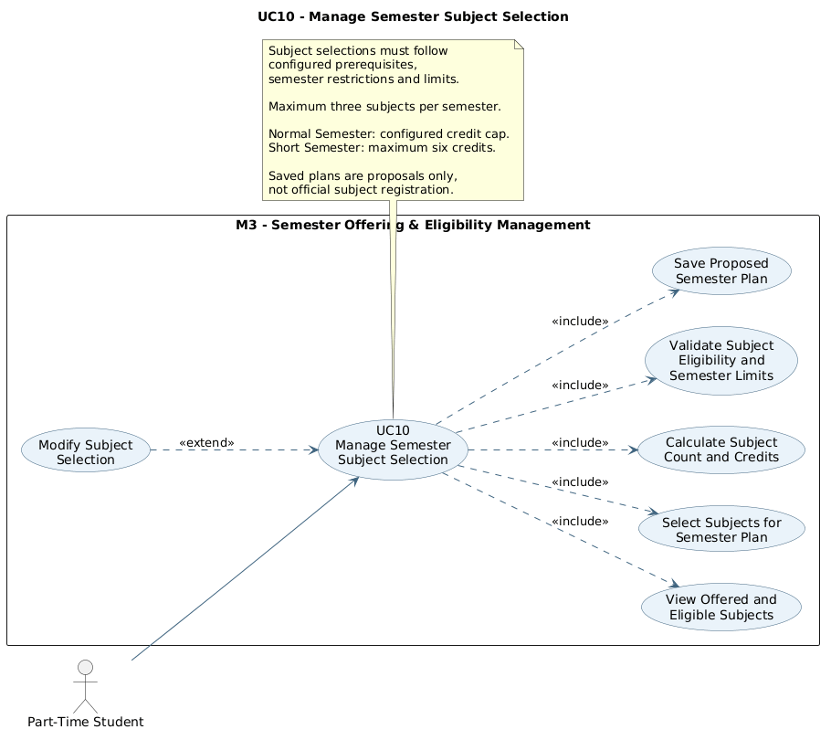
Manage Semester Subject Selection

2.2.10.1 Activity Diagram — Manage Semester Subject Selection
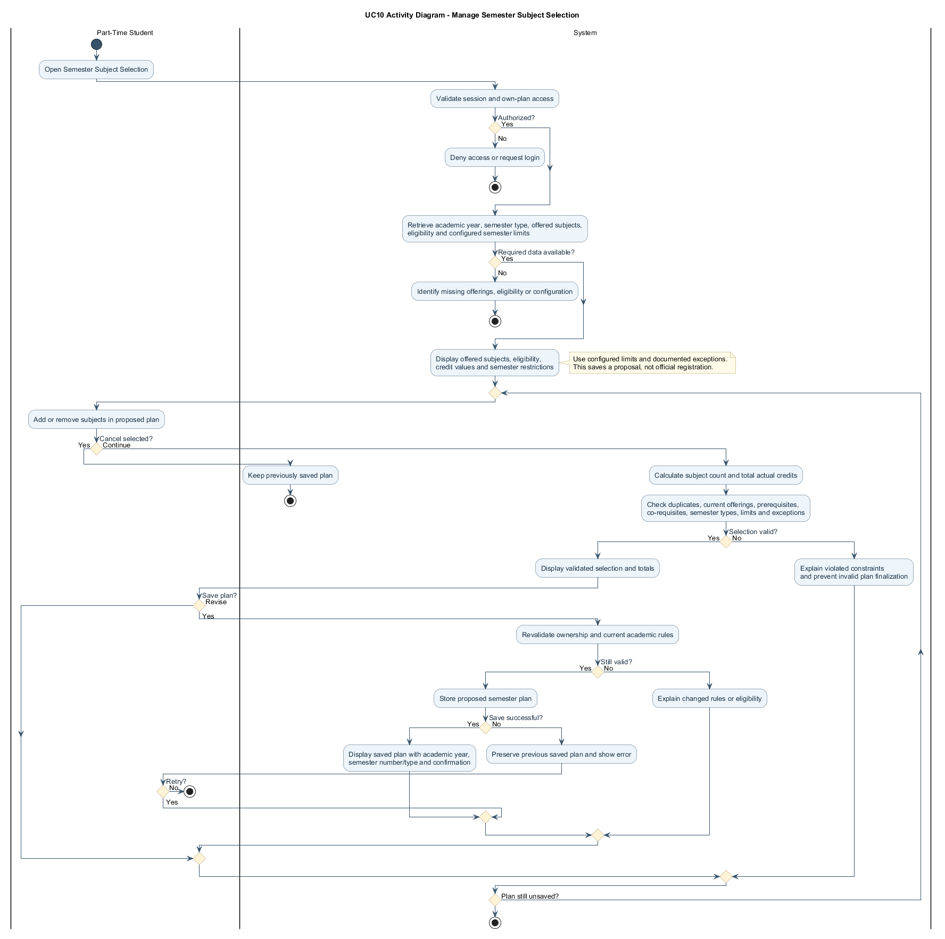

2.2.10.2 Sequence Diagram — Manage Semester Subject Selection
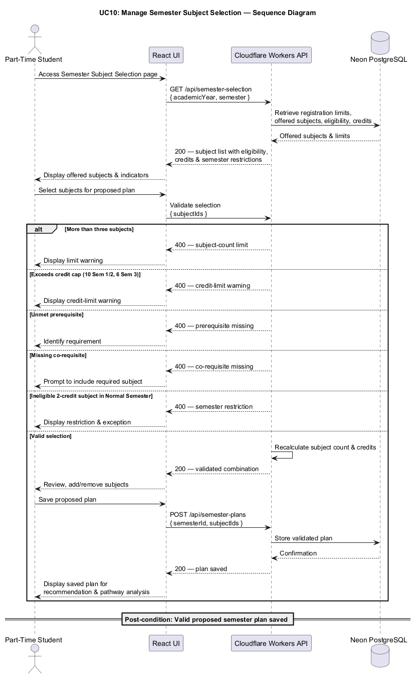

2.2.11 UC11: Use Case Generate Intelligent Subject Recommendations
Field | Description
Use case ID | UC11
Use Case Name | Generate Intelligent Subject Recommendations
Actor | Part-Time Student
Brief Description | Allows students to generate personalized semester subject recommendations based on current subject offerings, academic eligibility, prerequisite relationships, remaining programme requirements, and projected graduation pathways.
Includes | Subject eligibility checking, prerequisite graph analysis, subject combination generation, constraint-based optimization, graduation pathway evaluation.
Extension Points | Personalized planning strategies such as Fastest Graduation, Balanced Study Plan, or Lighter Academic Load, where adequate supporting data is available.
Pre-condition | 1. Student must be authenticated.  2. Student academic records must be sufficiently complete.  3. The relevant curriculum and graduation requirements must be configured.  4. Current semester subject offerings must be entered.  5. Subject eligibility validation must be available.
Normal Flow | 1. Student opens Subject Recommendations for the selected semester.  2. System retrieves the student's academic records, applicable curriculum, reported current offerings and configured study limits.  3. Eligibility service identifies offered subjects satisfying prerequisites, recognized exemptions and semester rules.  4. Recommendation service generates valid combinations within configured subject and credit caps.  5. The service ranks combinations using prerequisite bottlenecks, remaining graduation requirements and optional supported workload preferences.  6. System returns ranked combinations, explanations and clear assumptions about future offerings.  7. Student reviews alternatives and may save an eligible combination as a proposed plan.
Exception Flow | 1. If no eligible subjects are available, the system informs the student that no valid recommendations can be generated from the current offering list.  2. If prerequisite information is incomplete, the system identifies the missing data and avoids presenting unsupported recommendations.  3. If several combinations produce equivalent academic progression outcomes, the system may use student preferences to distinguish between them.  4. If employment or study-time information is unavailable, recommendations are generated using the available academic information without unsupported workload estimates.  5. If the planning engine fails, the system displays an error message and allows the student to retry.
Postcondition | The system generates a ranked list of valid subject combinations and presents personalized explanations to support the student's semester registration decisions.
Business Rules | 1. Recommendations shall include only subjects available in the current semester offering list and eligible under the applicable academic rules.  2. Recommended combinations shall comply with the configured semester subject and credit-hour limits.  3. The recommendation engine shall prioritize academic progression and the completion of prescribed programme requirements.  4. Subjects that unlock important future prerequisite sequences shall receive appropriate priority consideration.  5. Recommendations shall account for programme-specific compulsory subjects, elective requirements, and mandatory academic components.  6. The engine shall evaluate combinations using constraint-based optimization rather than relying solely on individual subject difficulty or dependency counts.  7. Future semester offerings shall be treated as uncertain unless confirmed information is available.  8. Employment and study-time preferences shall be considered only where sufficient information is available.  9. The system shall not present unsupported failure probabilities or guaranteed graduation dates.  10. Recommendations shall apply ten credits as the Normal Semester maximum and six credits as the Short Semester maximum, with up to three subjects in each.  11. Two-credit subjects other than approved exceptions shall only be recommended in Semester 3.  12. Sequential English requirements shall be prioritized according to their impact on the remaining Short-Semester schedule.

UC11 | INDIVIDUAL USE CASE DIAGRAM
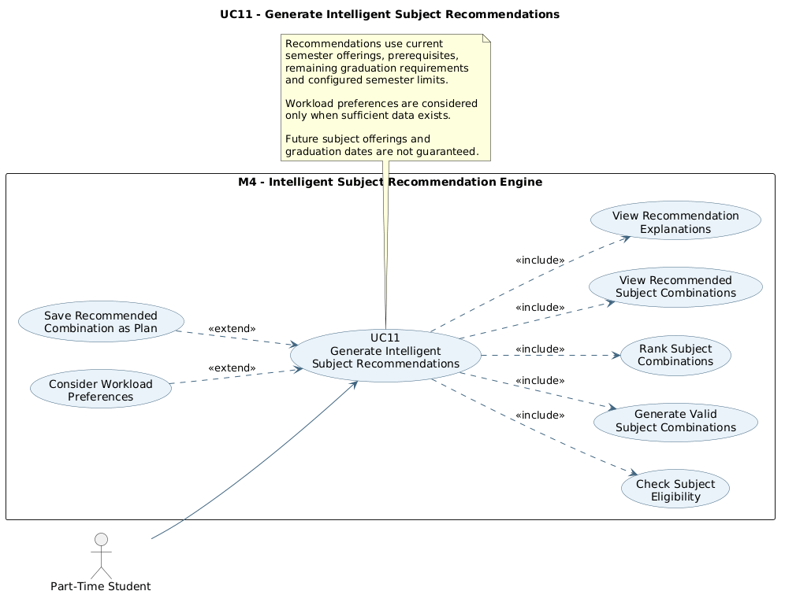
Generate Intelligent Subject Recommendations

2.2.11.1 Activity Diagram — Generate Intelligent Subject Recommendations

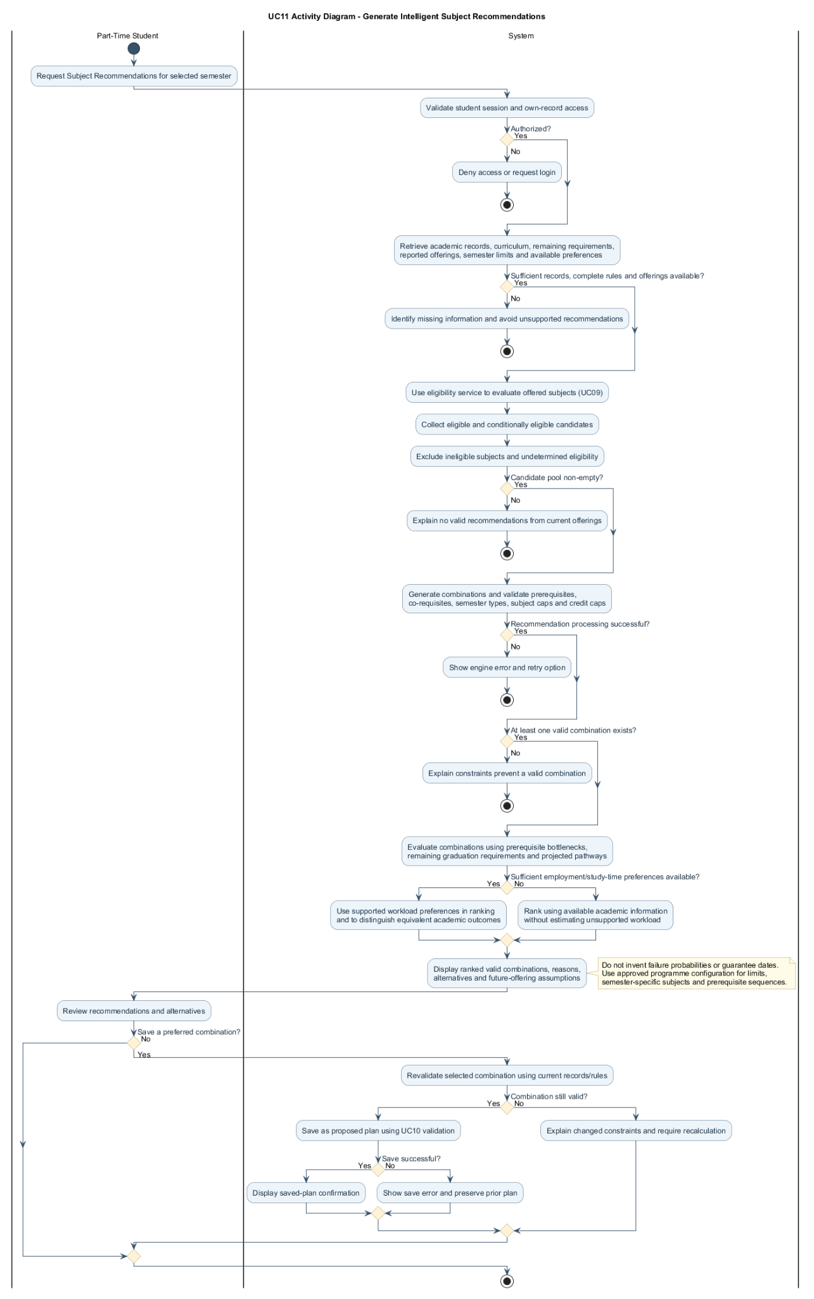
Figure 2.9: Activity Diagram for Generate Intelligent Subject Recommendations

2.2.11.2 Sequence Diagram — Generate Intelligent Subject Recommendations
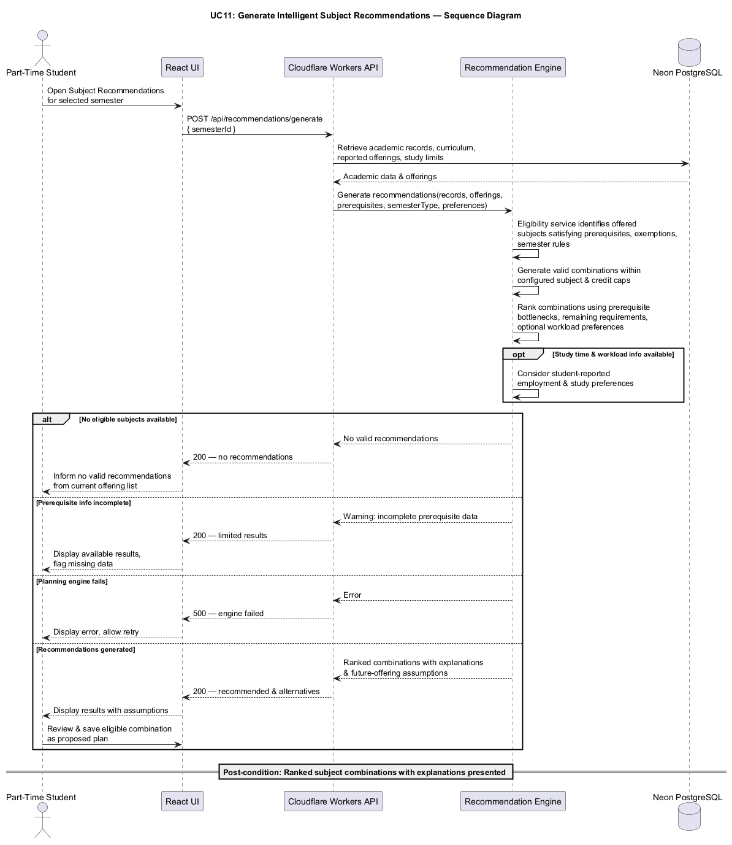
Figure 2.10: Sequence Diagram for Generate Intelligent Subject Recommendations

2.2.12 UC12: Use Case View Academic Bottlenecks and Alternative Recommendations
Field | Description
Use case ID | UC12
Use Case Name | View Academic Bottlenecks and Alternative Recommendations
Actor | Part-Time Student
Brief Description | Allows students to identify potential academic progression bottlenecks, understand the consequences of postponing important prerequisite subjects, and compare alternative subject combinations generated by the recommendation engine.
Includes | Prerequisite dependency analysis, bottleneck identification, academic progression warnings, alternative recommendation comparison.
Extension Points | Integration with the Interactive Academic Pathway simulator for detailed comparisons of projected graduation timelines.
Pre-condition | 1. Student must be authenticated.  2. The current semester offering list must be available.  3. Subject eligibility checking must be completed.  4. The recommendation engine must have generated valid recommendations or identified relevant academic constraints.
Normal Flow | 1. Student opens the Academic Recommendations results page.  2. System retrieves the recommended subject combinations and relevant prerequisite relationships.  3. The planning engine identifies subjects that unlock later academic requirements and detects potential bottlenecks.  4. System considers semester-type restrictions and highlights Short-Semester-only bottlenecks, such as postponing English 1 when offered in Semester 3.  5. System presents bottleneck warnings with explanations of the affected prerequisite sequences and uncertainty of future offerings.  6. System displays alternative valid combinations and their progression considerations.  7. Student selects an alternative to inspect its subjects, total credits, and potential academic pathway effects.  8. System compares the selected alternative with the primary recommendation and highlights relevant trade-offs.  9. Student may save a preferred valid combination as a proposed semester plan.
Exception Flow | 1. If no significant prerequisite bottlenecks are identified, the system informs the student that no specific prerequisite warning has been detected from the available data.  2. If no alternative valid combinations are available, the system displays only the valid recommendation and an appropriate explanation.  3. If a student chooses to postpone an important prerequisite subject, the system displays a potential academic progression warning.  4. If future subject offerings are unknown, the system explains that the exact graduation delay cannot be guaranteed.  5. If the student selects an invalid combination, the system displays the relevant eligibility or registration constraint.  6. If the student changes the semester offering list, the system requires the recommendations to be recalculated.
Postcondition | The student receives explanations of potential academic bottlenecks and can compare alternative subject combinations before deciding on a proposed semester plan.
Business Rules | 1. Academic bottlenecks shall be identified using configured prerequisite relationships and remaining academic requirements.  2. A subject shall be identified as a potential bottleneck when postponement may restrict access to subsequent required subjects or extend a prerequisite sequence.  3. Bottleneck warnings shall distinguish confirmed prerequisite dependencies from assumptions about future subject availability.  4. Alternative recommendations shall comply with subject eligibility and semester registration constraints.  5. The system shall explain why a subject is academically important rather than simply assigning an unexplained priority score.  6. The system shall not guarantee a specific graduation delay when future subject offerings are unknown.  7. Students shall retain control over the subject combination they select for their proposed academic plan.  8. Saving an alternative recommendation shall not register subjects through the official university system.  9. Bottleneck detection shall account for the fact that standard two-credit subjects can normally only be scheduled in Semester 3 and may therefore create academic-year delays.  10. Any statement about future delays shall identify unconfirmed subject offerings as assumptions.

UC12 | INDIVIDUAL USE CASE DIAGRAM
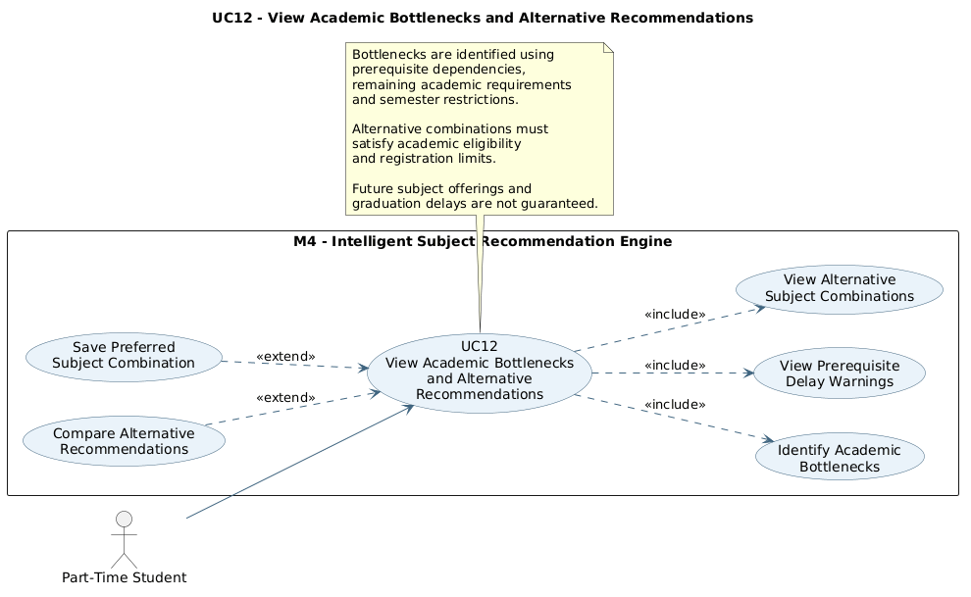
View Academic Bottlenecks and Alternative Recommendations

2.2.12.1 Activity Diagram — View Academic Bottlenecks and Alternative Recommendations
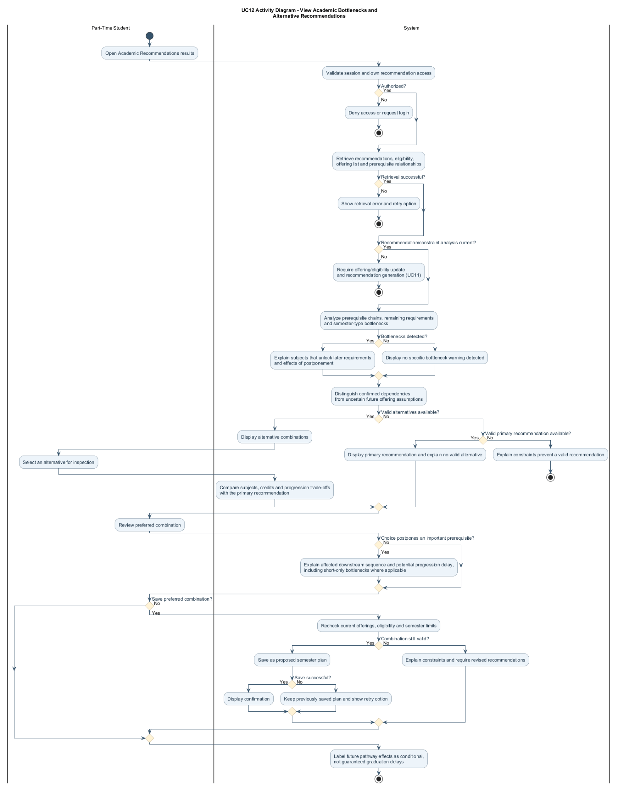

2.2.12.2 Sequence Diagram — View Academic Bottlenecks and Alternative Recommendations
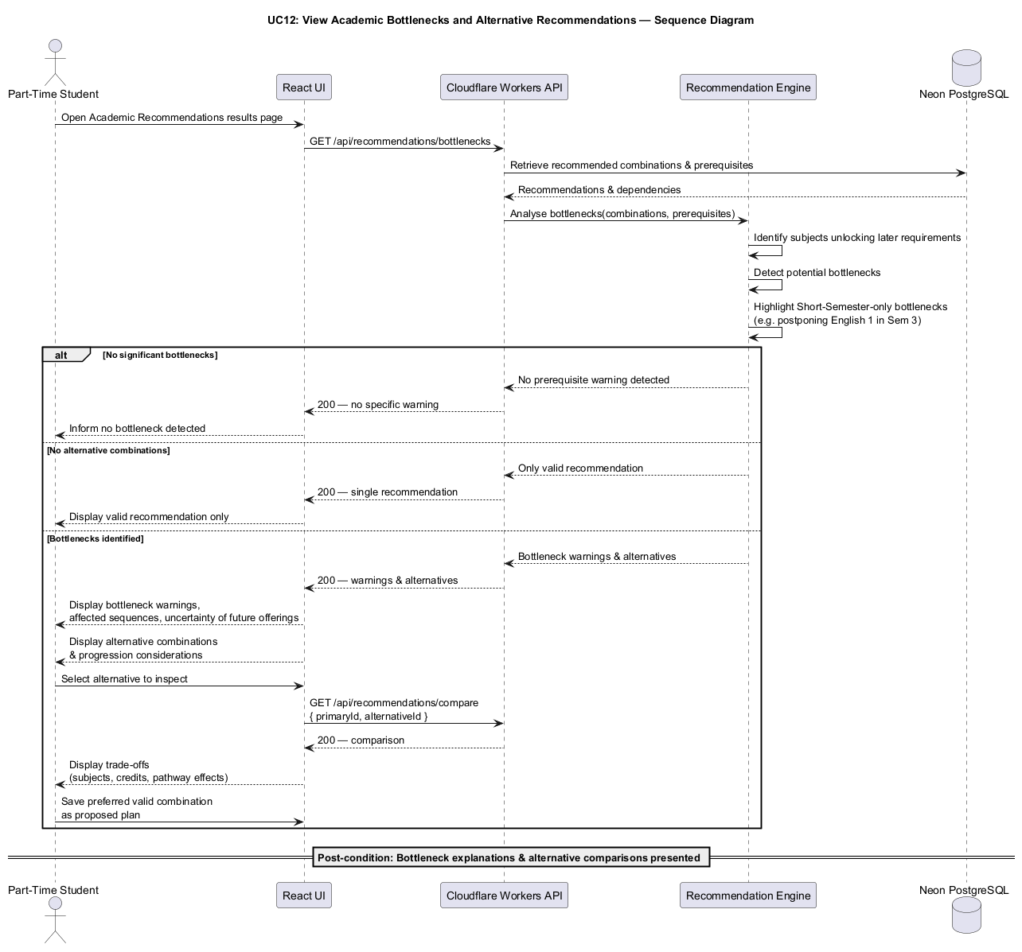

2.2.13 UC13: Use Case Check Graduation Eligibility
Field | Description
Use case ID | UC13
Use Case Name | Check Graduation Eligibility
Actor | Part-Time Student
Brief Description | Allows students to evaluate their progress towards graduation by verifying accumulated recognized credit hours and the completion of all prescribed curriculum requirements, including compulsory subjects, elective requirements, Final Year Projects, Industrial Training, and applicable academic exemptions or credit transfers.
Includes | Academic record retrieval, recognized credit calculation, exemption evaluation, compulsory subject verification, elective requirement validation, graduation eligibility assessment.
Extension Points | Use the shared M5 Academic Pathway Scheduling Engine to estimate a theoretical completion semester for any remaining requirements.
Pre-condition | 1. Student must be authenticated.  2. The student's academic profile and academic subject records must be available.  3. The applicable degree programme, curriculum, and graduation requirements must be configured.
Normal Flow | 1. Student logs in to the system.  2. Student navigates to the Graduation Eligibility page.  3. System retrieves the student's academic records, including completed, exempted, failed, and withdrawn subjects.  4. System retrieves the graduation requirements associated with the student's degree programme and curriculum.  5. System calculates the total accumulated recognized credit hours from successfully completed subjects and applicable approved credit transfers or credit-bearing exemptions.  6. System evaluates the completion status of all compulsory subjects and prescribed elective requirements.  7. System verifies the completion status of Final Year Project 1, Final Year Project 2, Industrial Training, and other mandatory curriculum components where applicable.  8. System checks whether the student has fulfilled the required credit hours and all prescribed curriculum requirements.  9. System identifies any outstanding subjects, credit requirements, or mandatory academic components.  10. System displays the graduation eligibility assessment, including accumulated credits, remaining requirements, and overall completion status.
Exception Flow | 1. If the student has not entered sufficient academic records, the system displays an incomplete information warning and prompts the student to update their records.  2. If accumulated credits satisfy the programme requirement but compulsory subjects or other mandatory components remain incomplete, the system identifies the outstanding requirements and indicates that graduation requirements have not been fully satisfied.  3. If exemption or credit transfer information is incomplete, the system identifies the missing details.  4. If the curriculum requirements are missing or inconsistent, the system cannot finalize the assessment and displays an appropriate warning.  5. If the database cannot be accessed, the system displays an error message and allows the student to retry.
Postcondition | The student's graduation eligibility assessment is generated and displayed based on their recorded academic information and applicable curriculum requirements.
Business Rules | 1. Graduation eligibility shall be evaluated according to the student's selected degree programme and applicable curriculum version.  2. The required graduation credit hours shall be obtained from the configured programme requirements rather than using a fixed value.  3. Compulsory subjects, electives, Final Year Projects, Industrial Training, and other prescribed curriculum components shall contribute towards the applicable total credit requirement.  4. Students must satisfy both the prescribed credit requirement and the completion requirements of mandatory curriculum components.  5. Successfully completed subjects shall contribute their applicable credit hours.  6. Approved exemptions shall satisfy the relevant academic requirements, but only recognized credit-bearing exemptions or transfers shall contribute to accumulated credits.  7. Failed and withdrawn subjects shall not contribute completed graduation credits.  8. The same academic credits shall not be counted more than once.  9. Eligibility results shall be based on recorded academic information and shall not constitute official confirmation of graduation by UTMSPACE.

UC13 | INDIVIDUAL USE CASE DIAGRAM
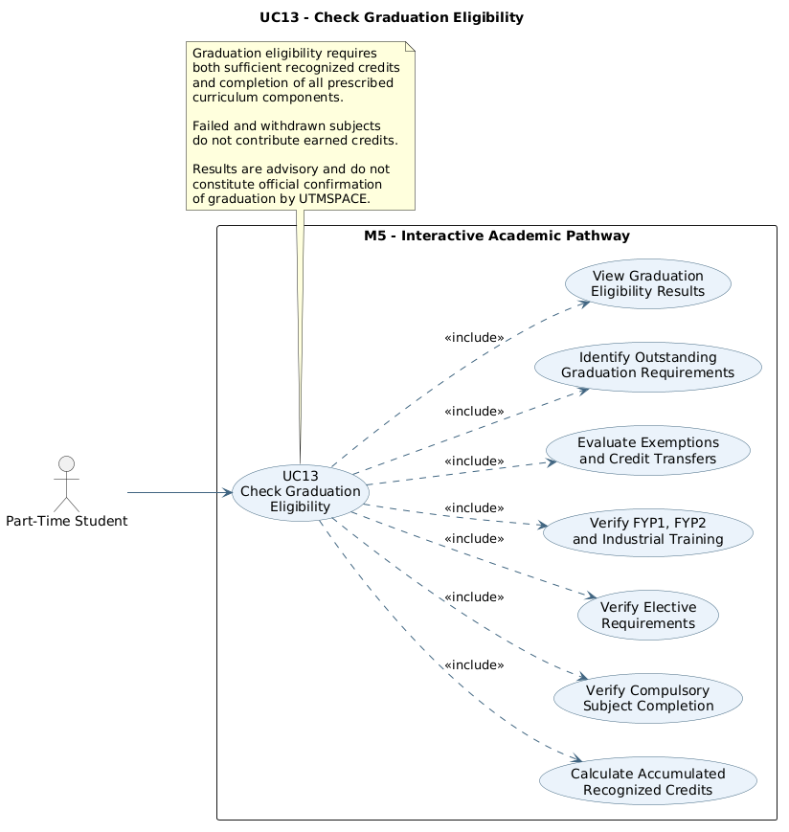
Check Graduation Eligibility

2.2.13.1 Activity Diagram — Check Graduation Eligibility
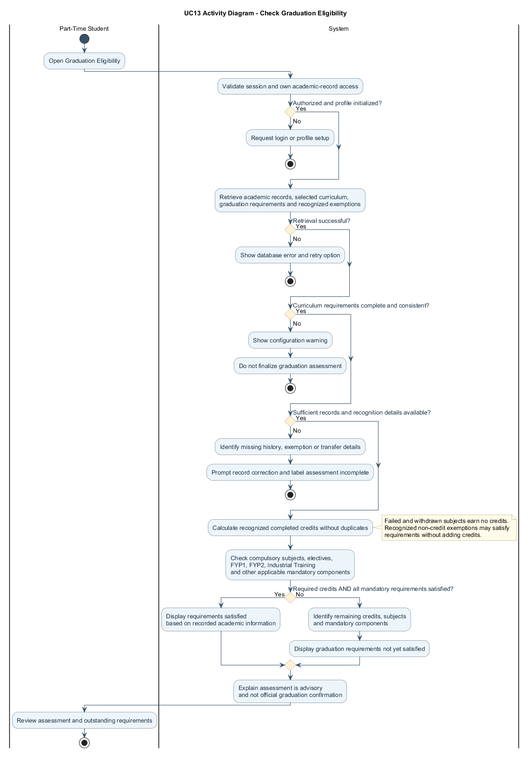

2.2.13.2 Sequence Diagram — Check Graduation Eligibility
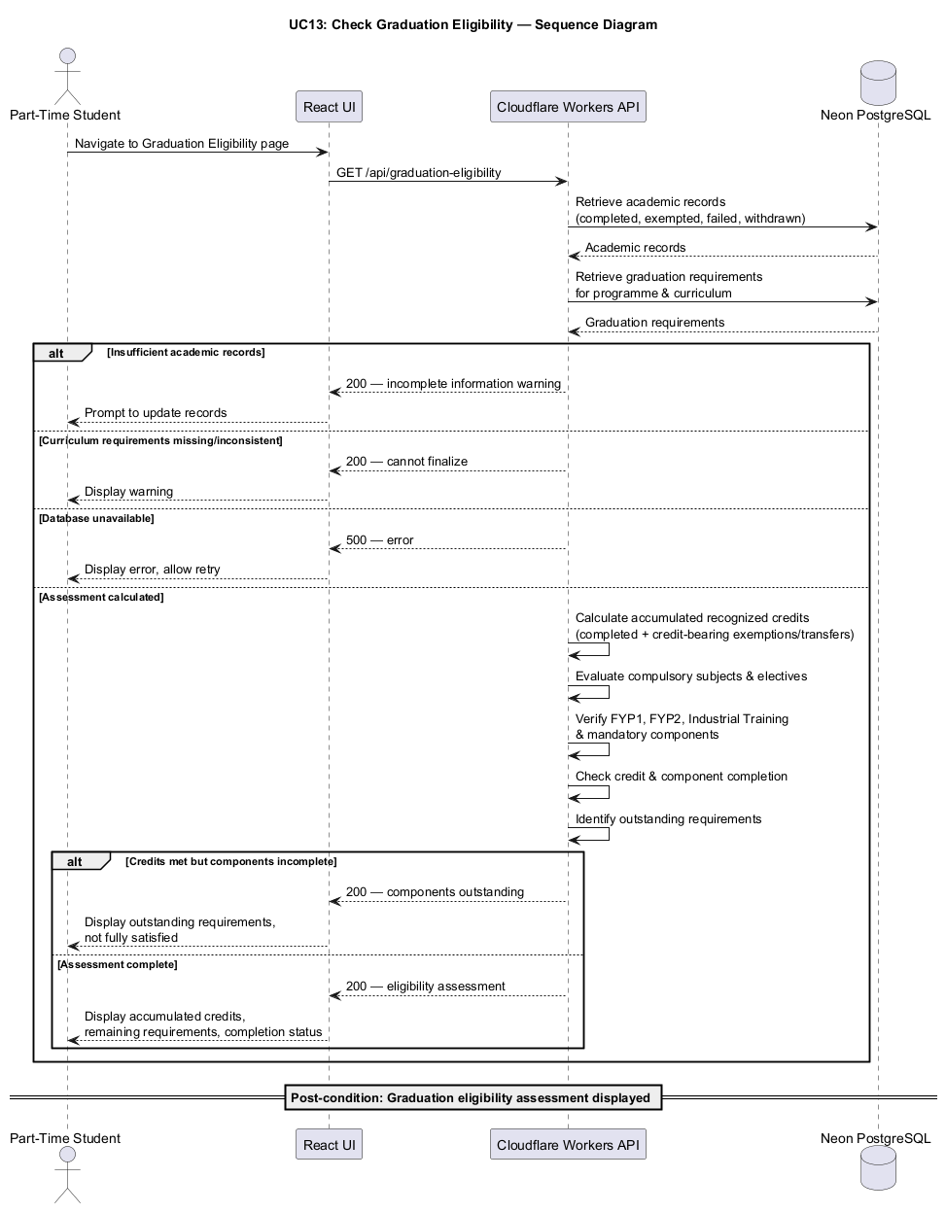

2.2.14 UC14: Use Case Generate Projected Academic Pathway
Field | Description
Use case ID | UC14
Use Case Name | Generate Projected Academic Pathway
Actor | Part-Time Student
Brief Description | Generates a theoretical semester-by-semester academic pathway based on remaining requirements, prerequisites, academic limits and stated offering assumptions.
Includes | Graduation eligibility analysis, remaining subject identification, prerequisite graph analysis, credit-based semester calculation, constraint-based academic scheduling, graduation pathway generation.
Extension Points | Integration with the Interactive Academic Pathway simulator and Intelligent Subject Recommendation Engine for alternative academic pathway comparisons.
Pre-condition | 1. Student must be authenticated.  2. The student's academic profile and subject records must be sufficiently complete.  3. The programme curriculum, prerequisite relationships, and graduation requirements must be configured.  4. The applicable semester registration constraints must be available.
Normal Flow | 1. Student opens Interactive Academic Pathway and requests a projected completion plan.  2. System retrieves the applicable curriculum, remaining requirements, credit recognition and subject dependency graph.  3. Scheduling engine constructs chronological Normal/Short semesters and applies configured caps, prerequisite and permitted-semester rules.  4. Engine evaluates the theoretical lower bound and generates a feasible semester-by-semester schedule under stated future offering assumptions.  5. Graduation checker verifies credits, mandatory components and applicable elective requirements.  6. System returns projected completion semester, semester allocations and bottleneck explanations.  7. Talent-tree and timeline views present the same calculated pathway without independently recalculating the result.
Exception Flow | 1. If the student's academic records are incomplete, the system requests the missing information before generating a reliable projection.  2. If no eligible subjects are available during the current semester, the system identifies the limitation and evaluates subsequent theoretical planning opportunities where possible.  3. If mandatory prerequisite sequences require additional semesters beyond the credit-based minimum, the system adjusts the projected academic pathway accordingly.  4. If Final Year Projects, Industrial Training, or other required components have special enrollment conditions, the system applies their configured restrictions during scheduling.  5. If future subject offerings are unavailable, the system clearly labels the projection as theoretical.  6. If the academic calendar is not configured, the system displays the estimated number of remaining semesters without assigning an unsupported calendar date.  7. If no feasible graduation pathway can be generated because of incomplete or conflicting academic rules, the system displays an appropriate warning.  8. If the planning engine fails, the system displays an error message and allows the student to retry.  9. If a remaining two-credit subject is limited to Semester 3, the engine delays it until the next eligible Short Semester.  10. If an English prerequisite chain remains incomplete, the engine schedules its members in separate eligible Short Semesters and recalculates the earliest theoretical completion.
Postcondition | The system generates an earliest possible graduation projection and a proposed semester-by-semester academic pathway based on the student's remaining academic requirements and stated planning assumptions.
Business Rules | 1. Graduation planning shall use the applicable programme curriculum, including compulsory subjects, electives, Final Year Projects and Industrial Training.  2. The engine shall recognize approved credit transfers and exemptions when calculating remaining requirements.  3. Plans shall follow mandatory prerequisites, co-requisites and enrollment restrictions.  4. Plans shall use actual subject credits and configured limits: up to three subjects per semester, the configured normal-semester credit cap and a six-credit Short Semester cap, subject to approved exceptions.  5. Each academic year shall follow Semester 1, Semester 2 and Semester 3 in sequence; Semester 3 is the Short Semester.  6. Confirmed current offerings shall be used when available. Unknown future offerings shall use clearly stated, optimistic assumptions.  7. Plans shall satisfy all remaining graduation requirements without violating the configured academic rules.  8. Standard two-credit subjects shall be scheduled in Semester 3. Eligible Final Year Project 1 may be scheduled in a Normal Semester if offered.  9. English 1, English 2 and English 3 shall follow their prerequisite order in separate eligible Short Semesters where required by the configured curriculum.  10. If the academic calendar is unavailable, the system shall present a semester count rather than an unsupported date.  11. Projected completion dates shall be labelled as theoretical, not guaranteed.  12. Outputs shall identify academic year, semester number and type, such as Academic Year 2026/2027 - Semester 3 (Short Semester).

UC14 | INDIVIDUAL USE CASE DIAGRAM
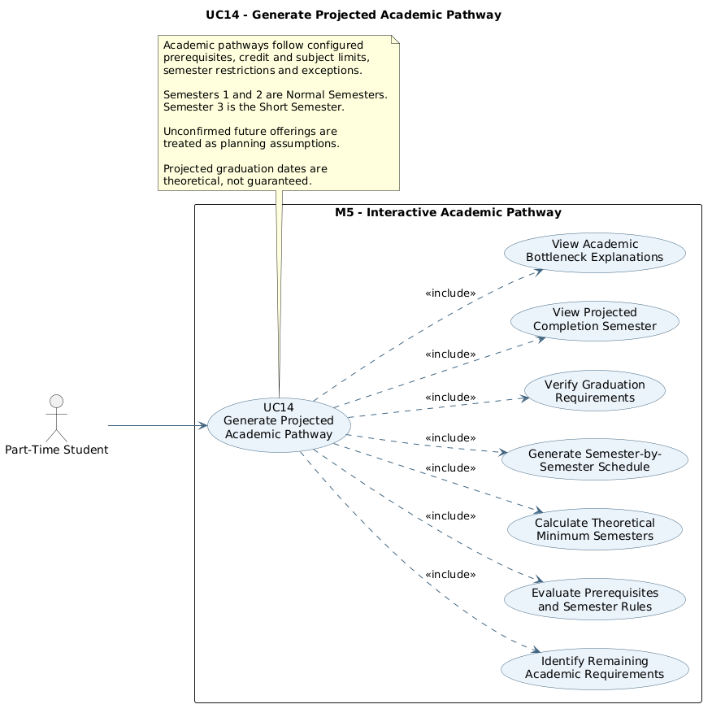
Generate Projected Academic Pathway

2.2.14.1 Activity Diagram — Generate Projected Academic Pathway
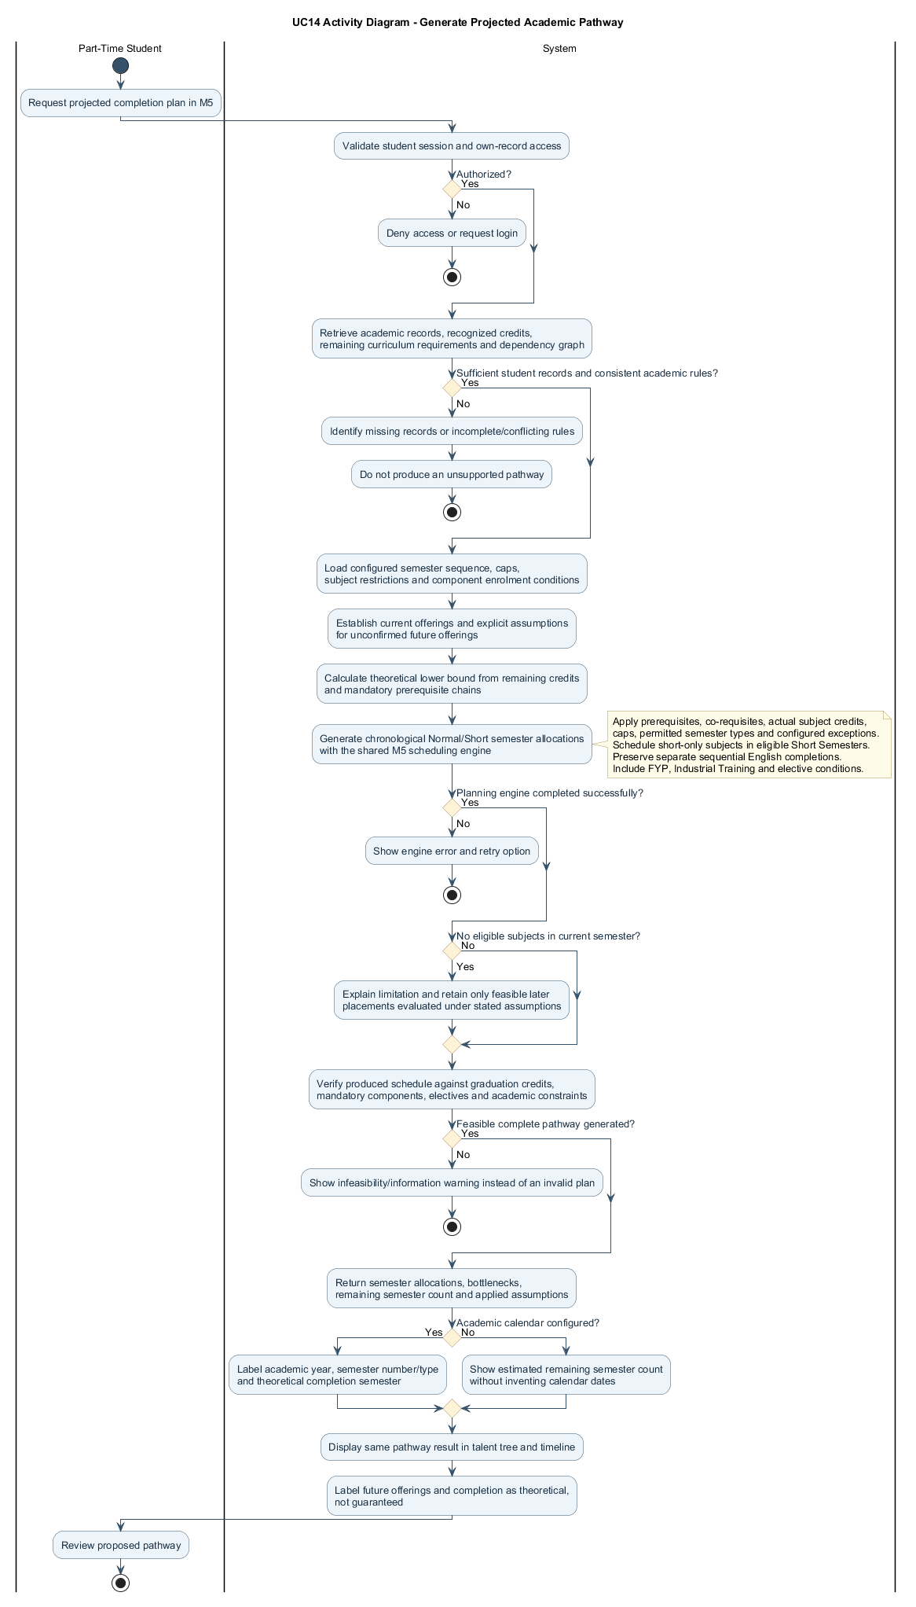
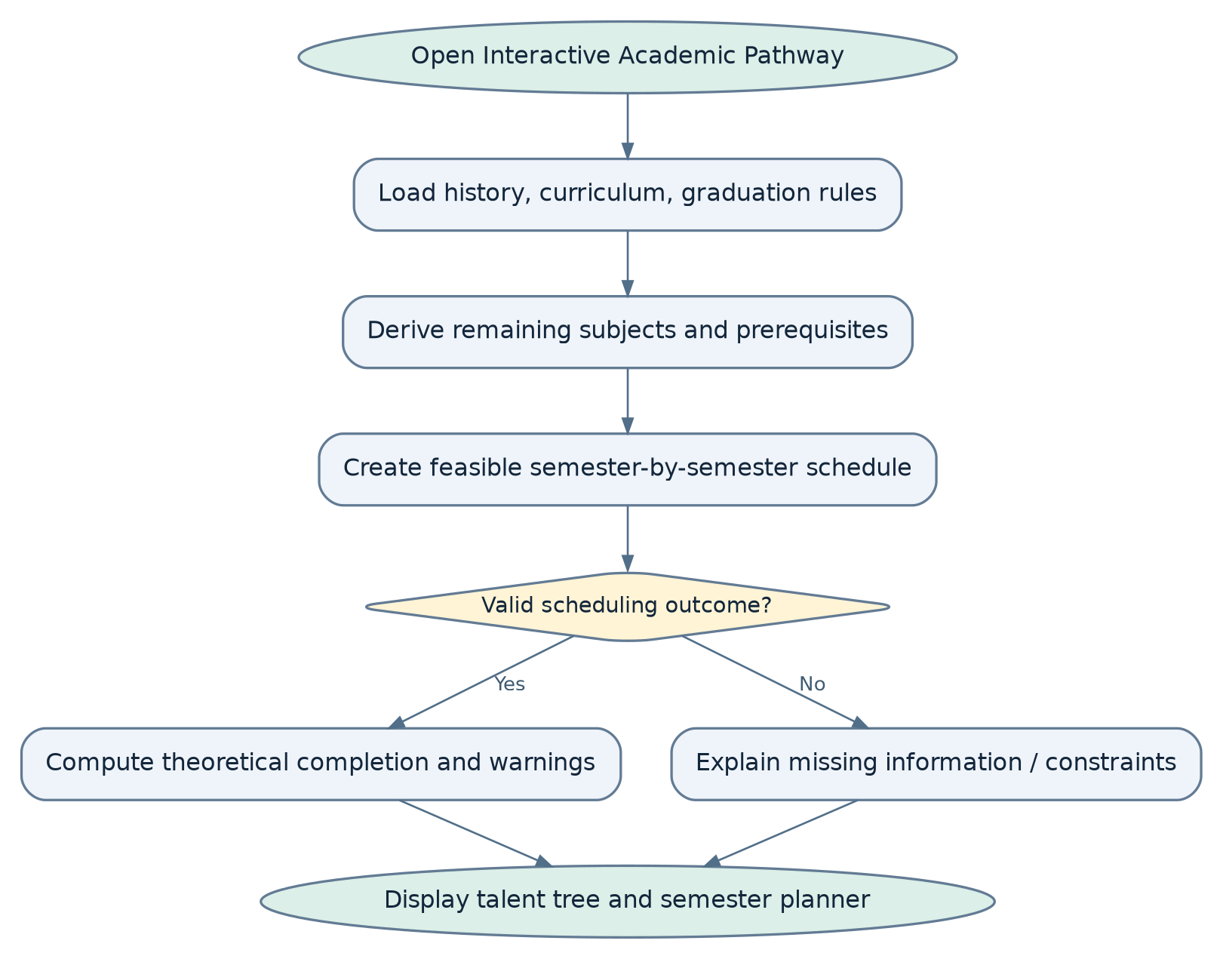
Figure 2.11: Activity Diagram for Generate Projected Academic Pathway

2.2.14.2 Sequence Diagram — Generate Projected Academic Pathway
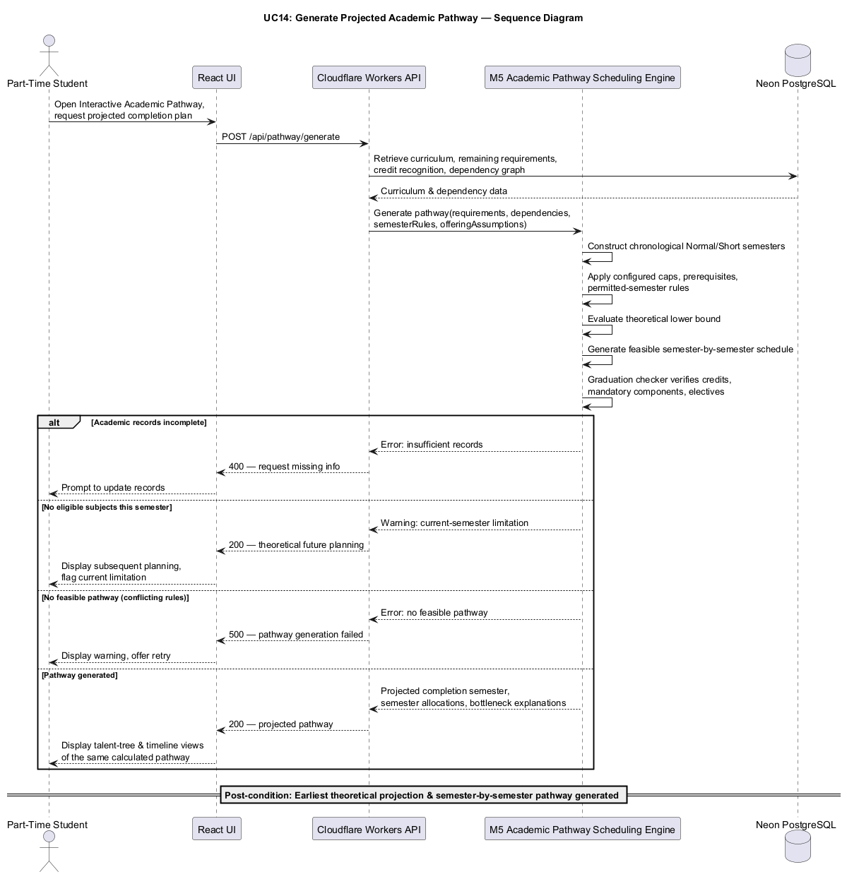
Figure 2.12: Sequence Diagram for Generate Projected Academic Pathway

2.2.15 UC15: Use Case Simulate Subject Choices in Interactive Pathway
Field | Description
Use case ID | UC15
Use Case Name | Simulate Subject Choices in Interactive Pathway
Actor | Part-Time Student
Brief Description | Lets students test changes to planned subjects and view their effect on prerequisite eligibility and projected completion.
Includes | Academic scenario creation, hypothetical subject status changes, prerequisite revalidation, academic progression recalculation, graduation pathway simulation.
Extension Points | Use the Interactive Academic Pathway to inspect effects of hypothetical changes on dependencies, semester assignments and theoretical graduation projection.
Pre-condition | 1. Student must be authenticated.  2. The student's academic records and applicable curriculum requirements must be available.  3. A baseline academic plan or graduation prediction must have been generated.  4. Current semester subject offering information must be available for simulations involving current semester selections.
Normal Flow | 1. Student opens the Interactive Academic Pathway simulator and reviews the baseline proposed plan and graduation projection.  2. Student selects Create Simulation and chooses a hypothetical change, such as postponing, replacing, withdrawing from, or failing a subject.  3. Student selects the affected subjects and specifies the hypothetical changes.  4. System creates a temporary simulated academic state without changing the student's original academic records.  5. System identifies the affected academic year and semester and applies the correct Normal or Short Semester limits, prerequisite rules, and subject-specific semester restrictions.  6. System validates any proposed subject selections against these restrictions; invalid selections are flagged for correction.  7. The academic planning engine recalculates subject eligibility, credit progress, and dependent prerequisite sequences within the hypothetical state.  8. The M5 academic pathway scheduling engine recalculates the feasible semester-by-semester pathway, including any effects on Short-Semester-only sequences.  9. System displays the hypothetical subject arrangements, academic progression changes, and theoretical graduation projection with their assumptions.  10. Student reviews the result and may revise the simulation without modifying the baseline.
Exception Flow | 1. If the student attempts to simulate a subject selection that violates mandatory prerequisites, the system displays the relevant restrictions and identifies the invalid combination.  2. If the simulated selection exceeds the permitted number of subjects or credit hours, the system requests an adjustment.  3. If a student simulates failing a subject, the system treats the selected attempt as unsuccessful and recalculates the affected prerequisites and remaining requirements.  4. If a student simulates withdrawing from a subject, the subject is treated as incomplete within the hypothetical scenario.  5. If the simulation creates a prerequisite bottleneck, the system displays a warning and identifies affected downstream subjects.  6. If the simulated scenario cannot produce a feasible completion pathway under the configured rules, the system displays the relevant limitation.  7. If the simulation engine encounters an error, the system displays an appropriate message without changing the student's existing plan.  8. If a simulation attempts to move a standard two-credit subject to Semester 1 or 2, the system reports the semester restriction, except where an approved course exception applies.
Postcondition | The system generates a hypothetical academic pathway and updated graduation projection while preserving the student's original academic records and baseline plan.
Business Rules | 1. Simulated academic decisions shall not overwrite the student's recorded academic history.  2. Hypothetical subject failures and withdrawals shall not contribute successfully completed credits.  3. Simulated subject selections shall comply with applicable prerequisite rules and semester registration limits.  4. Simulations shall consider all outstanding curriculum requirements, including compulsory subjects, electives, and mandatory programme components.  5. The simulation engine shall use the same academic rules and scheduling logic as the M5 academic pathway scheduling engine.  6. Changes to a prerequisite subject shall trigger recalculation of affected downstream subject eligibility.  7. Simulated graduation projections shall use clearly stated future offering assumptions.  8. Simulation results shall be identified as hypothetical and shall not represent actual registration or academic results.  9. Scenarios shall apply the three-subject limit and semester-specific credit limits of the configured normal-semester credit cap (normally ten credits, with approved exceptions) in Semester 1/2 and six credits in Semester 3.  10. The two-credit restriction and Final Year Project 1 exception shall apply consistently to simulated plans.  11. Simulated English prerequisites shall preserve English 1 before English 2 before English 3.

UC15 | INDIVIDUAL USE CASE DIAGRAM
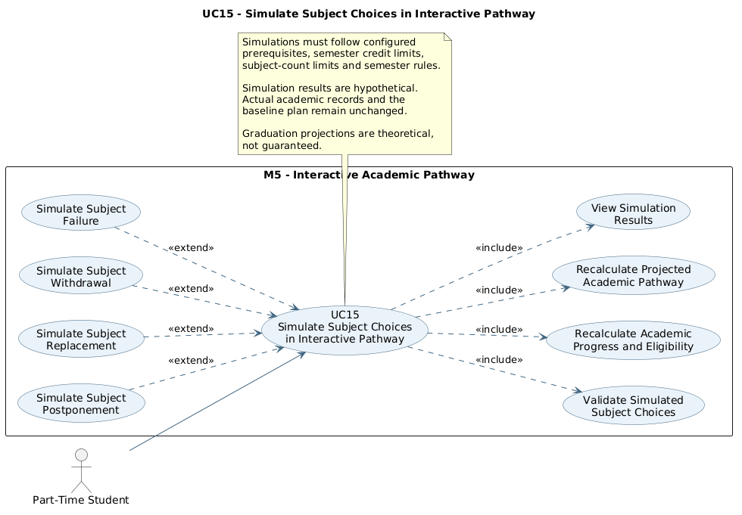
Simulate Subject Choices in Interactive Pathway

2.2.15.1 Activity Diagram — Simulate Subject Choices in Interactive Pathway
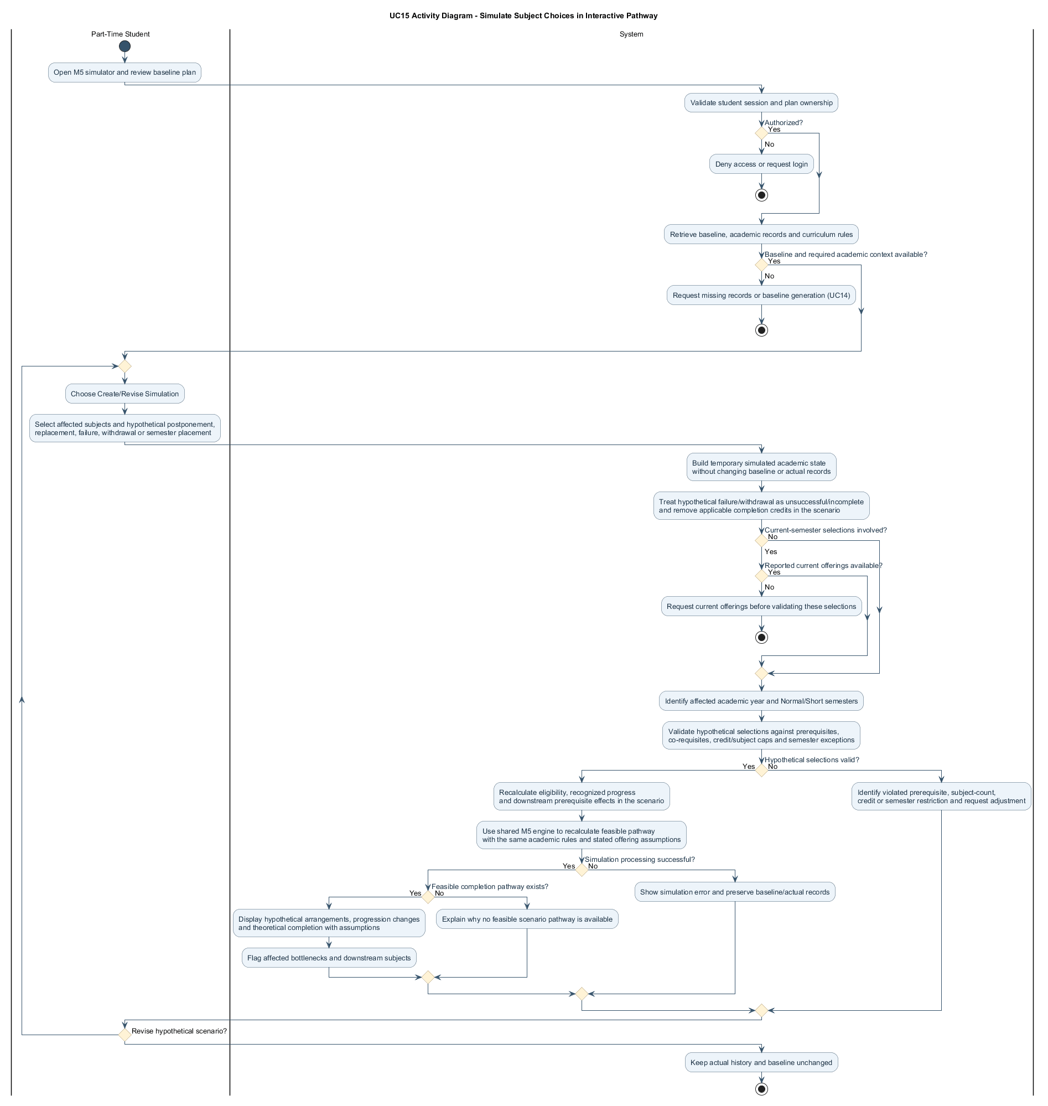
Figure 2.13: Activity Diagram for Simulate Subject Choices in Interactive Pathway

2.2.15.2 Sequence Diagram — Simulate Subject Choices in Interactive Pathway
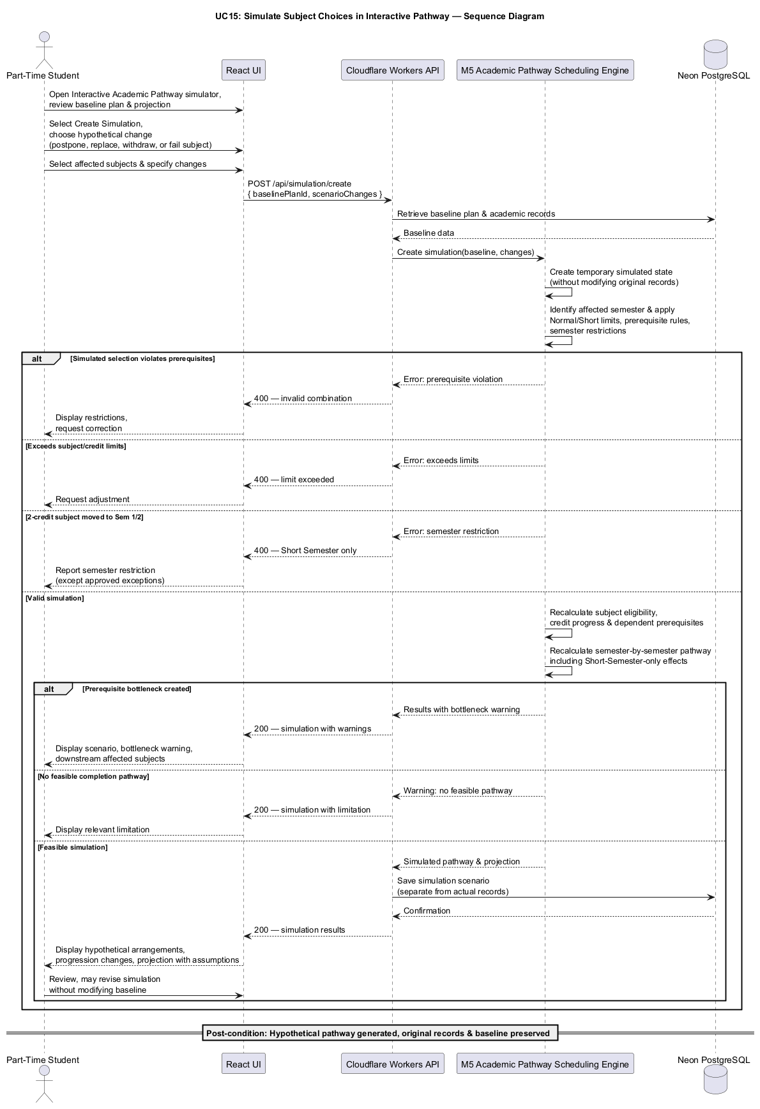
Figure 2.14: Sequence Diagram for Simulate Subject Choices in Interactive Pathway

2.2.16 UC16: Use Case Compare and Reset Pathway Scenarios
Field | Description
Use case ID | UC16
Use Case Name | Compare and Reset Pathway Scenarios
Actor | Part-Time Student
Brief Description | Compares baseline and simulated academic pathways and lets students reset a hypothetical plan without changing academic records.
Includes | Baseline plan retrieval, scenario comparison, graduation projection comparison, prerequisite impact analysis, simulation reset.
Extension Points | Use the Interactive Academic Pathway to inspect effects of hypothetical changes on dependencies, semester assignments and theoretical graduation projection.
Pre-condition | 1. Student must be authenticated.  2. An original academic plan or baseline graduation projection must be available.  3. At least one hypothetical academic scenario must have been generated using the Interactive Academic Pathway simulator.
Normal Flow | 1. Student opens the comparison view in Interactive Academic Pathway.  2. System retrieves the baseline plan and a valid hypothetical scenario.  3. The shared scheduling engine evaluates both using the same curriculum rules and future-offering assumptions.  4. System compares semester allocations, dependency effects, remaining requirements and theoretical completion semester.  5. Student reviews the highlighted differences in the talent tree and synchronized semester planner.  6. Student may select Reset Scenario.  7. System discards the hypothetical adjustments and restores the baseline display without editing actual academic records.
Exception Flow | 1. If the simulation produces no change in the graduation projection, the system informs the student that both scenarios have the same estimated completion semester under the applied assumptions.  2. If the simulated plan results in additional semesters, the system highlights the potential delay.  3. If the simulated plan results in an earlier theoretical completion, the system displays the revised projection and its assumptions.  4. If no valid simulation is available, the system prompts the student to create a scenario before comparing results.  5. If the original academic information has changed since the simulation was generated, the system requests recalculation before presenting an updated comparison.  6. If the student cancels the reset operation, the simulated scenario remains available.  7. If recalculation fails, the system displays an error and preserves the original academic records.
Postcondition | The student can view a comparison between the original and simulated academic plans. If the simulation is reset, the original academic planning state is restored without modifying the student's academic records.
Business Rules | 1. Scenario comparisons shall use the same applicable curriculum requirements and academic rules.  2. Baseline and simulated plans shall use identical semester rules and future-offering assumptions for meaningful comparisons.  3. Differences in graduation projections shall be calculated from the planning engine's results rather than independently estimated.  4. The system shall clearly distinguish actual academic records, proposed semester plans, and hypothetical simulation outcomes.  5. Simulation reset operations shall not modify completed subjects, exemptions, credit transfers, or other recorded academic history.  6. When a baseline plan changes, affected simulation results shall be recalculated or identified as outdated.  7. Students shall be informed that simulated graduation dates are theoretical planning outcomes and are subject to future subject availability.  8. Comparison labels shall identify the academic year, semester number and Normal/Short Semester type.

UC16 | INDIVIDUAL USE CASE DIAGRAM
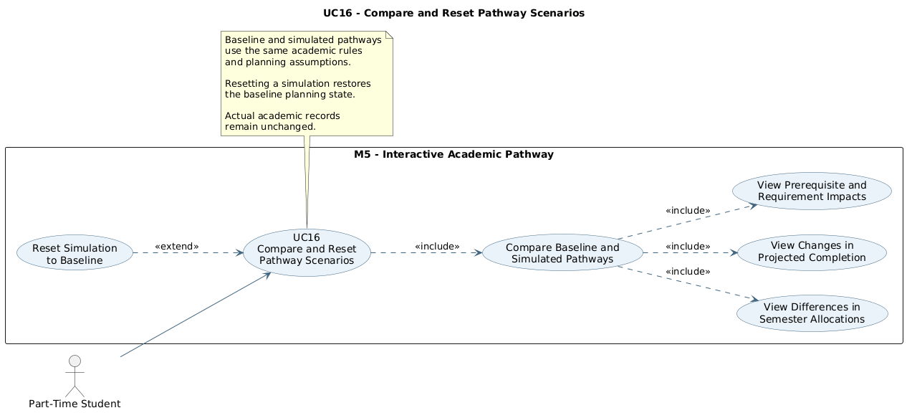
Compare and Reset Pathway Scenarios

2.2.16.1 Activity Diagram — Compare and Reset Pathway Scenarios
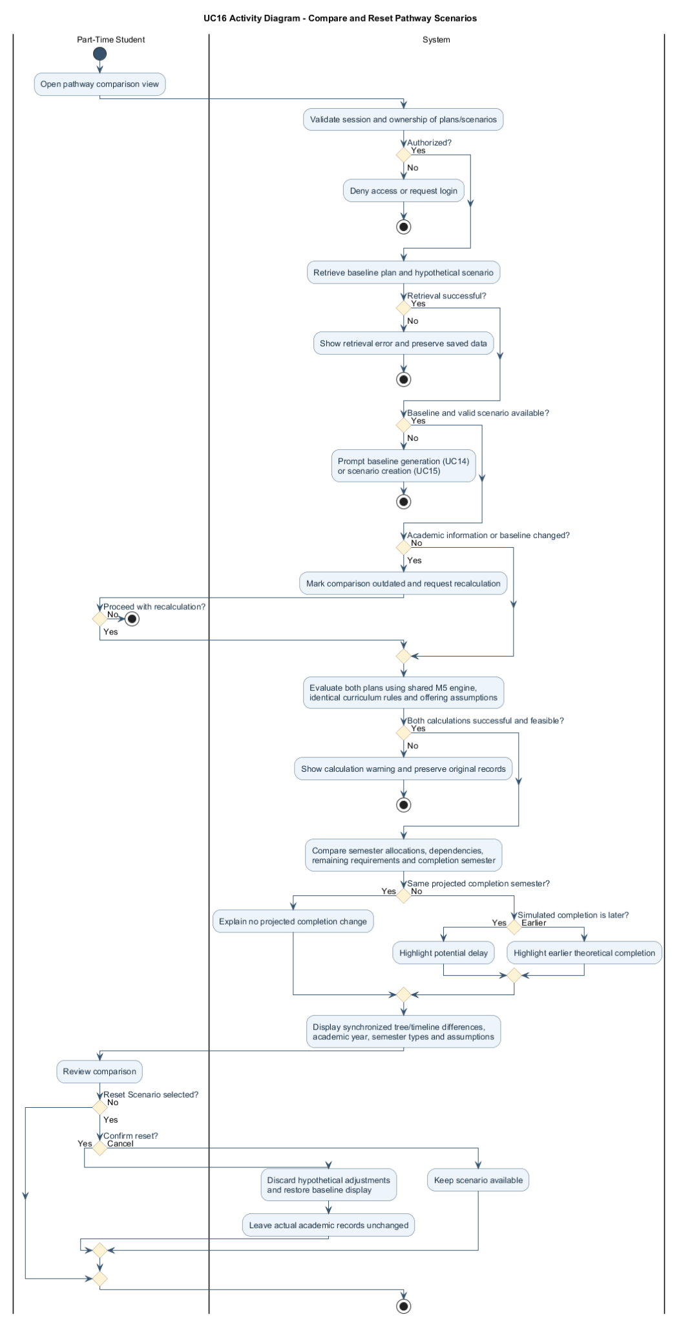

2.2.16.2 Sequence Diagram — Compare and Reset Pathway Scenarios
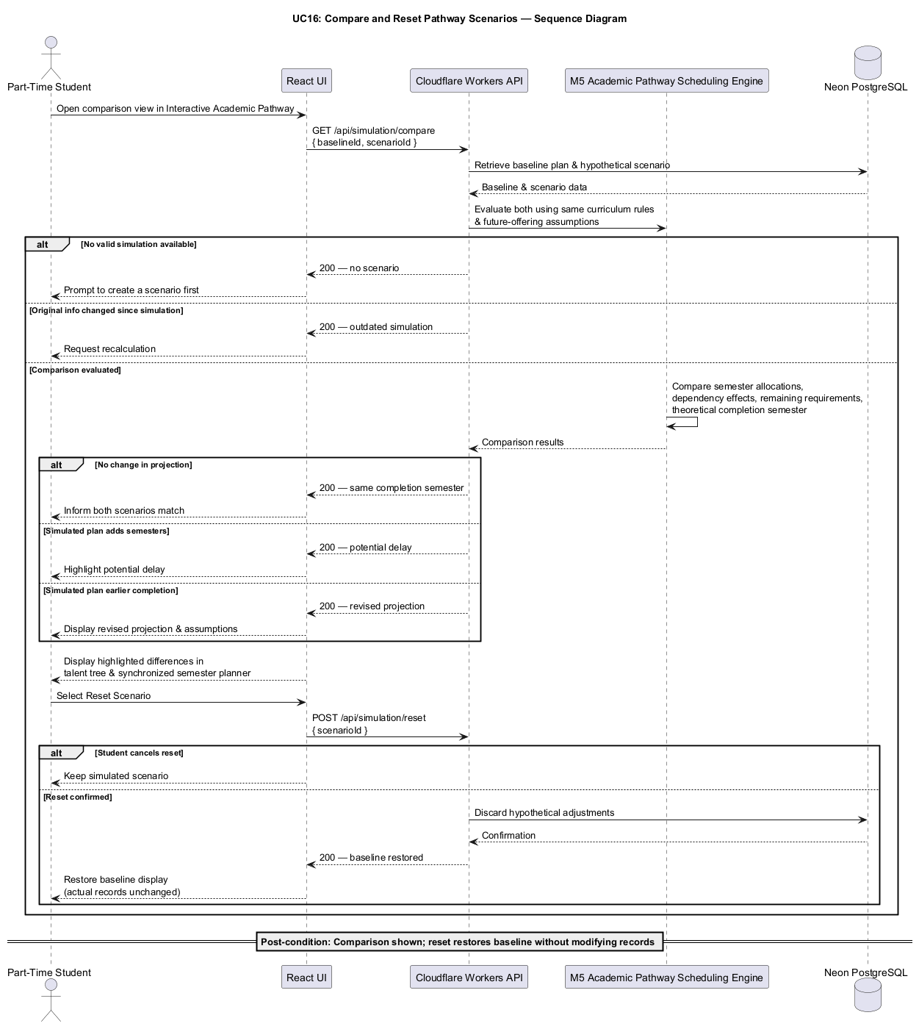

2.2.17 UC17: Use Case - View Interactive Academic Pathway
Field | Description
Use case ID | UC17
Use Case Name | View Interactive Academic Pathway
Actor | Part-Time Student
Brief Description | Displays completed, eligible, locked and remaining subjects in an interactive prerequisite talent tree.
Includes | Academic record retrieval, subject status classification, prerequisite relationship visualization, academic progress presentation.
Extension Points | Detailed subject dependency exploration and projected semester roadmap visualization.
Pre-condition | 1. Student must be authenticated.  2. The student's academic profile must be initialized.  3. The applicable curriculum and prerequisite relationships must be available.  4. Academic subject records must be available for progress visualization.
Normal Flow | 1. Student logs in to the system.  2. Student navigates to the Academic Roadmap page.  3. System retrieves the student's academic records and applicable curriculum information.  4. System retrieves subject prerequisite relationships and academic eligibility information.  5. System generates an interactive academic roadmap representing the subjects within the selected curriculum.  6. System classifies subjects according to their current statuses, including Completed, Exempted, Eligible, Locked, Recommended, and Remaining.  7. System visually distinguishes subject statuses using appropriate indicators and labels.  8. System displays relationships between subjects using a prerequisite dependency graph.  9. Student explores the roadmap to understand completed subjects, outstanding requirements, and possible academic progression pathways.  10. System updates the displayed information when the underlying academic records or planning results change.
Exception Flow | 1. If no academic subject records are available, the system displays the curriculum roadmap with uncompleted subjects and prompts the student to enter their academic history.  2. If prerequisite information is incomplete, the system identifies the affected relationships.  3. If academic planning recommendations have not been generated, the system displays available subject statuses without recommendation indicators.  4. If the curriculum cannot be retrieved, the system displays an appropriate error message.  5. If the visualization cannot be loaded, the system provides a simplified subject list where possible.
Postcondition | The student can view an interactive academic roadmap representing their current academic progression and applicable prerequisite dependencies.
Business Rules | 1. Subject statuses shall reflect the student's recorded academic history and applicable curriculum requirements.  2. Completed and exempted subjects shall be visually distinguishable.  3. Subjects with unmet mandatory prerequisites shall be identified as locked or ineligible.  4. Recommended subjects shall be identified using results generated by the academic recommendation engine.  5. Mandatory prerequisites shall be distinguished from recommended prior knowledge relationships.  6. Subject eligibility indicators shall reflect applicable semester-specific restrictions when a planning semester is selected.  7. The roadmap shall update when academic records, curriculum information, or calculated planning results change.  8. The visualization shall not present hypothetical academic results as completed academic records.

UC17 | INDIVIDUAL USE CASE DIAGRAM
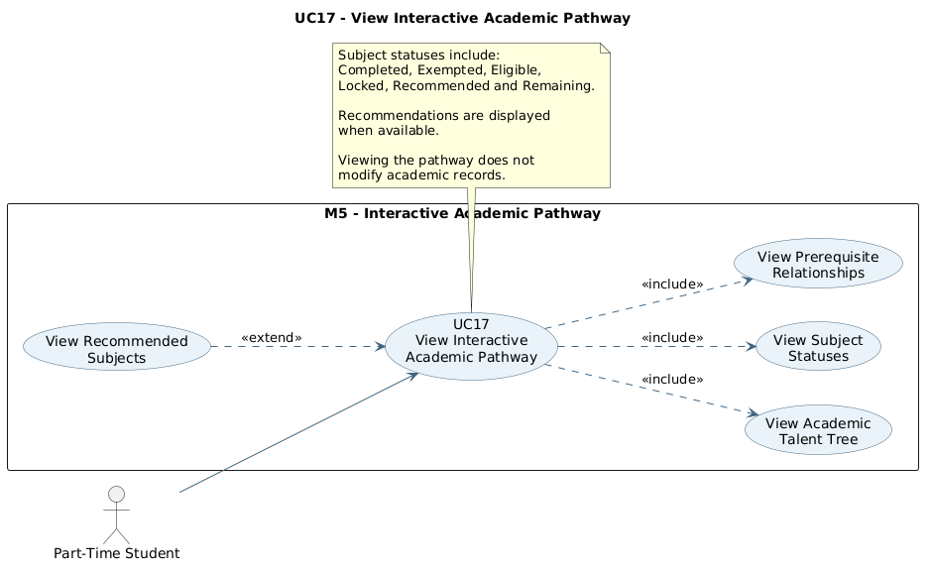
View Interactive Academic Pathway

2.2.17.1 Activity Diagram — View Interactive Academic Pathway
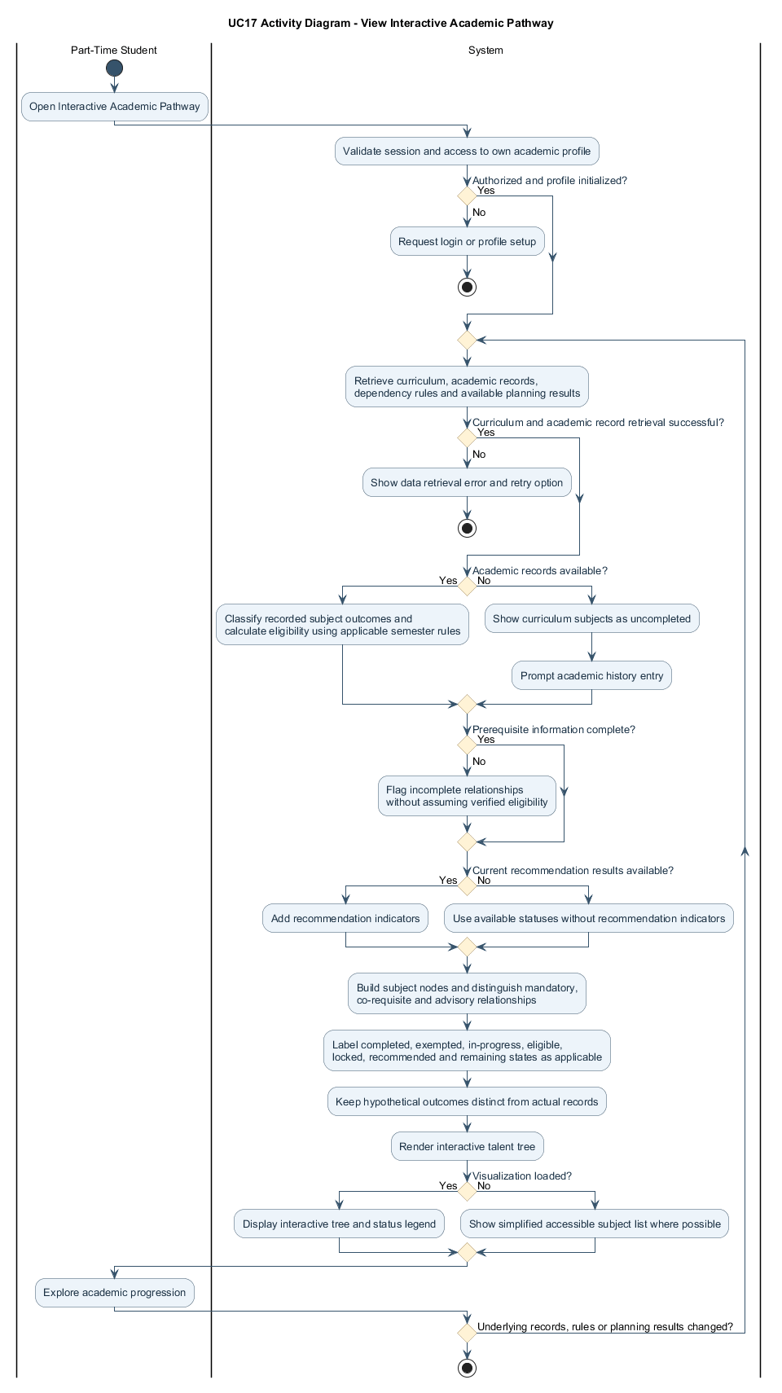

2.2.17.2 Sequence Diagram — View Interactive Academic Pathway
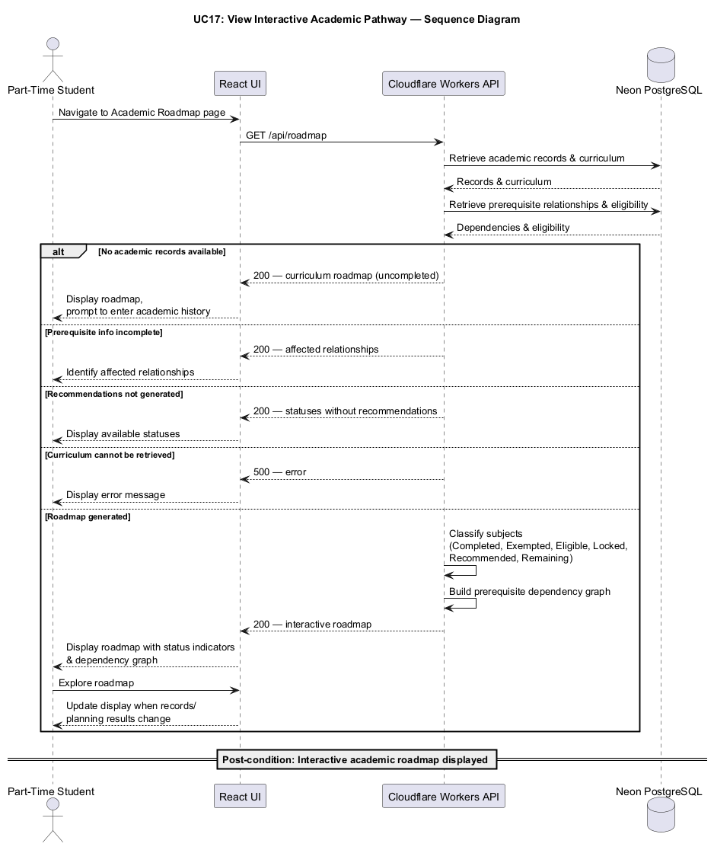

2.2.18 UC18: Use Case Explore Subject Dependencies
Field | Description
Use case ID | UC18
Use Case Name | Explore Subject Dependencies
Actor | Part-Time Student
Brief Description | Lets students inspect subject nodes and prerequisite links and explore possible placement in future semesters.
Includes | Subject information retrieval, prerequisite analysis, eligibility explanation, subject dependency visualization.
Extension Points | Direct navigation to related prerequisite subjects and integration with the semester subject recommendation interface.
Pre-condition | 1. Student must be authenticated.  2. The academic roadmap must be available.  3. Subject information and prerequisite relationships must be configured for the applicable curriculum.
Normal Flow | 1. Student accesses the Interactive Academic Pathway.  2. Student selects a subject displayed in the roadmap.  3. System retrieves the selected subject's information, including subject code, name, credit hours, classification, and prerequisite requirements.  4. System displays the subject's mandatory prerequisites and any configured co-requisite requirements.  5. System identifies subjects that depend on the selected subject.  6. System checks the student's academic records to determine whether the applicable prerequisite requirements have been satisfied.  7. System displays the subject's academic eligibility status and the reasons for eligibility or ineligibility.  8. System displays any applicable semester restrictions, including whether the subject can be taken during a Normal Semester or Short Semester.  9. If recommended prior knowledge relationships are available, the system displays them separately from mandatory prerequisites.  10. Student reviews the subject information and may select another subject for further exploration.
Exception Flow | 1. If the selected subject has no prerequisites, the system indicates that no mandatory prerequisite is configured.  2. If prerequisites are not satisfied, the system identifies the outstanding prerequisite subjects.  3. If the subject has already been completed or exempted, the system displays the corresponding academic status.  4. If the subject is restricted to a different semester type, the system explains the restriction.  5. If the subject is eligible but is not included in the student-reported current offering list, the system indicates that its availability is not confirmed.  6. If the selected subject information cannot be retrieved, the system displays an appropriate error message.
Postcondition | The student obtains detailed information about the selected subject, its prerequisite relationships, and its academic eligibility conditions.
Business Rules | 1. Subject information shall be obtained from the curriculum configured in the system.  2. Mandatory prerequisite requirements shall be enforced according to the applicable curriculum rules.  3. Recommended prior knowledge shall not be treated as a mandatory prerequisite.  4. The system shall distinguish direct prerequisites, dependent subjects, and co-requisite relationships.  5. Failed or withdrawn subjects shall not satisfy mandatory prerequisites unless an applicable academic rule explicitly permits otherwise.  6. Approved exemptions shall satisfy prerequisites according to the configured academic recognition rules.  7. Subject eligibility shall account for semester-specific enrollment restrictions and exceptions.  8. Students shall not be permitted to modify curriculum or prerequisite information through the academic roadmap.

UC18 | INDIVIDUAL USE CASE DIAGRAM
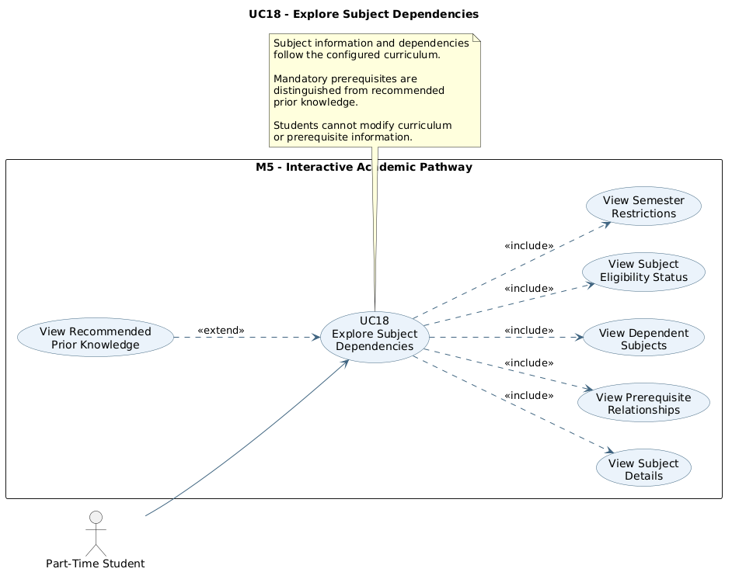
Explore Subject Dependencies

2.2.18.1 Activity Diagram — Explore Subject Dependencies
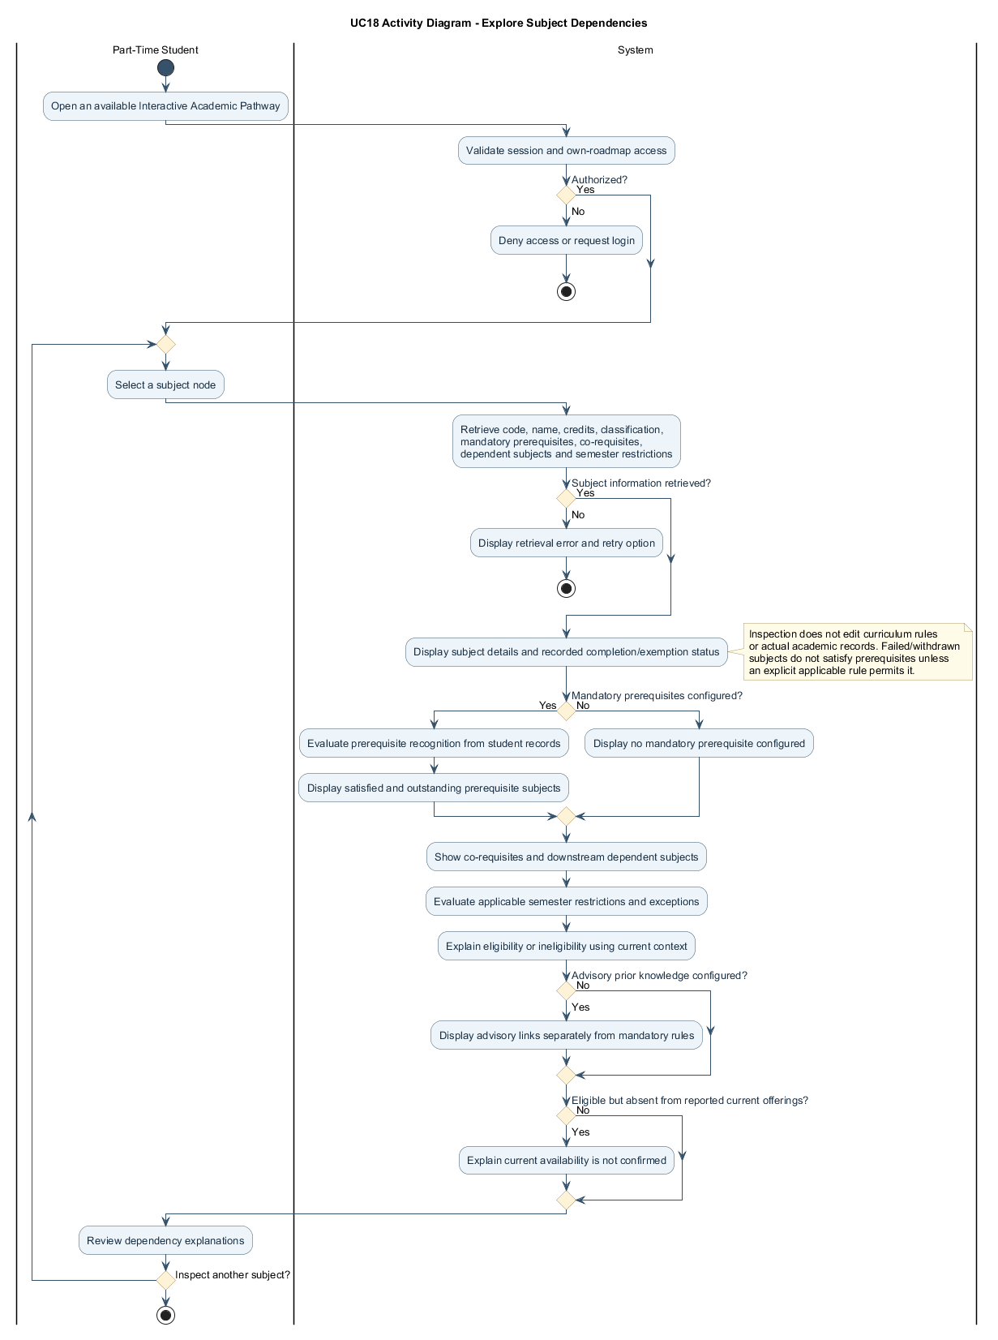

2.2.18.2 Sequence Diagram — Explore Subject Dependencies
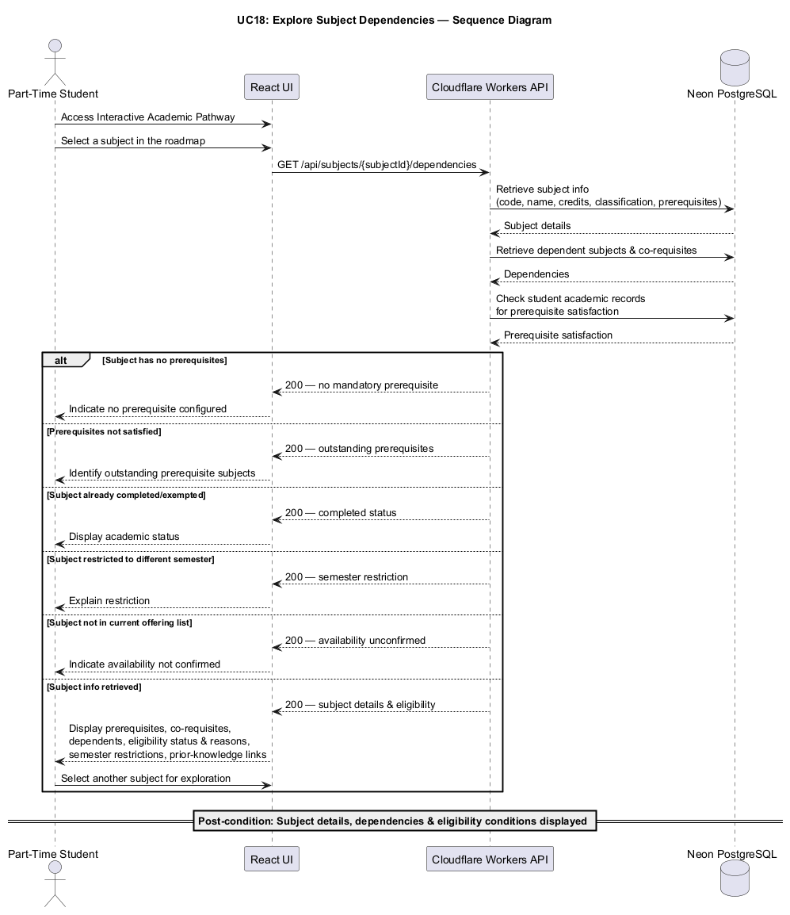

2.2.19 UC19: Use Case View Projected Semester Roadmap
Field | Description
Use case ID | UC19
Use Case Name | View Projected Semester Roadmap
Actor | Part-Time Student
Brief Description | Displays the M5 projected academic schedule as a semester timeline synchronized with the talent tree.
Includes | Shared M5 pathway retrieval, chronological semester display, credit and prerequisite visualization, and projected completion summary.
Extension Points | Show alternative pathways calculated by the Interactive Academic Pathway simulator.
Pre-condition | 1. Student is authenticated.  2. A valid M5 academic pathway has been calculated from sufficient student records and curriculum rules.
Normal Flow | 1. Student opens the projected semester timeline within M5.  2. System retrieves the pathway calculated by the shared M5 Academic Pathway Scheduling Engine.  3. System displays remaining subjects by academic year and semester, including credits, prerequisite dependencies and relevant mandatory components.  4. System shows the theoretical completion semester and synchronizes the timeline with the talent tree.  5. System displays planning assumptions and warnings for unknown future offerings or incomplete information.  6. Student reviews the proposed sequence of studies.
Exception Flow | 1. If no valid pathway exists, the system prompts the student to generate one using M5.  2. If all graduation requirements are met, the system displays completed progression rather than additional planned subjects.  3. If an underlying academic record or curriculum rule changes, the system requests a new M5 calculation.  4. If the scheduling engine cannot produce a feasible pathway, the system shows a warning instead of an invalid timeline.  5. If future offerings are unknown, the system labels the affected subject placements as theoretical.
Postcondition | The student can view a chronological academic roadmap showing the proposed remaining subjects and projected completion semester.
Business Rules | 1. The roadmap shall display the pathway calculated by the shared M5 engine; it shall not independently schedule or validate subjects.  2. The timeline shall identify academic year and semester type: Semesters 1 and 2 are Normal, and Semester 3 is Short.  3. Each semester shall show its proposed subjects, total credits and relevant prerequisite or mandatory-component indicators.  4. All semester allocations shall reflect the configured curriculum, registration limits and academic exceptions applied by the M5 engine.  5. Unknown future offerings and estimated completion semesters shall be labelled as theoretical, not guaranteed.  6. Baseline and simulated roadmap views shall use results from the same M5 scheduling rules.

UC19 | INDIVIDUAL USE CASE DIAGRAM
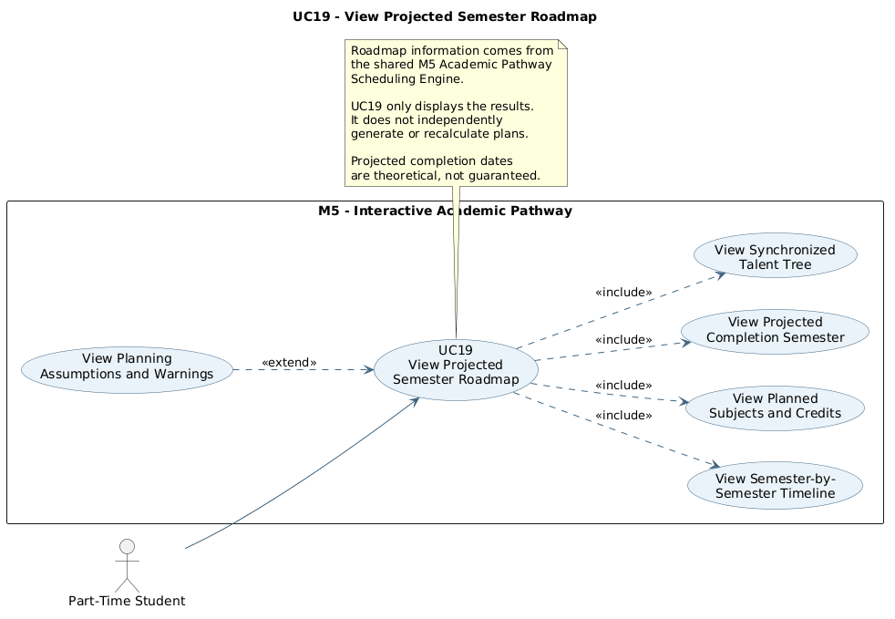
View Projected Semester Roadmap

2.2.19.1 Activity Diagram — View Projected Semester Roadmap
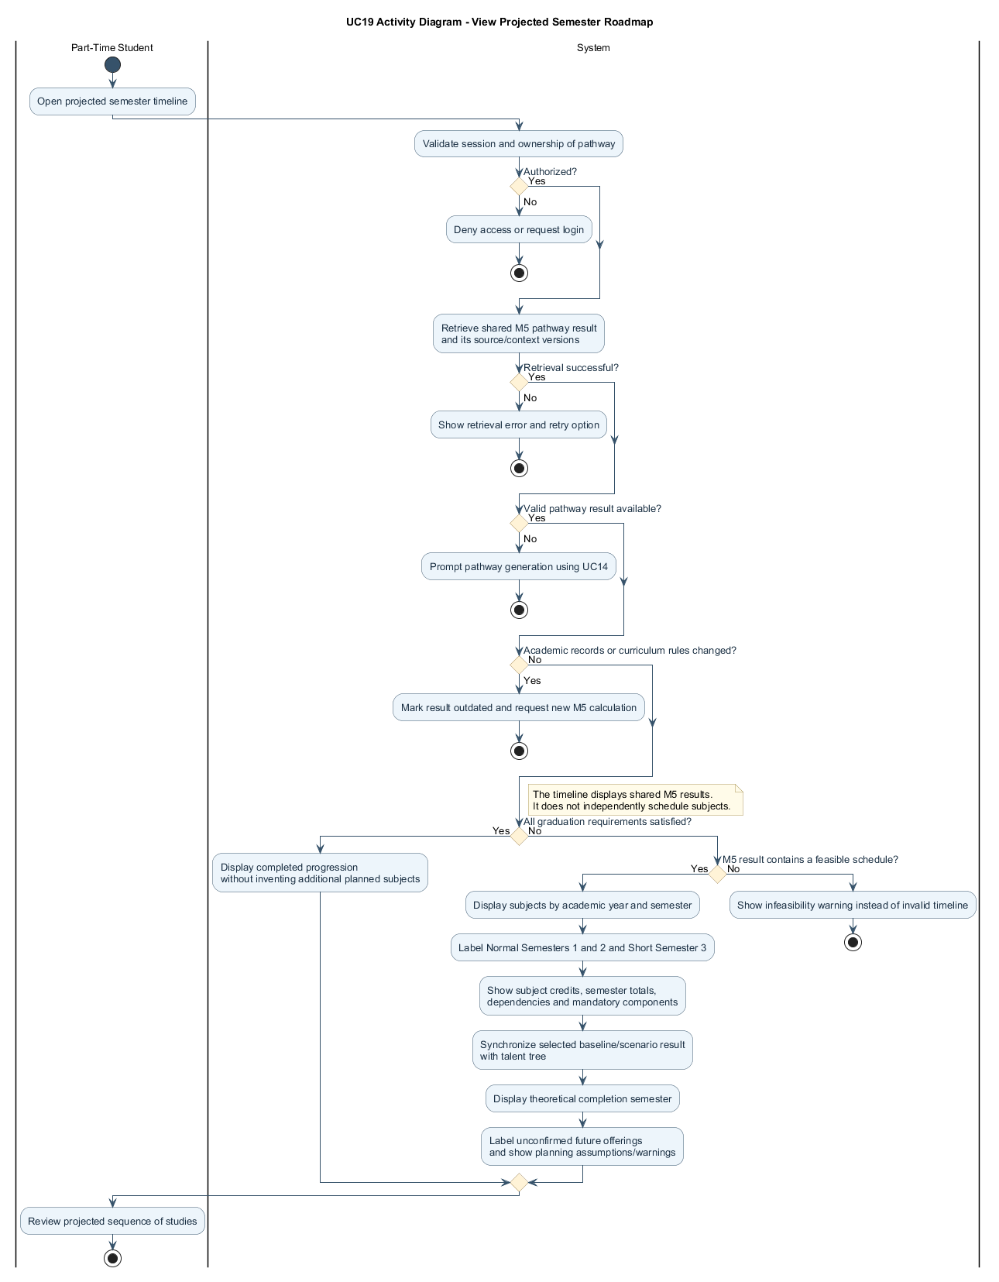

2.2.19.2 Sequence Diagram — View Projected Semester Roadmap
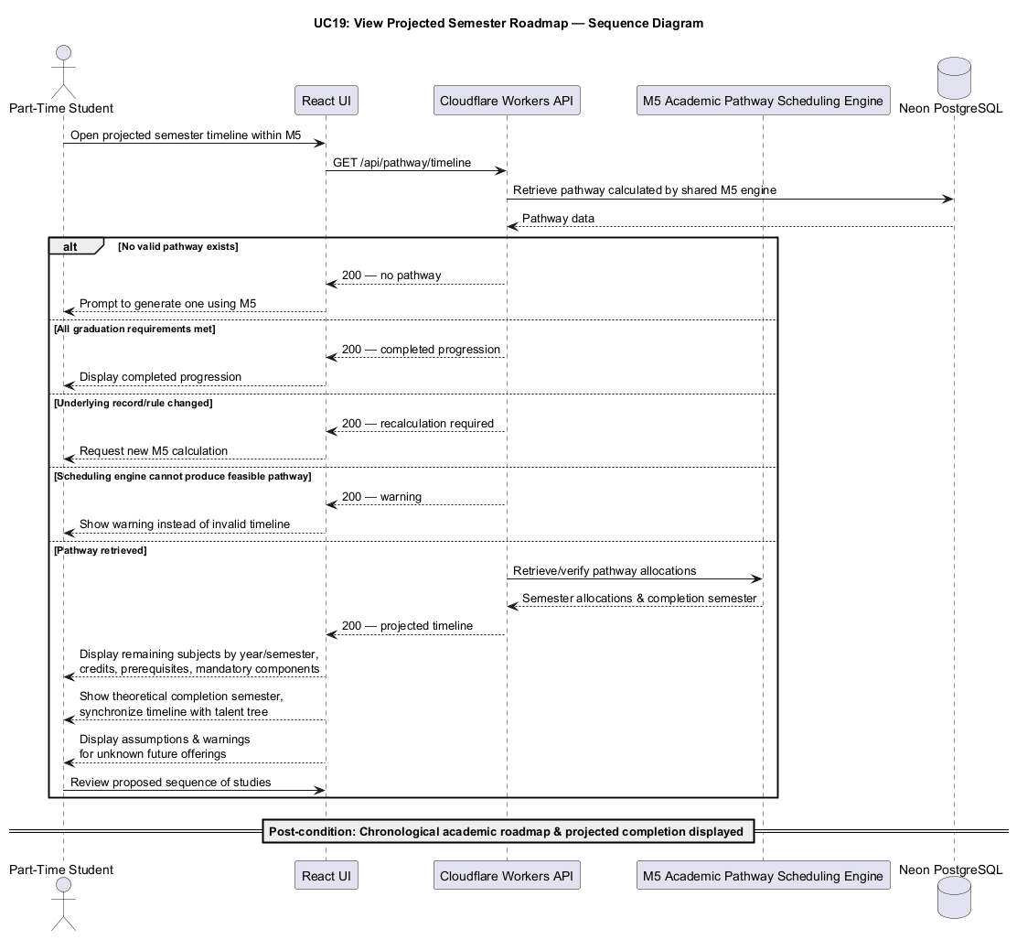

2.2.20 UC20: Use Case Provide Academic Data and Generate Class Offering Forecast
Field | Description
Use case ID | UC20
Use Case Name | Provide Academic Data and Generate Class Offering Forecast
Actor | Academic Coordinator; System Administrator (configuration only)
Brief Description | Lets an authorized Academic Coordinator provide and validate academic data, generate an initial advisory forecast, and review proposed class sections. Later updates and comparisons follow UC23.
Includes | Academic data provision and validation; subject-code reconciliation; source date and learning centre; demand estimation; forecast exclusions; capacity-based section allocation; data-quality warnings; exceptional review and audit.
Extension Points | Historical enrollment validation if actual outcomes become available; additional resource constraints; optional explanatory insights (not required in initial scope).
Pre-condition | 1. Coordinator is authenticated and authorized.  2. Shared Subject, Curriculum and semester rules are configured.  3. Class capacity policies are configured and verified.  4. Coordinator has a lawful, appropriately controlled external dataset for the target centre and semester.
Normal Flow | 1. Coordinator selects the learning centre and target semester, specifies the source date and provides student academic data.  2. Backend validates the provided data structure, required fields, duplicates and subject codes.  3. Coordinator corrects invalid records or reviews incompleteness warnings.  4. System stores the accepted data as a separate dated snapshot; it does not overwrite StudentProfile or AcademicRecord.  5. Coordinator requests Generate Forecast.  6. Engine applies the configured curriculum, prerequisites, exclusion flags and explicit forecast assumptions.  7. Engine estimates supported subject demand; unknown eligibility remains labelled uncertain.  8. System recommends section counts using minimum, break-even reference and capacity rules.  9. System flags low-enrollment subjects, including graduation-critical exceptions, for manual review.  10. Coordinator reviews, adjusts and records decisions with justification; system preserves the forecast and rule snapshot.
Exception Flow | 1. Invalid data structure or unmatched subject codes: reject affected records and show a correction report.  2. Missing subject histories: show preliminary demand or insufficient-data status, not verified eligibility.  3. Stale snapshot: warn that deferred or changed enrollments may affect the forecast.  4. Enrollment below 15: flag for review, not automatic cancellation.  5. Graduation-critical low enrollment: allow exceptional review with documented reason, subject to institutional approval.  6. Capacity exceeded: add sections or require authorized exception within configured maximum.  7. Unauthorized coordinator: deny access to provided data and forecasting functions.
Postcondition | An initial, dated forecast is saved with demand estimates, section proposals, assumptions, data-quality warnings and review decisions. It can be used as a baseline for future UC23 forecast versions. No official offerings are automatically published.
Business Rules | 1. M6 uses coordinator-provided snapshots independently of student portal participation.  2. Subject and curriculum rules reuse the shared master catalogue.  3. FYP1, FYP2 and Industrial Training are excluded from classroom section recommendations through subject configuration.  4. Working figures (lecture around 40; lab around 30 with some exceptions to 35; minimum 15; financial break-even around 25) are provisional and administrator-configurable.  5. Below-minimum offerings are flagged for human review, including exceptional graduation-critical cases.  6. Forecast eligibility is conditional on sufficient prerequisites and student histories; synthetic results cannot prove real demand accuracy.  7. Provided identifiable student records require access control, source tracking and retention safeguards.  8. An authorized coordinator decision does not constitute official semester offering approval unless institutional policy permits it.  9. No LLM is needed to calculate demand or allocate sections.  10. Coordinator decisions may be revised only during Draft or Under Review. Finalized results and decisions are read-only; later changes require a new forecast version.

UC20 | INDIVIDUAL USE CASE DIAGRAM
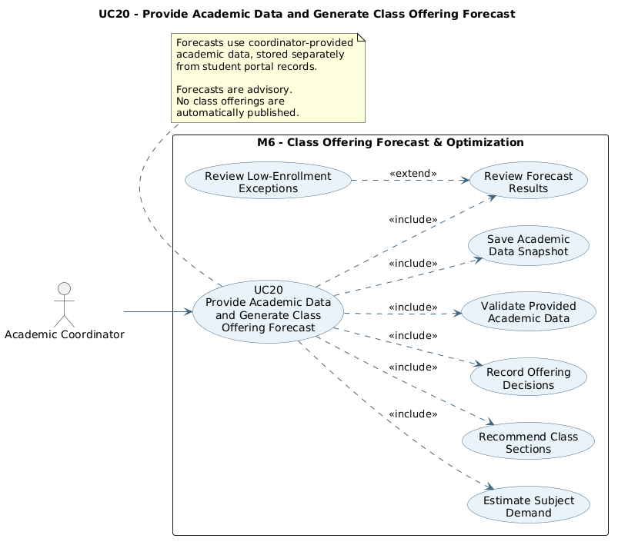
Provide Academic Data and Generate Class Offering Forecast

2.2.20.1 Activity Diagram — Provide Academic Data and Generate Class Offering Forecast
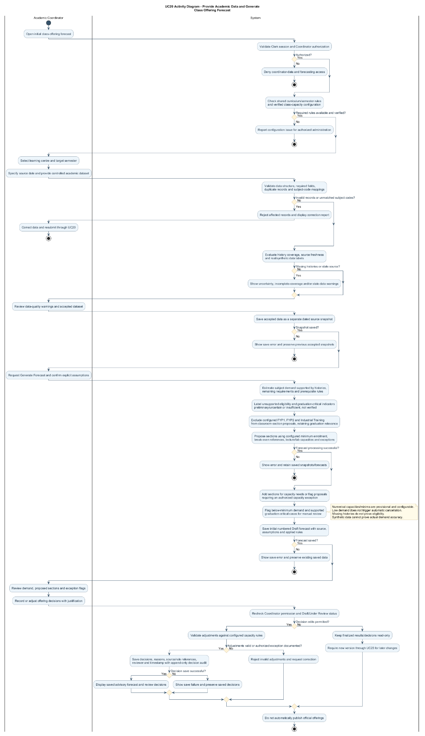
Figure 2.15: Activity Diagram for Provide Academic Data and Generate Class Offering Forecast

2.2.20.2 Sequence Diagram — Provide Academic Data and Generate Class Offering Forecast
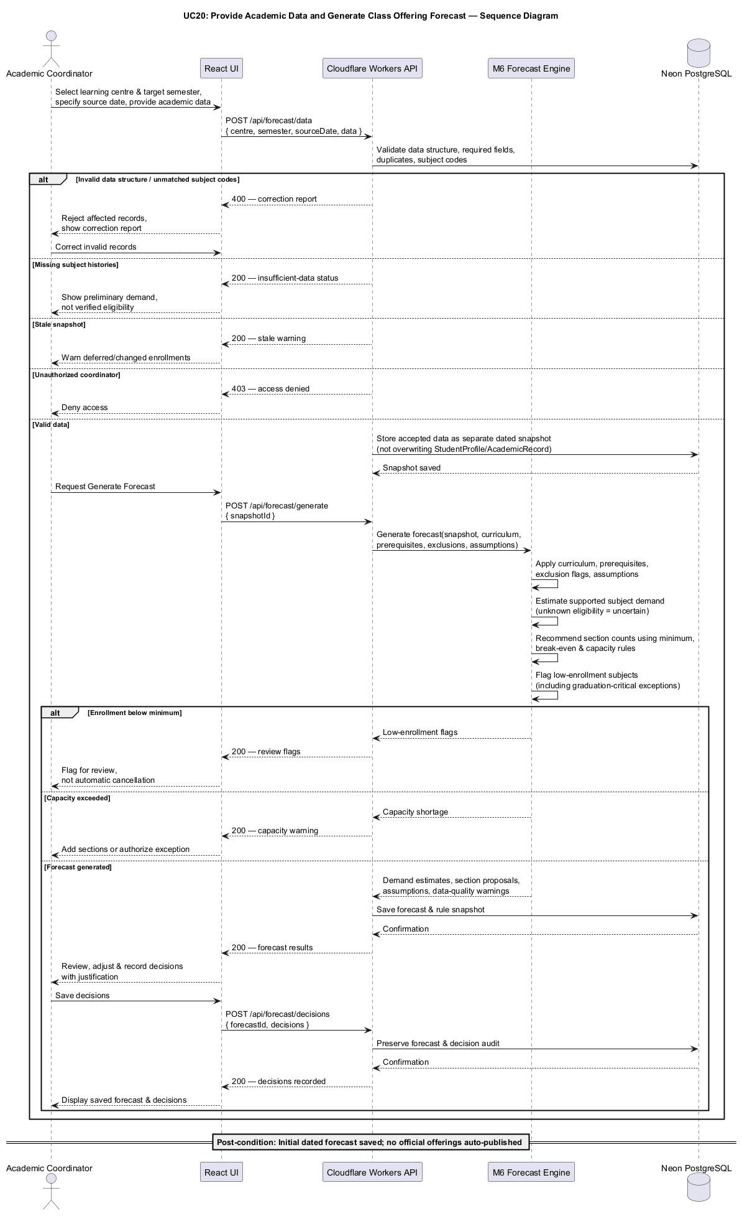
Figure 2.16: Sequence Diagram for Provide Academic Data and Generate Class Offering Forecast

2.2.21 UC21: Use Case View System Administration Dashboard

Field | Description
Use case ID | UC21
Use Case Name | View System Administration Dashboard
Actor | System Administrator
Brief Description | Shows authorized System Administrators an overview of user access status, role distribution and system warnings.
Includes | Dashboard retrieval, role-based counts, access-status summaries, configuration-readiness messages.
Extension Points | Additional privacy-preserving usage indicators may be introduced after data availability and policy are verified.
Pre-condition | 1. An authenticated Clerk identity is active.  2. The backend confirms the System Administrator role.
Normal Flow | 1. System Administrator signs in and opens the Administration Dashboard.  2. Backend validates the Clerk session and administrator access.  3. Service aggregates application access counts by role and active/suspended state.  4. Service retrieves configuration warnings without returning identifiable student records.  5. The system displays summary cards and links to permitted user-management functions.  6. Administrator selects an item to inspect authorized detail.
Exception Flow | 1. If the user lacks administrator rights, access is denied.  2. If role configuration is incomplete, the dashboard indicates unavailable metrics.  3. If services fail, the system displays a non-sensitive error and retry option.
Postcondition | The administrator views up-to-date administrative summaries without modifying user access or academic records.
Business Rules | 1. Counts are based on available application access information and include a calculation timestamp.  2. The dashboard must not disclose coordinator-provided identifiable student records or personal academic histories by default.  3. Access is enforced on the backend, not solely through hidden UI controls.

UC21 | INDIVIDUAL USE CASE DIAGRAM
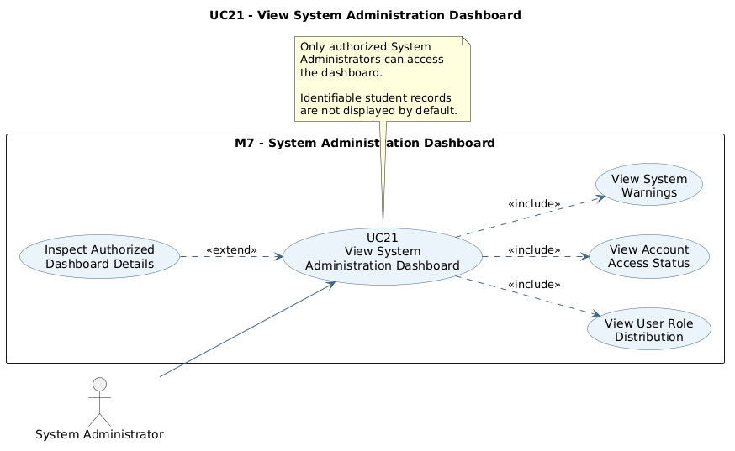
View System Administration Dashboard

2.2.21.1 Activity Diagram — View System Administration Dashboard
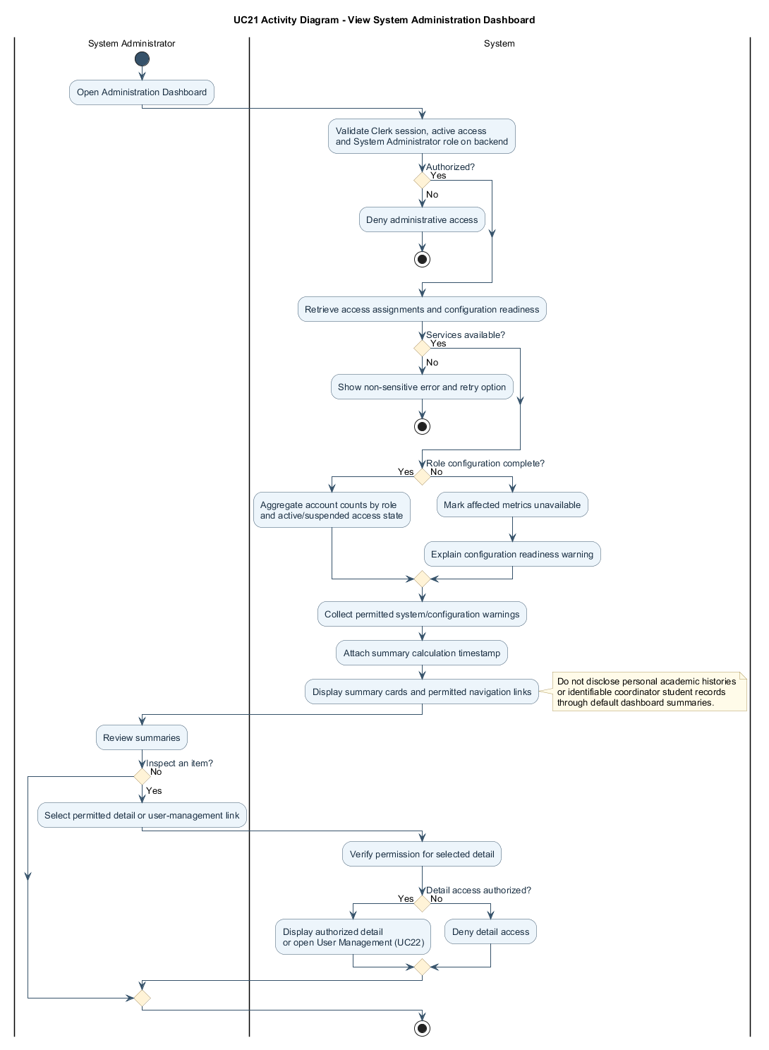

2.2.21.2 Sequence Diagram — View System Administration Dashboard
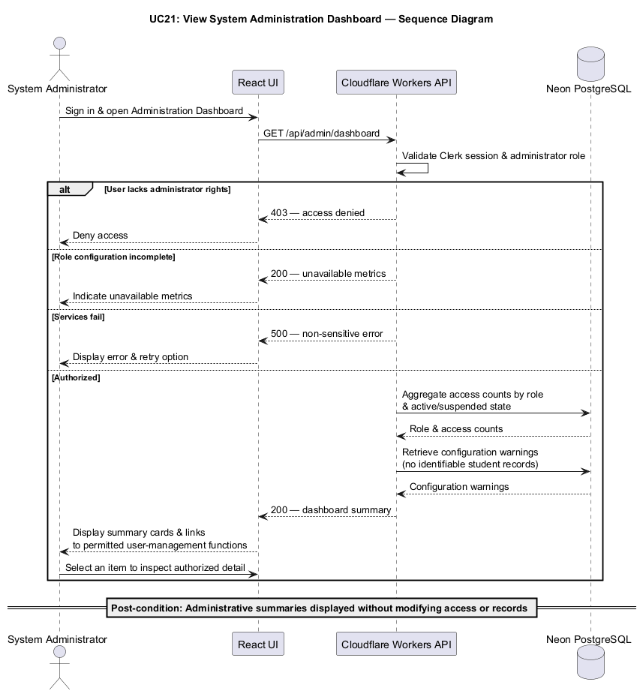

2.2.22 UC22: Use Case Manage User Access and Roles
Field | Description
Use case ID | UC22
Use Case Name | Manage User Access and Roles
Actor | System Administrator, Clerk Authentication Service
Brief Description | Lets authorized administrators manage Clerk-linked application roles and access status with enforced security checks and audit logging.
Includes | Account search, role assignment, access suspend/reactivation, permission validation, audit logging.
Extension Points | Optional role-invitation notifications and approval requirements may be configured later.
Pre-condition | 1. The initiating administrator is authenticated and authorized.  2. A matching Clerk identity exists or is invited through an authorized procedure.
Normal Flow | 1. Administrator opens User Management.  2. System retrieves user access assignments and available roles.  3. Administrator searches for or selects an account.  4. Administrator chooses an approved role or access-state change and enters a reason where required.  5. Backend checks administrator permissions, the Clerk identity, and safety policies.  6. System applies the authorization change using its configured role authority and updates the application access record.  7. System appends an audit event containing actor, target, old/new value, timestamp and reason.  8. Updated status is shown without exposing or changing user passwords.
Exception Flow | 1. Unauthorized administrator or invalid Clerk identity: reject the change.  2. Attempted self-elevation or removal of the final active administrator: reject and explain the constraint.  3. Failed identity/role synchronization: do not mark the access change as complete and flag it for retry/reconciliation.  4. Duplicate or conflicting assignments: reject or request correction.
Postcondition | An authorized user-access change is consistently recorded and available for audit; passwords and academic histories remain untouched.
Business Rules | 1. Clerk remains the source for authentication; role authority is configured explicitly and validated server-side.  2. Only explicitly authorized administrators can grant administrative or coordinator roles.  3. Students cannot promote their own access.  4. The last active System Administrator cannot be deactivated or demoted through this feature.  5. Application access suspension does not imply deletion of academic records.  6. Each successful role or access change is auditable.

UC22 | INDIVIDUAL USE CASE DIAGRAM
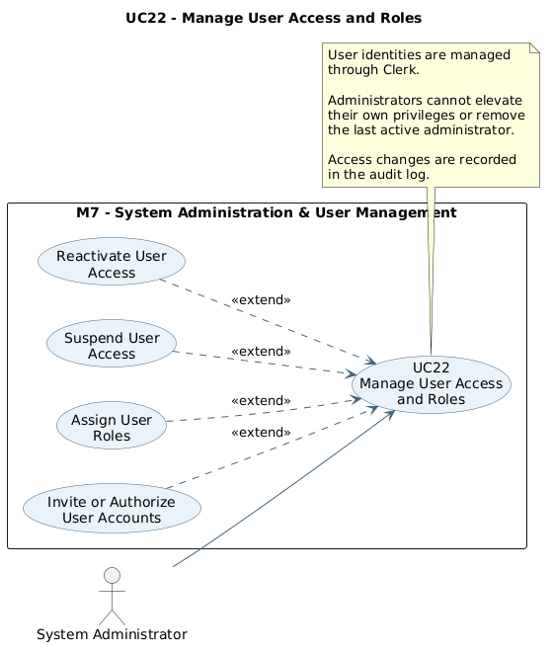
Manage User Access and Roles

2.2.22.1 Activity Diagram — Manage User Access and Roles
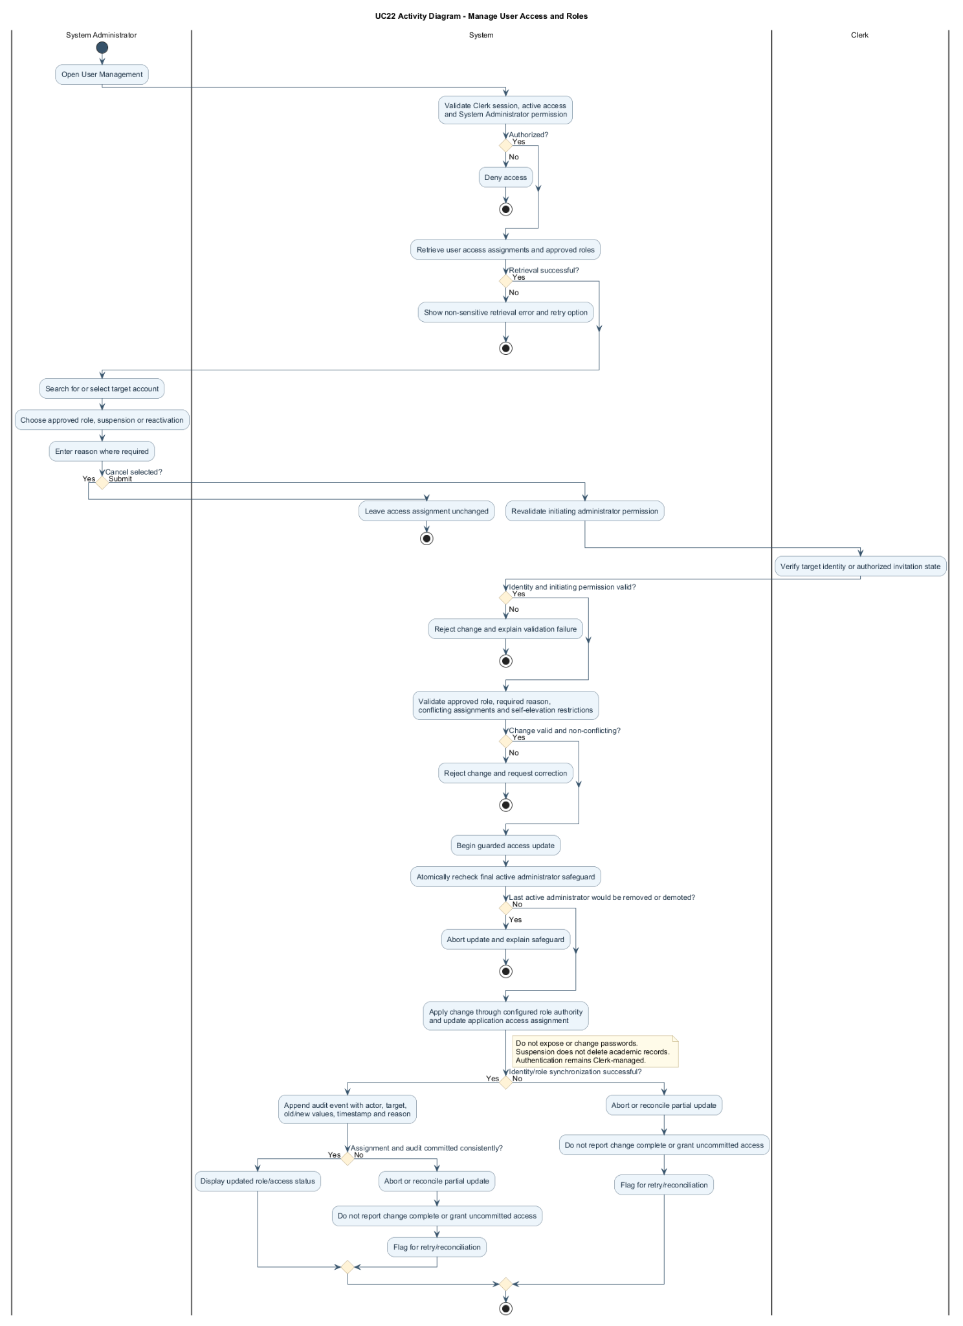

2.2.22.2 Sequence Diagram — Manage User Access and Roles

2.2.23 UC23: Use Case Manage and Compare Forecast Versions
Use case ID | UC23
Use Case Name | Manage and Compare Forecast Versions
Actor | Academic Coordinator
Brief Description | Coordinators can refresh academic data, create forecast versions, reset draft changes and compare past forecasts without deleting saved results or decisions.
Includes | Select learning centre and target semester; view version history; validate updated data; reforecast; reset unsaved draft; compare two versions; finalize and archive; preserve decision audit history.
Extension Points | Actual-enrollment comparison may be added later when confirmed registration outcomes are available; it is not required in this use case.
Pre-condition | 1. Coordinator is authenticated and authorized.  2. At least one forecast exists for the selected learning centre and target semester.  3. Curriculum and class-capacity rules are available.
Normal Flow | 1. Coordinator selects the learning centre and target semester and opens Forecast History.  2. System lists version number, source date, status, author and data-quality labels.  3. Coordinator chooses Refresh Data, Reforecast, Reset Draft or Compare Versions.  4. For Refresh Data, coordinator provides updated academic data. System validates and saves a new dated source snapshot.  5. For Reforecast, coordinator confirms assumptions. System creates a new ForecastRun linked to its prior version and retains earlier results.  6. For Reset Draft, system discards only unsaved changes and reloads the last saved draft.  7. For Compare Versions, coordinator selects two versions for the same centre and semester.  8. System shows changes in demand, coverage, source date, proposed sections and pending reviews.  9. Coordinator may mark a reviewed version Finalized. Older versions may be marked Superseded or Archived without being deleted.
Exception Flow | 1. Invalid updated data: reject affected records and retain the previous accepted snapshot.  2. No prior forecast: instruct the coordinator to generate the initial forecast using UC20.  3. Incompatible centre or semester: reject comparison and request matching versions.  4. Finalized forecast: prohibit edits to results and decisions or destructive reset; allow read-only comparison and authorized status transitions.  5. Missing academic histories: mark estimated demand and graduation-critical indicators as uncertain.  6. Unauthorized user: deny data and forecast access.
Postcondition | A new version is saved when reforecasting succeeds. Draft reset changes only unsaved values. Historical forecasts, finalized decisions, source snapshots and append-only decision audit events remain available.
Business Rules | 1. Forecast version numbers are unique per learning centre and target semester.  2. Updated data creates a new source snapshot; the student portal data is never overwritten.  3. Finalized forecast results and decisions are immutable. An authorized metadata status change may mark an older version Superseded or Archived without replacing its contents.  4. Decision changes are recorded with previous and new values, reason, reviewer and timestamp.  5. Comparisons are advisory and cannot be treated as verified enrollment outcomes.  6. Class offering recommendations still require authorized institutional review; no automatic publication.

UC23 | USE CASE DIAGRAM
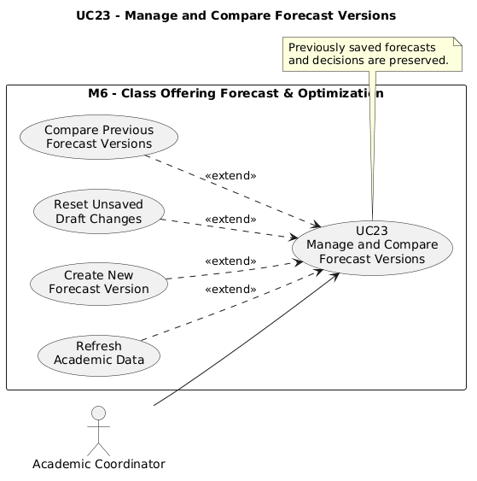
Manage and Compare Forecast Versions

2.2.23.1 Activity Diagram — Manage and Compare Forecast Versions
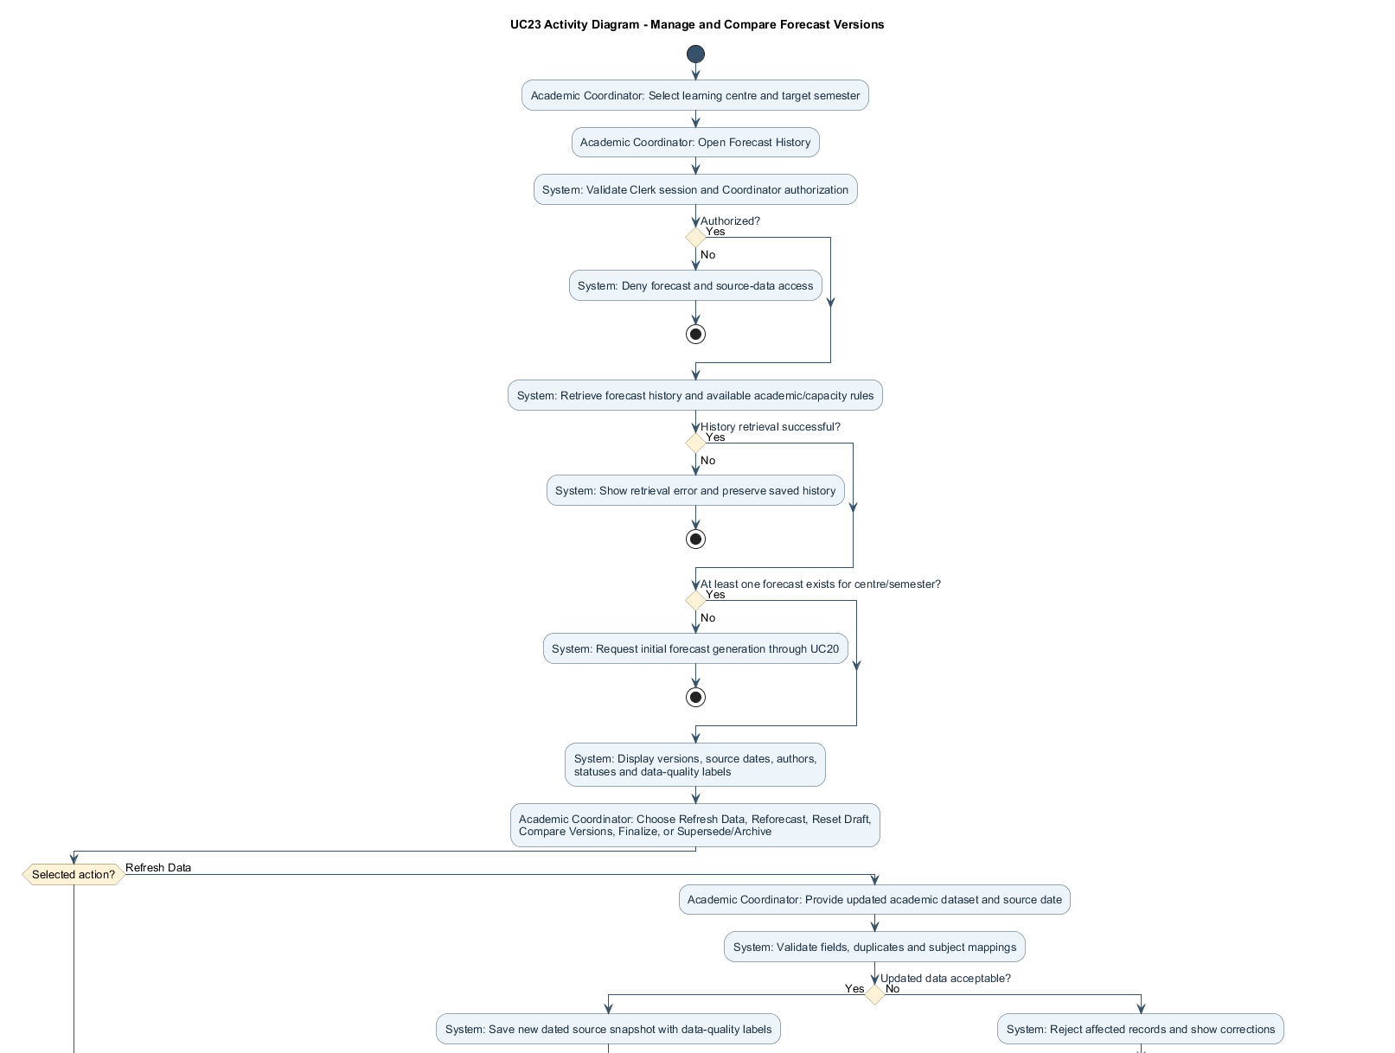
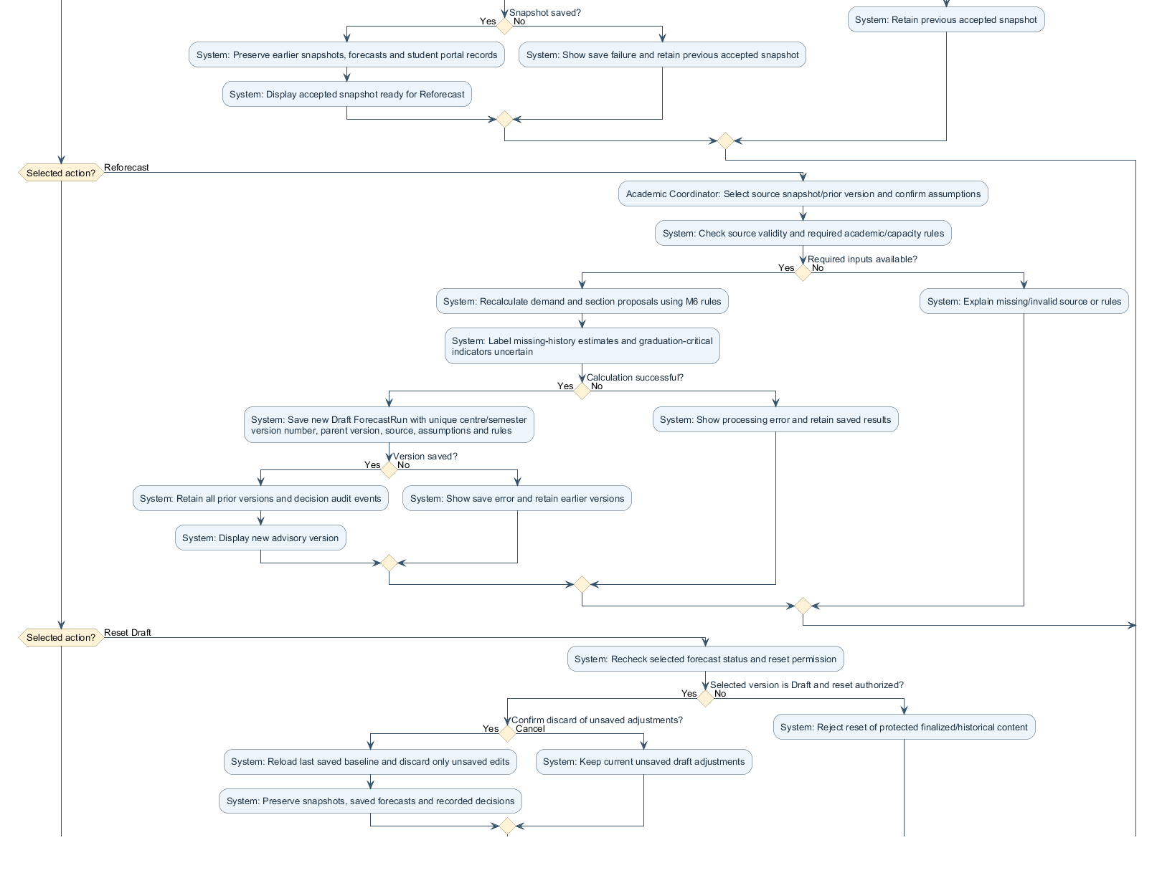
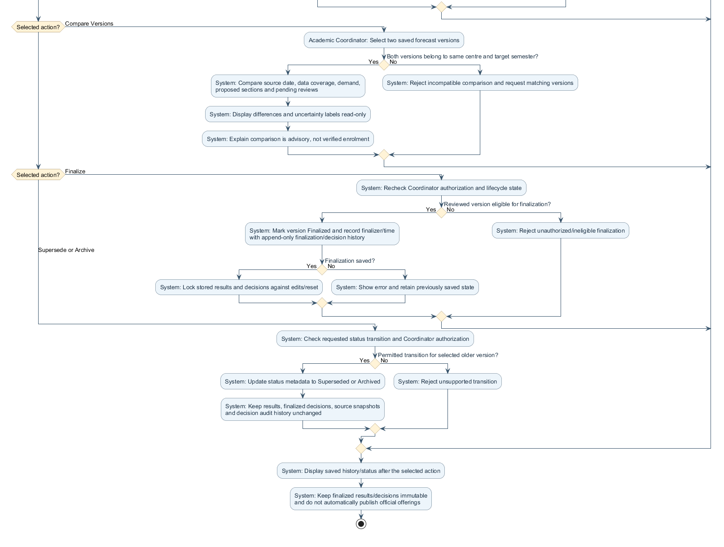
Figure 2.19: Activity Diagram for Refresh, Reforecast, Draft Reset and Comparison

2.2.23.2 Sequence Diagram — Manage and Compare Forecast Versions
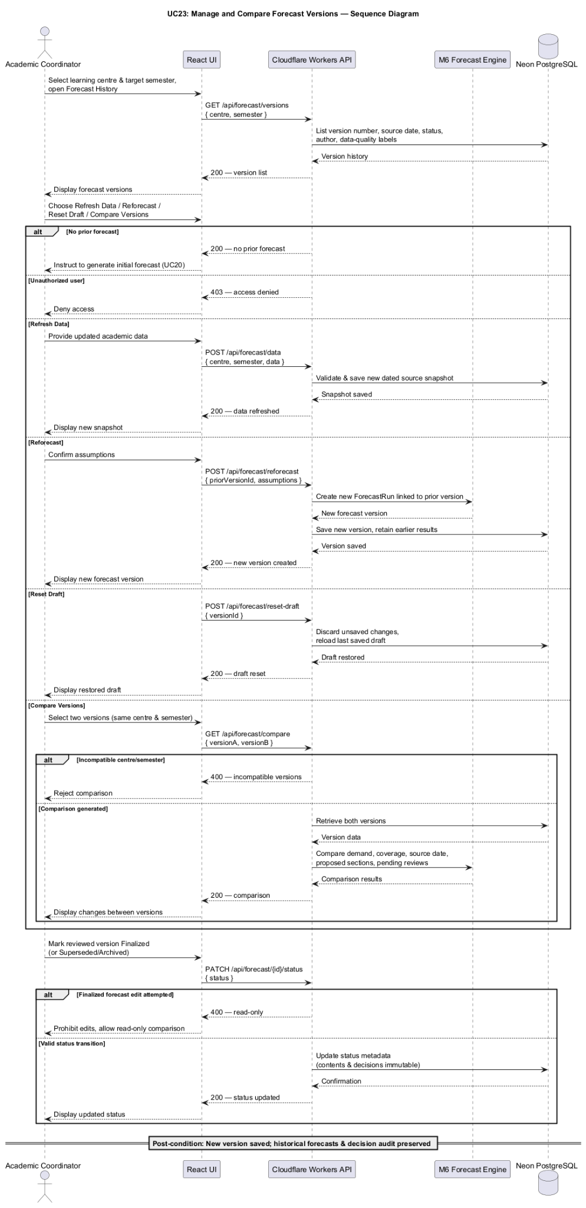
Figure 2.20: Technical Sequence Diagram for M6 Forecast Version Management

2.3 Software System Attributes, Performance and Other Requirements
These quality requirements apply to the web interface, backend APIs, academic engines and database. M = Must Have; S = Should Have.

2.3.1 Performance Requirements
Index | Description | Priority
NFR-P1 | The system shall aim to load its main application pages within five seconds under normal network conditions and the defined testing environment. | M
NFR-P2 | The system shall aim to complete routine academic operations, including profile retrieval, academic progress calculations, and subject eligibility validation, within three seconds for the supported programme dataset. | M
NFR-P3 | The Intelligent Subject Recommendation Engine shall aim to generate valid subject combinations within ten seconds under the defined testing conditions. | M
NFR-P4 | The Interactive Academic Pathway planning engine shall aim to generate or recalculate a feasible semester pathway within ten seconds for the supported programme dataset under defined test conditions. | M
NFR-P5 | The system shall display progress indicators during recommendations, pathway calculations, academic-data validation and class forecasting. | M
NFR-P6 | Forecasting operations shall use configured processing limits and clear retry/recovery messages; no external LLM availability is required. | M

2.3.2 Security Requirements
Index | Description | Priority
NFR-S1 | The system shall use Clerk authentication to manage secure user registration, login, logout, and authenticated sessions. | M
NFR-S2 | The system shall restrict student access to authenticated users with verified institutional email addresses belonging to the @graduate.utm.my domain. Authorization shall be enforced by the backend. | M
NFR-S3 | The application shall enforce backend role-based access control for Student, System Administrator and Academic Coordinator accounts. | M
NFR-S4 | The backend shall ensure that students can view and change only their own academic records, plans and simulations. | M
NFR-S5 | The system shall use encrypted connections between the frontend, backend, identity provider and database. | M
NFR-S6 | The system shall protect database credentials, Clerk configuration and any sensitive environment settings as backend secrets. | M
NFR-S7 | The system shall validate input and use secure queries to reduce SQL injection, cross-site scripting and other common attacks. | M
NFR-S8 | The backend shall restrict coordinator academic datasets to authorized users and prevent students from accessing identifiable coordinator records. | M
NFR-S9 | The backend shall enforce all privileged account changes through authenticated, atomic authorization checks so failed changes do not grant access. | M
NFR-S10 | The system shall protect user-access audit logs against unauthorized viewing, editing or deletion. | M
NFR-S11 | The backend shall restrict forecast finalization, status changes and decision history to authorized coordinators, and protect finalized results and decisions against edits. | M

2.3.3 Reliability and Availability
Index | Description | Priority
NFR-R1 | The system shall handle invalid inputs, incomplete academic records, database failures, and external service errors without causing an uncontrolled application failure. | M
NFR-R2 | The system shall preserve previously saved student academic records when an update or processing operation fails. | M
NFR-R3 | Student academic planning functions shall operate independently of Academic Coordinator data-provision or forecasting failures. | M
NFR-R4 | The system shall provide clear error messages and appropriate recovery options when an operation cannot be completed. | M
NFR-R5 | The academic planning engine shall produce consistent results when the same academic records, curriculum configuration, semester structure, and planning assumptions are used. | M
NFR-R6 | The system shall not use incomplete or invalid provided datasets as validated forecast sources. | M
NFR-R7 | The system shall preserve older forecast versions and finalized decisions if data refresh, reforecasting or draft reset fails. | M

2.3.4 Usability and Accessibility
Index | Description | Priority
NFR-U1 | The application shall offer clear navigation for profiles, eligibility, recommendations, M5 talent tree and semester planner, and the separate M6 coordinator interface. | M
NFR-U2 | The system shall explain eligibility, prerequisites, academic bottlenecks and subject recommendations in clear language. | M
NFR-U3 | The interface shall consistently label completed, exempted, eligible, locked, recommended and remaining subjects. | M
NFR-U4 | The system shall display academic years and semesters in a consistent format, such as Academic Year 2026/2027 — Semester 3 (Short Semester). | M
NFR-U5 | The system shall clearly differentiate Normal Semesters and Short Semesters when presenting registration limits, subject restrictions, and projected academic pathways. | M
NFR-U6 | The system shall provide a responsive interface that adapts to desktop, tablet, and mobile screen sizes. | M
NFR-U7 | The system should follow recognized web accessibility practices, including readable text, meaningful form labels, keyboard navigation, and sufficient visual contrast, with WCAG 2.1 Level AA used as a design target. | S
NFR-U8 | The Interactive Academic Pathway shall allow accessible inspection of prerequisite nodes and semester schedules; an equivalent list or keyboard-operable navigation shall be provided where practical. | M
NFR-U9 | Coordinator and System Administrator dashboards shall have separate navigation and access permissions. | M
NFR-U10 | The Coordinator Dashboard shall distinguish current, superseded and archived forecasts and show a clear warning before resetting a draft. | M

2.3.5 Data Integrity and Accuracy
Index | Description | Priority
NFR-D1 | The system shall maintain accurate relationships between academic programmes, curriculum versions, subjects, prerequisite requirements, and student academic records. | M
NFR-D2 | The system shall prevent duplicate academic credit counting and distinguish successfully completed credits from recognized transferred credits and non-credit-bearing exemptions. | M
NFR-D3 | The system shall keep academic progress, eligibility, recommendations and M5 pathway results consistent with shared curriculum rules. | M
NFR-D4 | Simulations shall not change real student records. Coordinator datasets shall remain separate from student academic records. | M
NFR-D5 | The system shall label student-reported, coordinator-provided and synthetic test data and preserve source dates and assumptions. | M
NFR-D6 | The system shall retain sufficient information about the applicable curriculum, semester configuration, and planning assumptions to support consistent interpretation of generated academic plans. | M
NFR-D7 | The system shall label uncertain future offerings, graduation dates and class-demand estimates as projections rather than verified outcomes. | M
NFR-D8 | The system shall preserve forecast version lineage, source snapshots, data-quality labels and an append-only history of coordinator decision changes. | M

2.3.6 Maintainability and Extensibility
Index | Description | Priority
NFR-M1 | The architecture shall separate the React interface, authenticated APIs, academic rule services, planning, data validation, forecasting and persistence. | M
NFR-M2 | The frontend application shall be developed using React, TypeScript, and Vite, while backend services and academic planning algorithms shall be implemented using TypeScript on Cloudflare Workers. | M
NFR-M3 | The system shall maintain curriculum information, prerequisite relationships, graduation requirements, and subject-specific semester restrictions in configurable data structures rather than hardcoding them within planning algorithms. | M
NFR-M4 | The system shall allow curriculum and programme configurations to be extended to support additional degree programmes and curriculum versions without requiring major changes to the core academic planning algorithms. | S
NFR-M5 | The development team shall use GitHub for source code version control, team collaboration, and tracking implementation changes. | M
NFR-M6 | The system shall maintain a consistent coding structure, naming conventions, and documentation to support development and maintenance by all four programmers. | M
NFR-M7 | Prerequisite, credit-limit, pathway, subject-demand and class-section calculations shall be testable independently from the user interface. | M

2.3.7 Compatibility and Integration
Index | Description | Priority
NFR-C1 | The system shall operate as a web-based application without requiring installation of a separate desktop or native mobile application. | M
NFR-C2 | The system shall support current versions of commonly used web browsers, including Google Chrome, Microsoft Edge, Mozilla Firefox, and Safari. | M
NFR-C3 | The frontend shall communicate with backend application services through authenticated API requests. | M
NFR-C4 | The system shall integrate with Clerk for authentication and Neon PostgreSQL for persistent academic data storage. | M
NFR-C5 | The Academic Coordinator shall provide externally sourced academic data through authorized system interfaces; M6 shall not depend on live university student-information APIs or external LLM services. | M
NFR-C6 | The system shall validate provided data, identify unmatched subject codes and incomplete student histories, and preserve previously accepted data snapshots when processing fails. | M
NFR-C7 | Academic data mapping should accommodate documented variations in source field names or data structures without changing the shared subject catalogue. | S

2.4 Design Constraints
- Initial implementation targets a single UTMSPACE curriculum; graduation credits and subject rules are configuration-driven rather than fixed in code.
- Semester 1 and Semester 2 permit no more than three subjects / the configured normal-semester credit limit (usual planning figure: ten; possible authorized exception: twelve); Semester 3 permits no more than three subjects / six credits.
- Two-credit courses are normally available for short-semester planning only; Final Year Project 1 is a curriculum-configured exception.
- The English 1 → English 2 → English 3 sequence, when confirmed in the selected curriculum, must be enforced as mandatory prerequisites.
- Current offerings are manually reported by students; actual future offerings are not confirmed and projections are theoretical.
- The system is an independent planning tool, not an official registration or academic record verification system.
- Clerk handles authentication; Cloudflare Workers validate session access and authorizations. Coordinator student snapshots are provided; no live UTM/SPACE API is assumed.
- Original academic models were prepared in Visual Paradigm. Revised diagrams are provided as high-resolution image exports and source scripts for further editing.

3.0 System Architectural Design

3.1 Architecture Pattern and Rationale
The system uses React and TypeScript for the web interface, Cloudflare Workers for APIs, Neon PostgreSQL for data and Clerk for authentication. Academic calculations use defined rules. P003 owns M5; P004 owns M0, the separate coordinator forecasting module M6 and System Administration M7. M6 shares curriculum rules with P001/P002 but keeps coordinator data separate from student-reported records.
Academic eligibility, pathway scheduling, demand estimation and class-section allocation are performed by explicit TypeScript rules. The student portal cannot confirm future offerings or graduation dates. Coordinator forecasts depend on the freshness and completeness of independently provided records. No mandatory LLM service is included in this revised scope.

3.2 Technology Architecture and Services
Layer / Service | Technology | Design Responsibility
User interface | React + TypeScript + Vite | Student profile, semester selection, recommendations and talent-tree/semester planner; separate data provision, forecast results and exceptional review for Academic Coordinators.
API & authorization | Cloudflare Workers | Verify Clerk identity, enforce student data access and coordinate planning requests.
Academic planning | TypeScript algorithms | Prerequisite graph, subject recommendations, semester planning and simulation, provided cohort demand estimation and capacity-based section optimization.
Persistent storage | Neon PostgreSQL | Existing academic entities and independent coordinator data-provision/forecast entities.
Authentication | Clerk | Registration, email verification and sessions.
External student data | Academic Coordinator-provided data | Dated student cohort and available academic history supplied outside official UTM APIs; validated and mapped to shared Subject/Curriculum data. Data provision is not restricted to a specific data structure.
Version control | GitHub | Shared source code and collaboration; not a production runtime component.
Administrator dashboard & user access | Clerk + TypeScript services | System status overview; server-authorized role/access assignments and audit records.

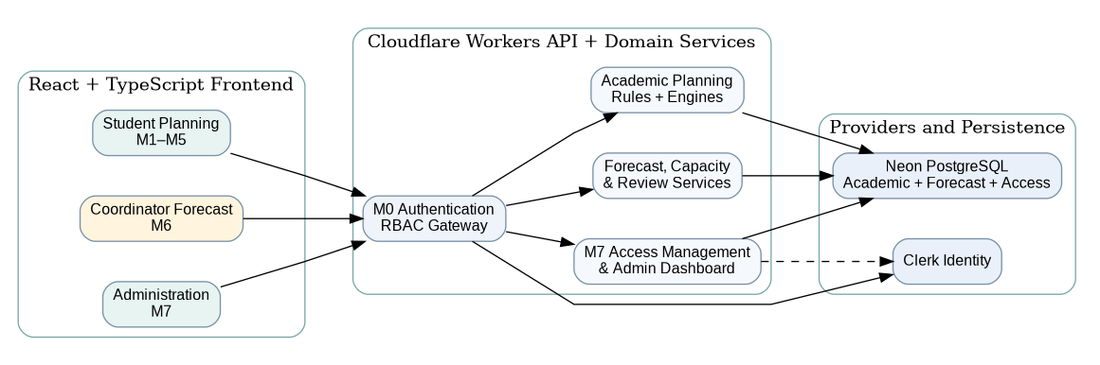
Figure 3.1: Component Diagram for the Revised Student, Coordinator and Administrator System
The diagram groups components into Frontend Application, Backend Application and External Services. Dependency arrows indicate services required by each component. They do not represent the direction of data transfer.

3.3 Academic Scheduling Architecture
The M5 planning engine schedules eligible subjects through Normal Semesters 1 and 2 and Short Semester 3, applying configured prerequisites, semester credit limits, subject availability assumptions and graduation requirements. Student interactions on the React Flow talent tree create temporary hypothetical plans and synchronized semester timelines. M6 separately uses dated imported academic snapshots and administrator-confirmed class capacity rules to propose next-semester class sections.

4.0 Detailed Description of Components

4.1 Complete Package Diagram
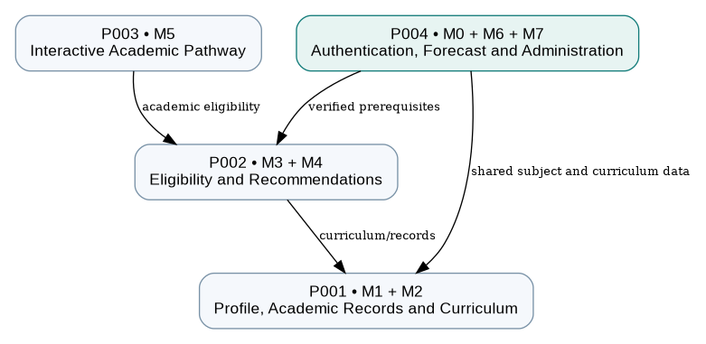
Figure 4.1: Complete Package Diagram — Four Implementation Subsystems

4.2 Detailed Description of Subsystems (P001–P004)
The technical sequence diagrams in this chapter show implementation-level interactions between the React frontend, Cloudflare Workers APIs, domain services, authentication and Neon PostgreSQL. User-oriented interaction flows remain in Chapter 2.

4.2.1 P001 — Student Profile and Curriculum Subsystem
The P001 Student Profile and Curriculum Subsystem comprises two functional modules: M1 Student Profile and Academic Progress Management, and M2 Curriculum, Prerequisite and Graduation Requirements Management.
The subsystem follows a layered architecture consisting of the Presentation Layer, Domain/Service Layer and Data Access Layer. The Presentation Layer provides student and administrator interfaces developed using React and TypeScript. The Domain/Service Layer handles business logic, academic record validation, credit progress calculations and curriculum management through Cloudflare Workers. The Data Access Layer manages persistent academic information in Neon PostgreSQL.
The subsystem uses the shared M0 Authentication and Account Management module for authenticated access and authorization. It also provides validated academic data and curriculum rules required by other subsystems, including subject recommendations and interactive academic planning.

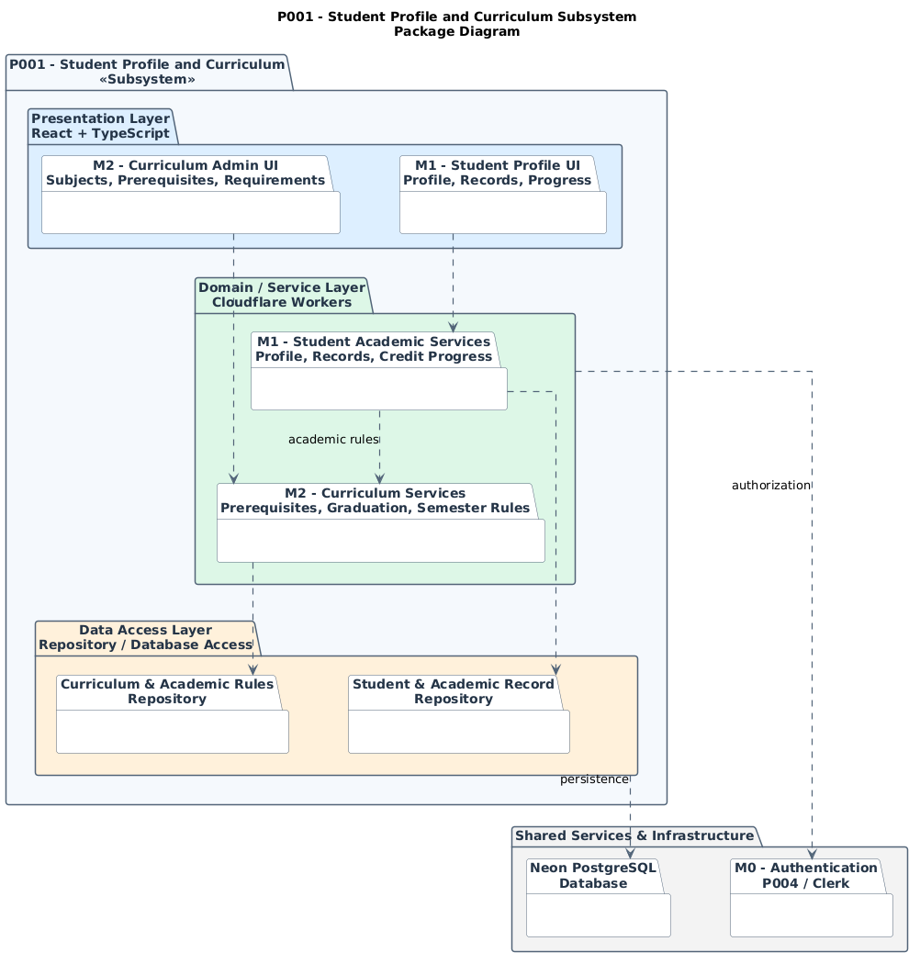
Package Diagram for Student Profile and Curriculum Subsystem
Figure 4.2: Package Diagram for Student Profile and Curriculum Subsystem

4.2.1.1 Class Diagram — Student Profile and Curriculum Subsystem
The P001 Class Diagram illustrates the principal entity, service, data transfer and repository classes involved in the Student Profile and Curriculum Subsystem. The M1 module manages student profiles, academic subject records and academic progress calculations, while the M2 module manages programme curricula, subjects, prerequisite relationships, semester restrictions and graduation requirements.
The StudentAcademicService coordinates academic profile and record management, while CreditProgressCalculator calculates academic progression using applicable curriculum requirements. CurriculumManagementService is responsible for maintaining and validating academic configurations. Repository interfaces separate business logic from persistent data access in Neon PostgreSQL.
The subsystem uses authenticated user information provided by M0 Authentication and Account Management, while authorization is enforced through the backend services.

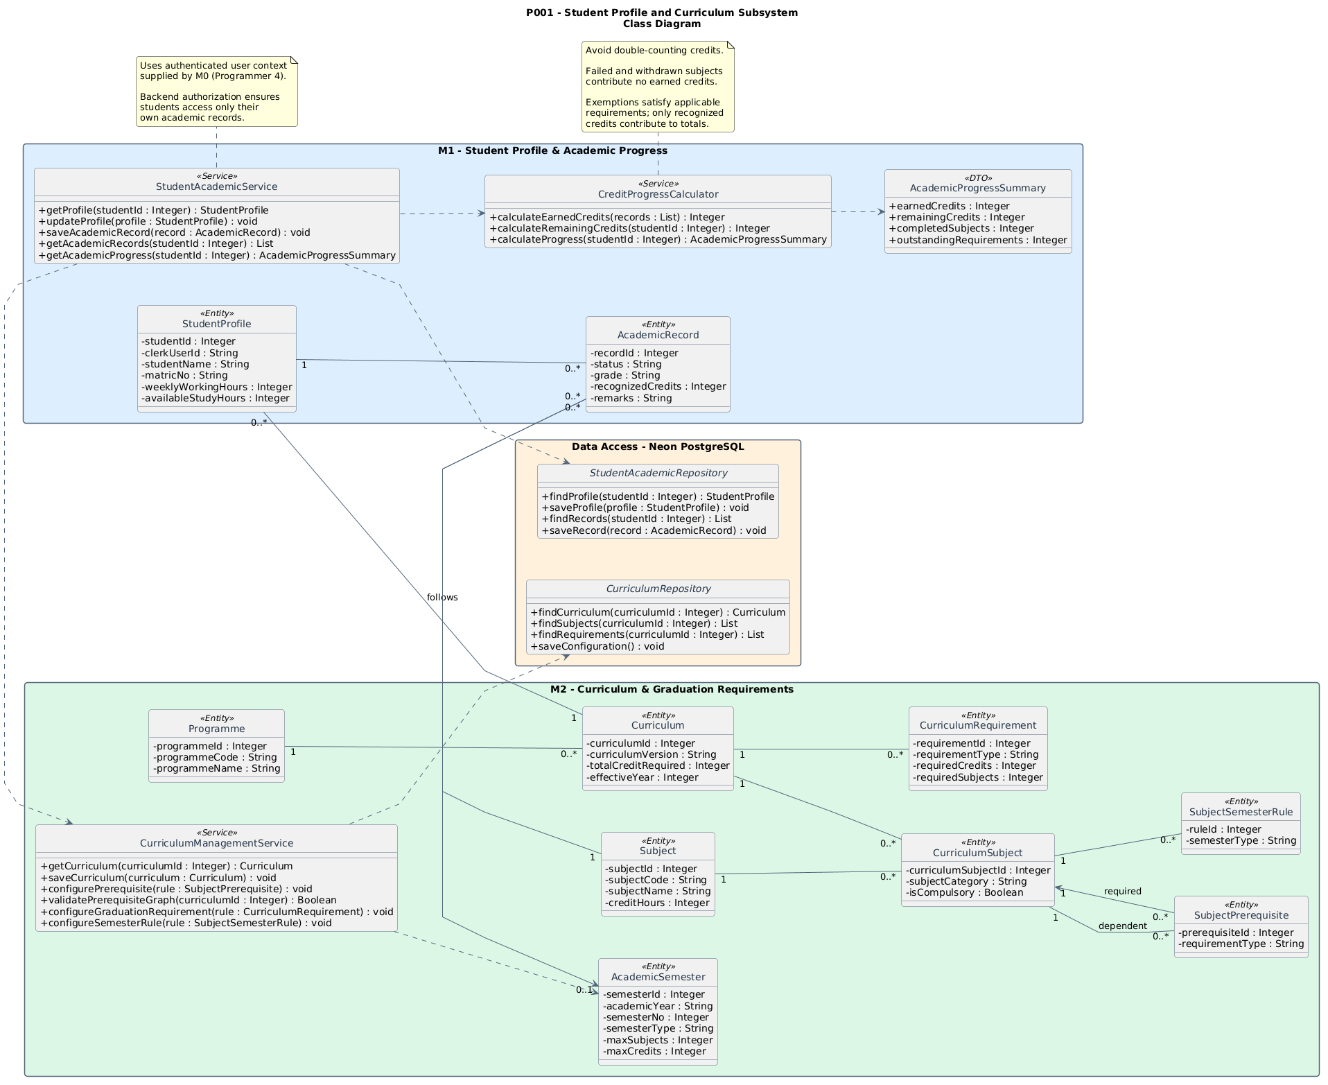
Class Diagram for Student Profile and Curriculum Subsystem
Figure 4.3: Class Diagram for Student Profile and Curriculum Subsystem

4.2.1.2 Technical Sequence Diagram — Student Profile and Curriculum (P001)
Key interactions: Maintain profile and subject history; Configure curriculum prerequisites and semester rules; Calculate recognized credits.
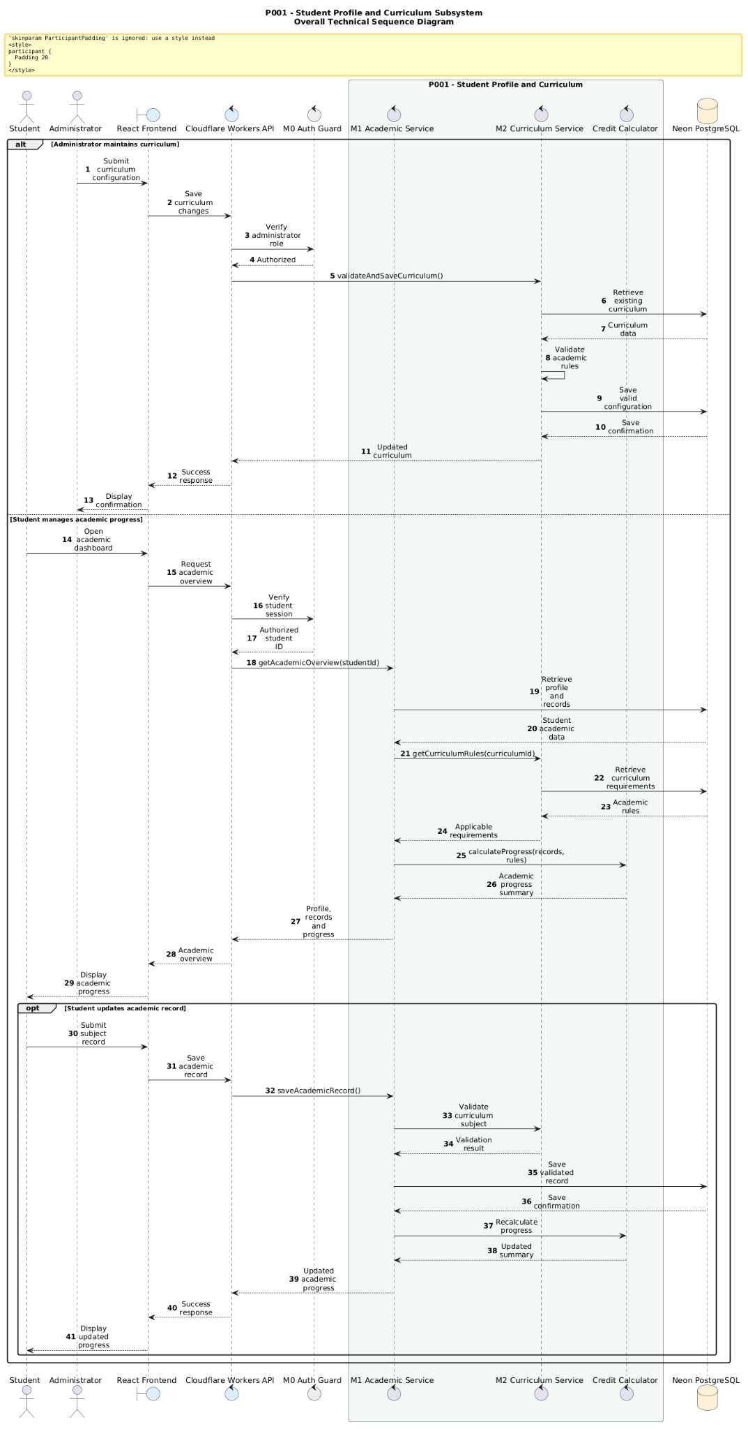
Overall Sequence Diagram for Student Profile and Curriculum Subsystem
Figure 4.4: Technical Sequence Diagram — Student Profile and Curriculum (P001)

4.2.2 P002 — Offering and Recommendation Subsystem
The P002 Offering and Recommendation Subsystem consists of two functional modules: M3 Semester Offering and Eligibility Management and M4 Intelligent Subject Recommendation.
The subsystem follows a layered architecture comprising the Presentation Layer, Domain/Service Layer and Data Access Layer. M3 manages student-entered semester subject offerings, validates subject eligibility and supports semester subject selection. M4 generates personalized subject recommendations using validated academic information, identifies potential academic bottlenecks and provides alternative subject recommendations.
The M4 Recommendation Services depend on eligibility results provided by M3. Both modules utilize student academic records and curriculum rules from P001, while authentication and authorization are provided through the shared M0 module. Persistent data is managed through repositories connected to Neon PostgreSQL.

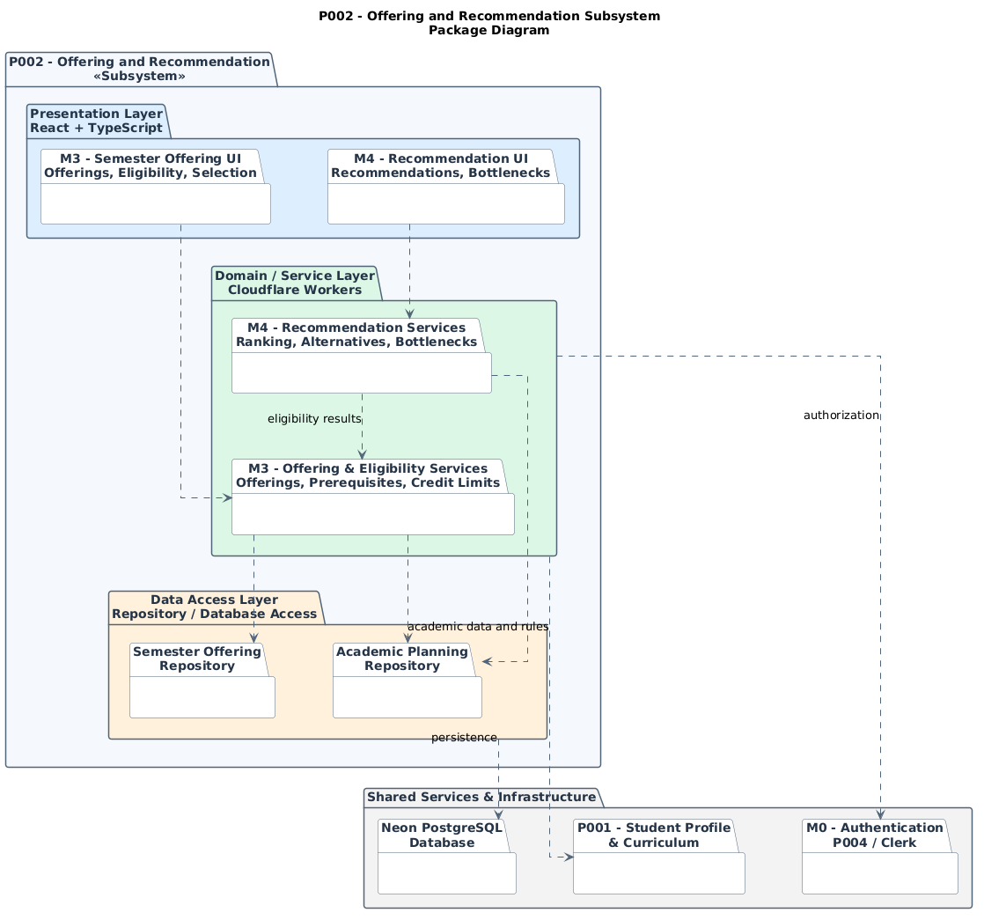
Package Diagram for Offering and Recommendation Subsystem
Figure 4.5: Package Diagram for Offering and Recommendation Subsystem

4.2.2.1 Class Diagram — Offering and Recommendation Subsystem
The P002 Class Diagram illustrates the main entity, service, repository and data transfer classes within the Offering and Recommendation Subsystem.
The M3 module manages student-entered semester subject offerings, evaluates subject eligibility based on academic records and curriculum rules, and validates semester subject selections against prerequisite and credit restrictions. SemesterOfferingService manages available subject information, SubjectEligibilityService performs academic eligibility validation, and SemesterSelectionService manages student subject selections.
The M4 module generates personalized subject recommendations using validated eligibility results and academic dependency information. RecommendationService ranks eligible subjects, while BottleneckAnalyzer identifies prerequisite bottlenecks and possible alternatives.
Both modules depend on student academic records and curriculum configurations provided by P001. Persistent semester offering and academic planning data are managed through repository interfaces connected to Neon PostgreSQL. Recommendation results are calculated dynamically and returned to the frontend for presentation.
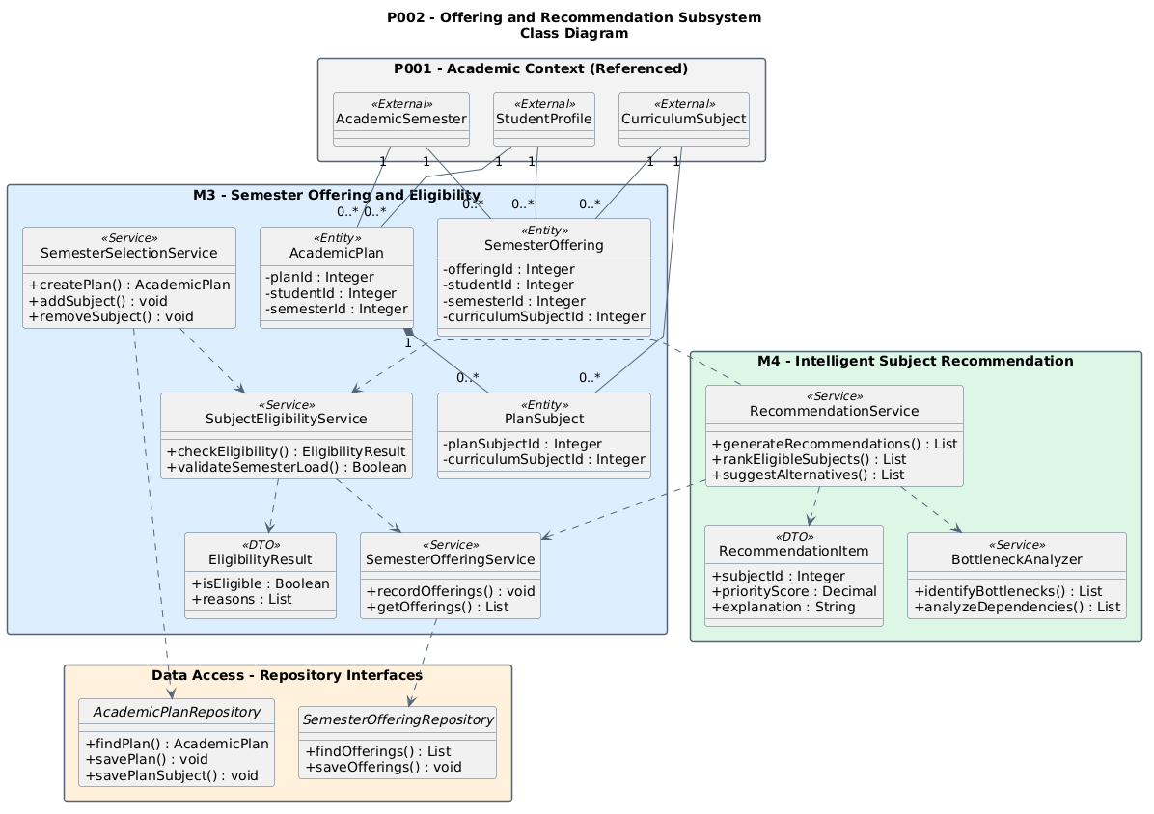
Class Diagram for Offering and Recommendation Subsystem
Figure 4.6: Class Diagram for Offering and Recommendation Subsystem

4.2.2.2 Technical Sequence Diagram — Offering and Recommendation (P002)
The sequence diagram illustrates the technical interaction between the M3 Semester Offering and Eligibility module and the M4 Intelligent Subject Recommendation module.
The process begins when a student submits the subjects offered during the current semester through the React frontend. The Cloudflare Workers backend validates the authenticated session and forwards the offering information to the M3 Offering Service for validation and storage.
When recommendations are requested, the backend retrieves the student's semester offerings and academic context from P001. The M3 Eligibility Service evaluates the offered subjects against prerequisite requirements, academic records and applicable semester rules.
The M4 Recommendation Service uses the validated eligibility results to generate ranked subject recommendations, identify academic bottlenecks and suggest alternatives. Students may subsequently select recommended subjects, subject to semester credit and subject-count restrictions. Valid selections are persisted in Neon PostgreSQL through the repository layer.

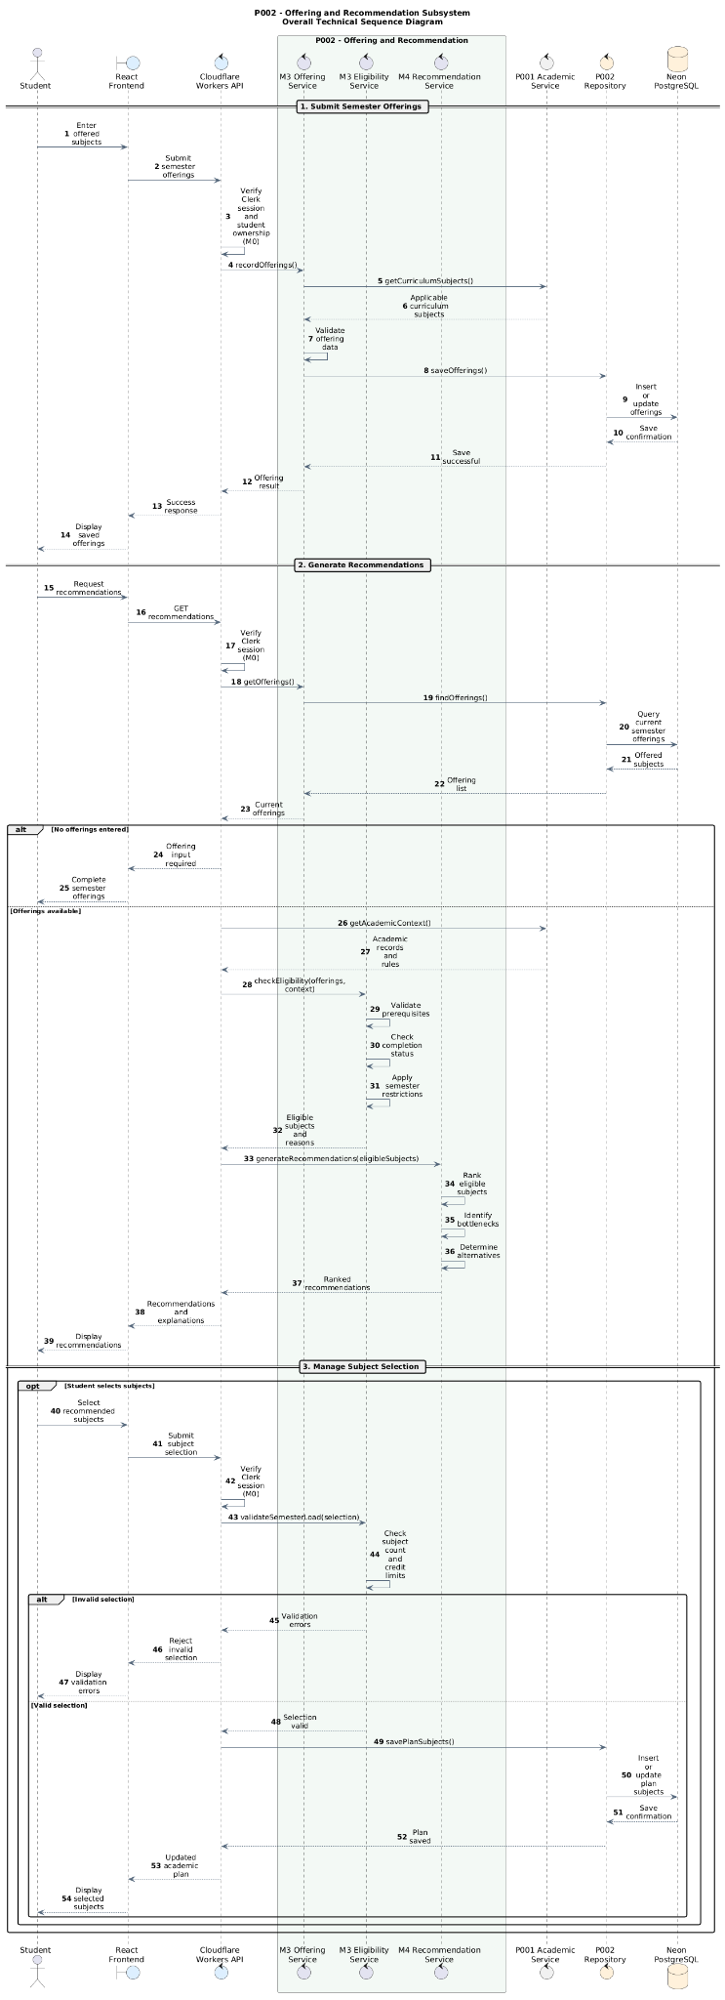
Sequence Diagram for Offering and Recommendation Subsystem
Figure 4.7: Technical Sequence Diagram — Offering and Recommendation (P002)

4.2.3 P003 — Interactive Academic Pathway Subsystem
The P003 subsystem implements the unified M5 Interactive Academic Pathway, combining theoretical graduation forecasting, interactive prerequisite talent-tree visualization and what-if semester planning into one student workflow.
Its React Flow presentation layer displays subject nodes, dependencies, selected scenario changes and semester-by-semester results. Cloudflare Workers services calculate eligible subject states and feasible schedules using shared curriculum and prerequisite rules.
The same deterministic pathway engine evaluates baseline and hypothetical choices; no simulation can overwrite actual student academic records. Future offerings remain assumptions when not officially confirmed.
P003 reuses academic records and curriculum configuration from P001 and validated eligibility capabilities from P002, with shared M0 authorization. Scenario and plan persistence uses Neon PostgreSQL.

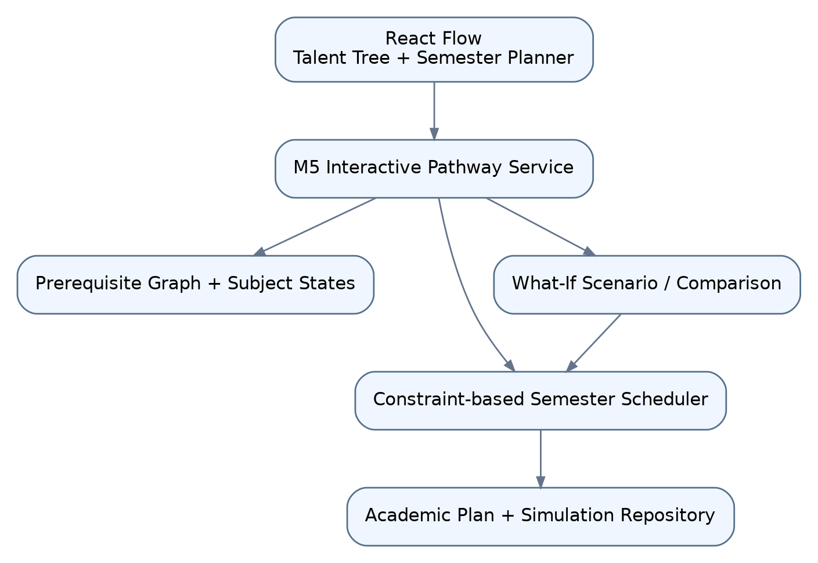

Figure 4.8: Package Diagram for Interactive Academic Pathway Subsystem

4.2.3.1 Class Diagram — M5 Interactive Academic Pathway
The M5 class model centers on InteractivePathwayView, PathwayService, PrerequisiteGraphService, SemesterSchedulingEngine, simulated scenario state and PathwayResult. The talent tree is a UI over validated academic rules, not an independent eligibility engine.
PathwayService generates the baseline semester plan and recalculates what-if subject selections. The scheduling engine applies prerequisites, subject-count and credit limits, permitted semester types and curriculum requirements.
The same service returns semester assignments and projected completion results to both the talent tree and the semester timeline.
SimulationScenario and SimulationSubject remain separate from student AcademicRecord. The system can compare baseline and hypothetical plans without overwriting recorded academic outcomes.
The engine uses shared curriculum and academic record repositories and labels unknown future offerings as assumptions.

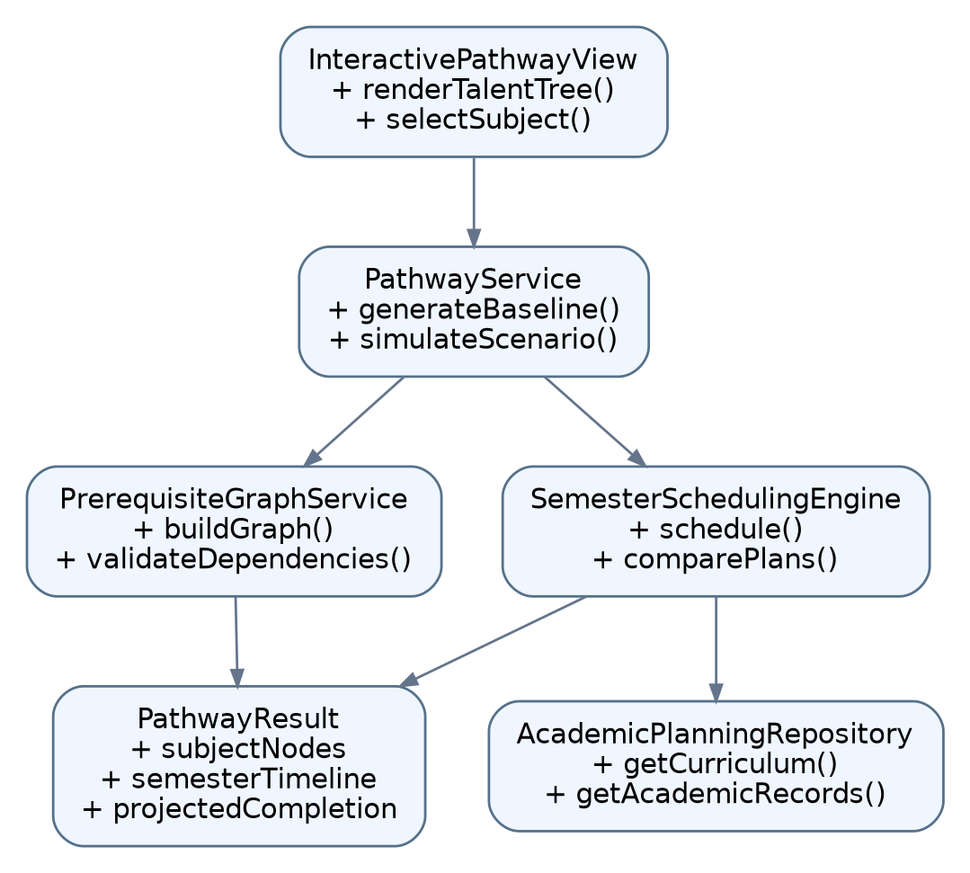

Figure 4.9: Class Diagram for Interactive Academic Pathway Subsystem

4.2.3.2 Technical Sequence Diagram — M5 Interactive Academic Pathway (P003)
The technical sequence illustrates opening the talent tree, retrieving the prerequisite graph and baseline plan, selecting a hypothetical subject action, validating the scenario and recalculating the synchronized semester timeline.
M5 retrieves the selected student academic history and curriculum rules, computes baseline eligibility and scheduling, then returns a graph of completed, available and locked subjects.
When a student selects a subject or postpones a planned node, the simulation service builds an isolated hypothetical state and calls the same academic scheduling engine. Invalid prerequisite or credit-limit choices return explainable warnings.
The response updates the talent-tree highlighting, semester assignments and projected graduation comparison. Resetting the scenario restores the baseline view and leaves actual academic records unchanged.

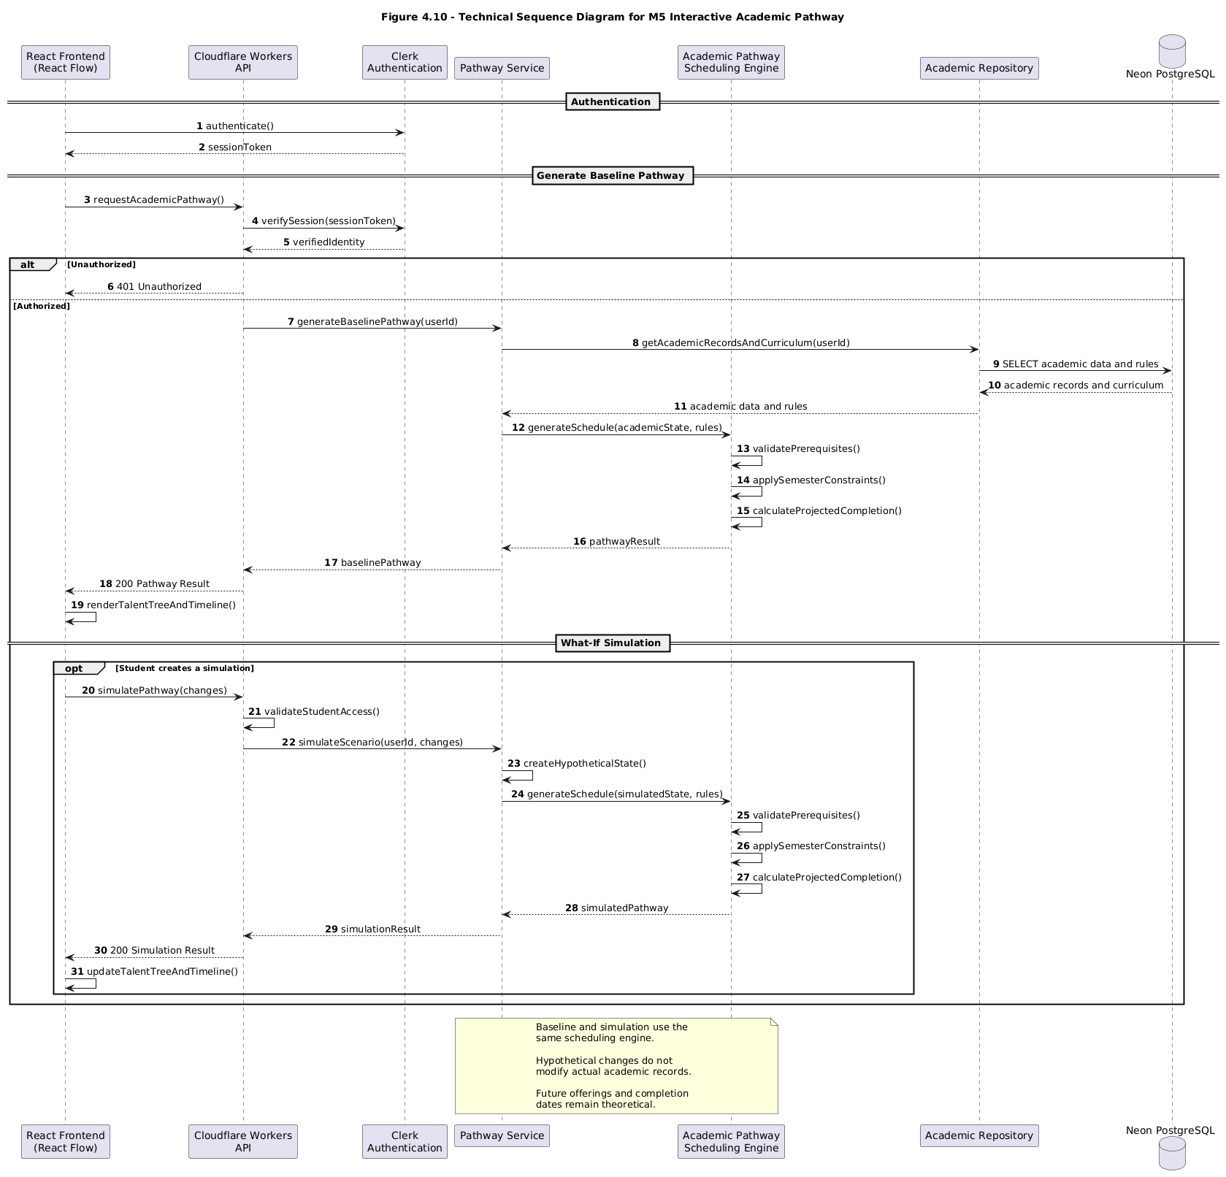
Figure 4.10: Technical Sequence Diagram — M5 Interactive Academic Pathway (P003)

4.2.4 P004 — Authentication, Forecast and Administration Subsystem
P004 contains M0 Authentication & Account Management, M6 Class Offering Forecast & Decision Dashboard, and M7 System Administration Dashboard & User Management. M0 uses Clerk-backed role checks. M6 keeps Academic Coordinator data separate from the student portal, and manages forecasts per learning centre and target semester.
The coordinator provides dated academic data about student cohorts and available subject histories. AcademicDataValidator checks required fields, duplicate records, subject-code mappings and source dates before forecasting.
M6 reuses shared Subject, Curriculum and prerequisite rules. It applies configurable class capacities, minimum enrollments and break-even references, excludes non-classroom subjects and flags proposed sections requiring review. Forecast calculations do not require an LLM.
The Academic Coordinator reviews low-demand and potentially graduation-critical proposals and records a decision and reason. Coordinator data stays separate from StudentProfile and AcademicRecord.
M6 also manages forecast versions. ForecastVersionService creates numbered, linked runs from current source snapshots and assumptions. The Coordinator Dashboard supports data refresh, draft reset, read-only finalized results and side-by-side comparison. DecisionAuditService records changes to proposed offering decisions; older versions are never silently overwritten.
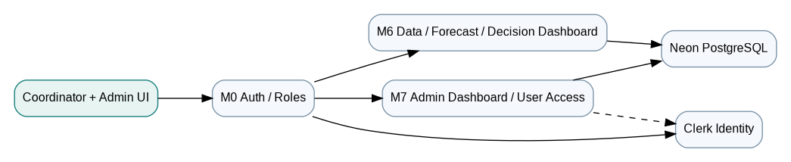
Figure 4.11: P004 Package Diagram — M0 Authentication, M6 Forecast and M7 Administration

4.2.4.1 Class Diagram — M0 Authentication, M6 Forecast and M7 Administration
The P004 class model separates authentication and authorization from academic-data validation, demand estimation, section optimization and forecast storage.
M0 validates Clerk sessions and protects all coordinator data routes with backend role checks. The independent M6 academic data provision is validated and normalized to shared Subject and Curriculum references.
SubjectDemandEstimator estimates demand only to the extent supported by the academic data. SectionOptimizer applies class capacities, minimum enrollment, break-even references and authorized exceptions.
ProposedClassSection records review status, reasons and decision metadata. Forecast results preserve the import batch, data source date, assumptions and capacity rule identifiers for reproducibility.
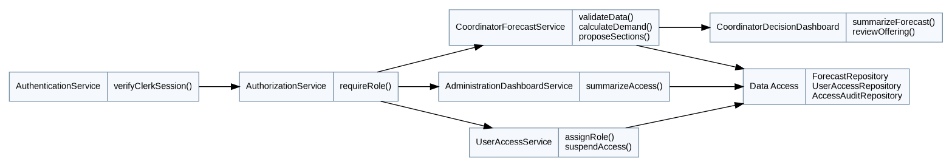
Figure 4.12: P004 Class Diagram — Authentication, Forecast and User Access Management

4.2.4.2 Technical Sequence Diagram — M0 Authentication and M6 Forecast Generation (P004)
The M0 workflow checks Clerk identity and coordinator access. M6 then validates provided data, estimates demand, proposes class sections and supports coordinator review.
After import, the backend validates subject codes against the shared master data, stores a dated source snapshot and reports unknown or missing histories instead of inventing subject eligibility.
M6 applies academic rules and class capacities to estimate next-semester demand. It excludes FYP1, FYP2 and Industrial Training from classroom-section proposals, then flags low-demand sections for review. Coordinator decisions are stored but do not publish official offerings.

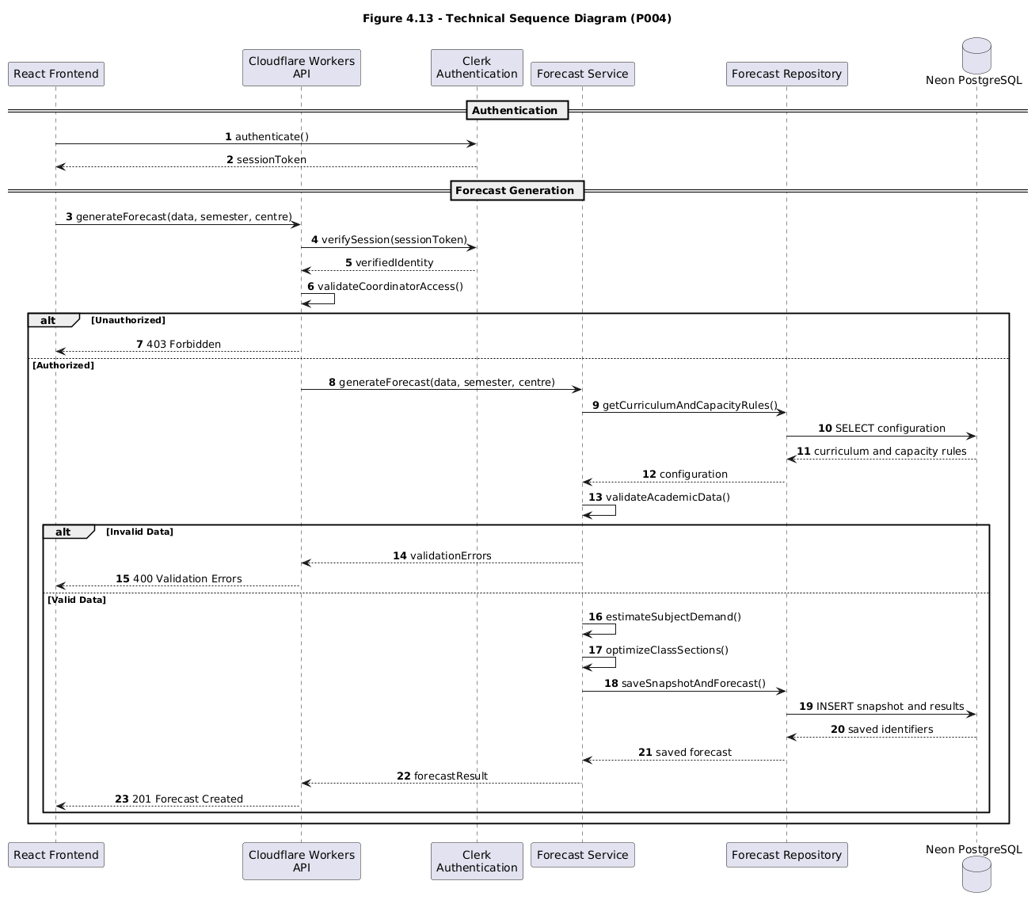
Figure 4.13: Technical Sequence Diagram — M0 Authentication and M6 Forecast Generation (P004)

4.2.4.3 M7 Administration Dashboard and User Management
M7 provides an administrator dashboard and Clerk-linked application role management. AdministrationDashboardService summarizes account status; UserAccessService manages role permissions; AuditAccessRepository records access changes. M7 does not expose coordinator academic histories without separate authorization.
Clerk handles authentication. Neon PostgreSQL stores application access assignments and audit events, not passwords. Backend safeguards prevent unauthorized privilege changes and removal of the final active System Administrator.
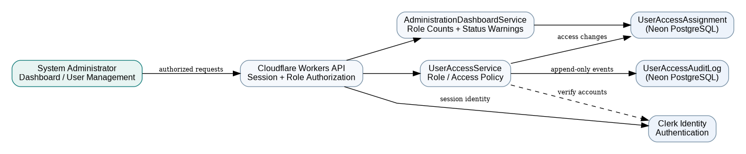
Figure 4.14: M7 Administration Dashboard and User Management Component Overview

4.2.4.4 M6 Forecast Version Management and Decision History
The dashboard retrieves ForecastRun history for the selected centre and semester. A data refresh creates a new AcademicImportBatch; reforecasting creates a linked ForecastRun instead of editing a finalized one. Resetting a draft restores saved values only. A comparison service calculates differences in source date, demand estimates, class sections and review flags. Decision changes are preserved as separate audit events.
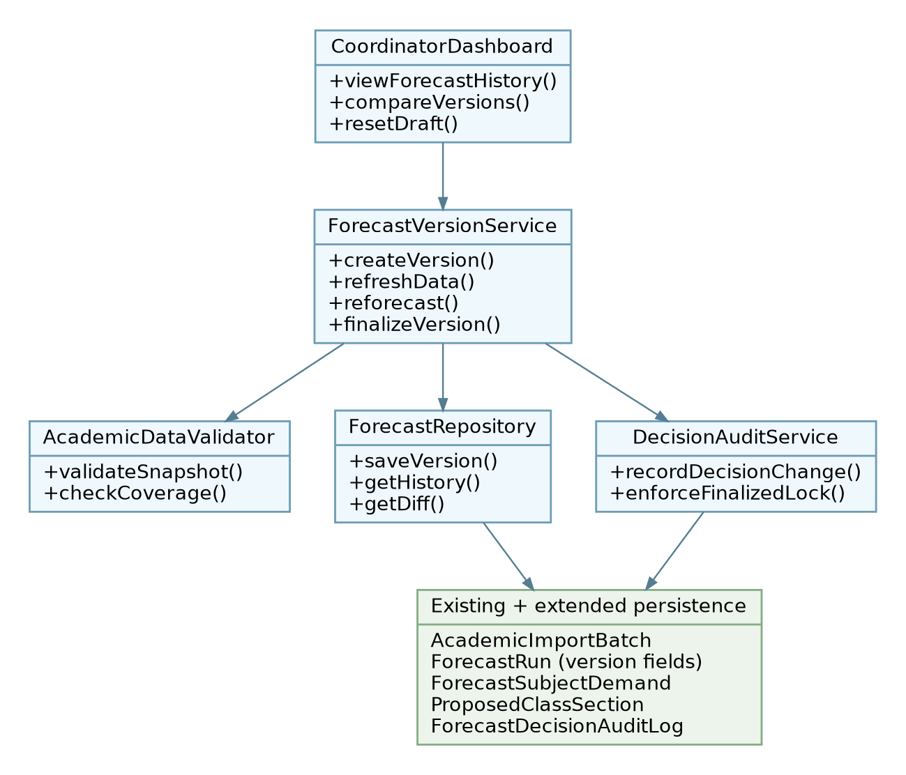
Figure 4.15: M6 Forecast Version Management — Component and Class Responsibilities

5.0 Data Design

5.1 Data Description
The data design contains 26 entities: 15 academic entities (Figure 5.1), nine coordinator-forecast entities (Figures 5.2 and 5.4) and two administrator-access entities (Figure 5.3). Subject and Curriculum are shared references; coordinator student data remains independent from the student portal. ForecastRun provides version lineage and ForecastDecisionAuditLog keeps decision history.
No. | Entity Name | Description
1 | Programme | Master record for degree programmes and their configuration status.
2 | Curriculum | Versioned programme curricula and total required graduation credits.
3 | Subject | Catalogue of academic subjects, their credit value and optional classifications.
4 | CurriculumSubject | Links subjects to curriculum versions and defines compulsory/category information.
5 | CurriculumRequirement | Graduation requirement groups, including credits and required-subject counts.
6 | SubjectPrerequisite | Curriculum-specific prerequisite, co-requisite or advisory subject relationships.
7 | SubjectSemesterRule | Specifies which semester type is permitted for a curriculum subject.
8 | AcademicSemester | Academic-year semesters and configured Normal/Short Semester limits.
9 | StudentProfile | Student academic identity, curriculum and self-reported study availability.
10 | AcademicRecord | Student-entered subject outcomes and credits recognized for progress calculations.
11 | SemesterOffering | Student-reported list of subjects offered in a particular academic semester.
12 | AcademicPlan | Saved proposed academic plans belonging to students.
13 | PlanSubject | Selected curriculum subjects and semester assignments within a proposed plan.
14 | SimulationScenario | Hypothetical planning scenarios kept separate from actual academic records.
15 | SimulationSubject | Individual hypothetical subject changes and proposed semester placements.
16 | LearningCentre | Academic learning centre identifier and code for independent coordinator cohorts.
17 | AcademicImportBatch | Metadata and provenance of the provided external academic data, dated snapshot and validation status.
18 | ImportedStudent | Imported student cohort linked to curriculum and batch (separate from StudentProfile).
19 | ImportedSubjectRecord | Imported completed/failed/in-progress/exempted subjects and provenance.
20 | ClassCapacityRule | Configurable minimum, break-even reference, lecture/lab capacity and exceptions.
21 | ForecastRun | Forecast generation parameters, source batch, assumptions and target semester.
22 | ForecastSubjectDemand | Subject-level expected demand, coverage and possible graduation-critical counts.
23 | ProposedClassSection | Optimized class sections, review flags and authorized decisions.
24 | UserAccessAssignment | Application-level Clerk-linked role and access-status mapping for the three user categories.
25 | UserAccessAuditLog | Append-only history of account-role and access-state changes by authorized administrators.
26 | ForecastDecisionAuditLog | Append-only coordinator decision history for proposed class sections, including previous status, new status, justification, reviewer and timestamp.

Table 5.1: Proposed Database Entities — Academic (15), Coordinator Forecast (9) and Administration (2)

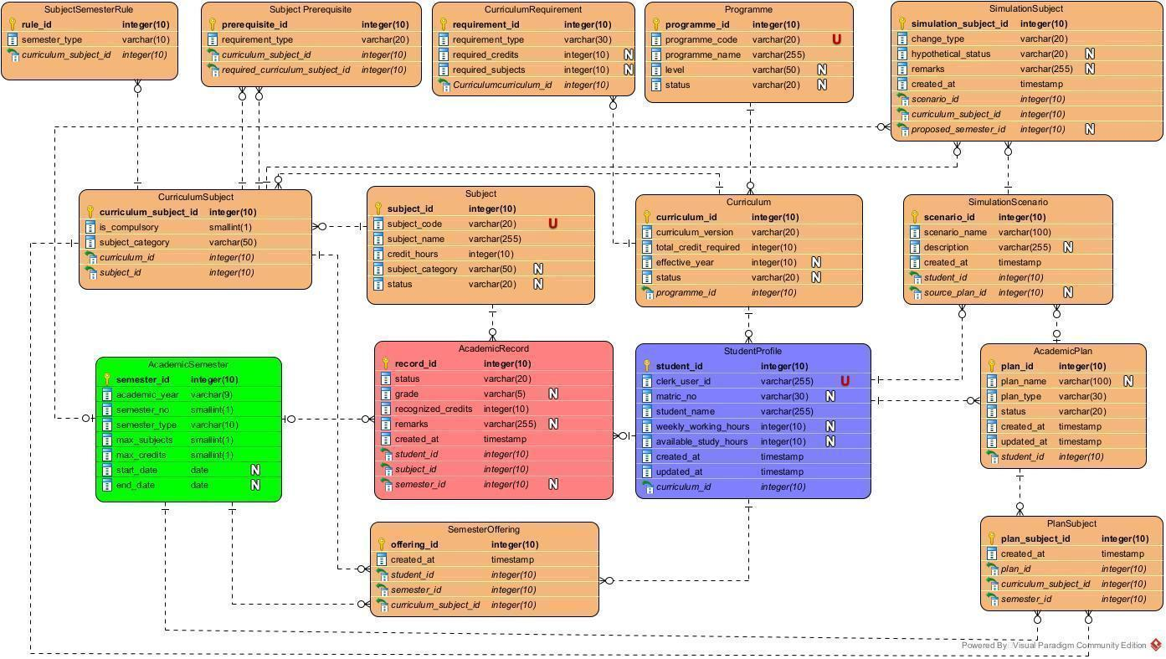
Entity Relationship Diagram (ERD)
Model programme/curriculum/subject tables, student records, semester configurations, proposed plans and hypothetical scenarios; include keys and cardinalities.
Figure 5.1: Existing Academic Core ERD (15 entities)
Figure 5.2: M6 Coordinator Data Provision and Forecast ERD Extension (8 new entities)
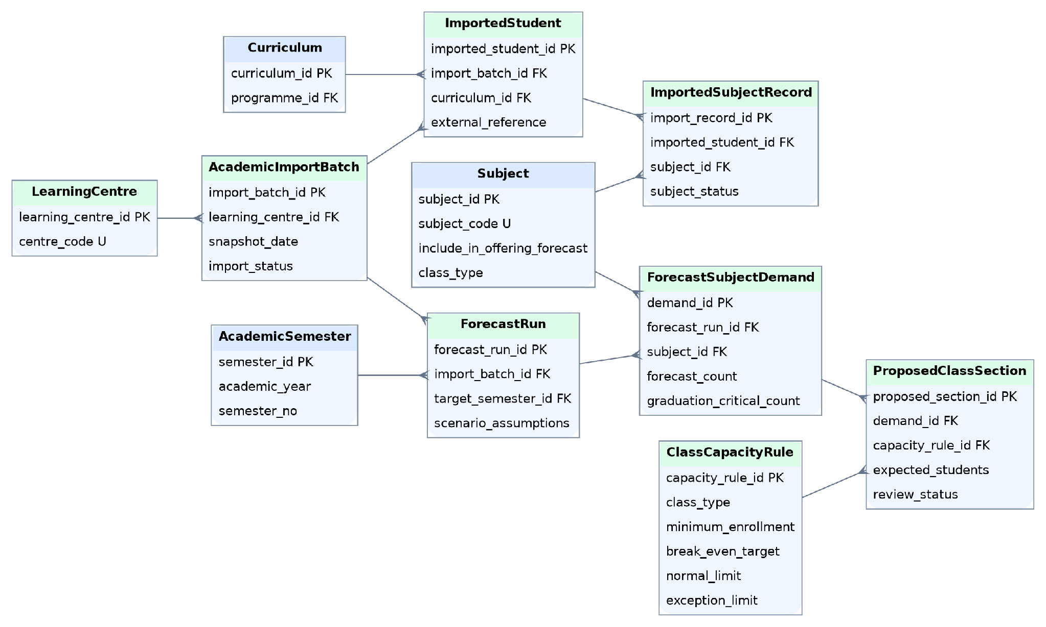

5.2 Data Dictionary
The data dictionary lists 26 proposed entities: 15 academic, nine coordinator-forecast and two administrator-access entities. PK = primary key; FK = foreign key; U = unique. Proposed fields and constraints remain subject to validation against actual permitted data sources.

5.2.1 Entity: Programme
Attribute Name | Type / Constraint | Description
programme_id | INTEGER; PK; NOT NULL | Unique programme identifier.
programme_code | VARCHAR(20); U; NOT NULL | Unique programme code.
programme_name | VARCHAR(255); NOT NULL | Official programme name.
level | VARCHAR(50); NULL | Optional qualification or programme level.
status | VARCHAR(20); NULL | Optional programme status.

5.2.2 Entity: Curriculum
Attribute Name | Type / Constraint | Description
curriculum_id | INTEGER; PK; NOT NULL | Unique curriculum version identifier.
curriculum_version | VARCHAR(20); NOT NULL | Version label for the curriculum.
total_credit_required | INTEGER; NOT NULL | Credit total needed for graduation under this curriculum.
effective_year | INTEGER; NULL | Optional year in which this curriculum takes effect.
status | VARCHAR(20); NULL | Optional curriculum status.
programme_id | INTEGER; FK; NOT NULL | Parent Programme.

5.2.3 Entity: Subject
Attribute Name | Type / Constraint | Description
subject_id | INTEGER; PK; NOT NULL | Unique subject identifier.
subject_code | VARCHAR(20); U; NOT NULL | Unique subject code in the current ERD.
subject_name | VARCHAR(255); NOT NULL | Subject title.
credit_hours | INTEGER; NOT NULL | Credit value assigned to the subject.
subject_category | VARCHAR(50); NULL | Optional subject category.
status | VARCHAR(20); NULL | Optional subject availability/status.
include_in_offering_forecast | BOOLEAN; NOT NULL; DEFAULT TRUE | Controls inclusion in M6 class-section recommendations; FALSE for FYP1, FYP2 and Industrial Training.
class_type | VARCHAR(20); NULL | LECTURE or LAB for M6 capacity rules; future combined teaching components may require a separate mapping.

5.2.4 Entity: CurriculumSubject
Attribute Name | Type / Constraint | Description
curriculum_subject_id | INTEGER; PK; NOT NULL | Identifier for the curriculum-subject mapping.
is_compulsory | SMALLINT; NOT NULL | Compulsory-subject flag (0 or 1 in the current ERD).
subject_category | VARCHAR(50); NOT NULL | Subject classification within the applicable curriculum.
curriculum_id | INTEGER; FK; NOT NULL | References Curriculum.
subject_id | INTEGER; FK; NOT NULL | References Subject.

5.2.5 Entity: CurriculumRequirement
Attribute Name | Type / Constraint | Description
requirement_id | INTEGER; PK; NOT NULL | Unique graduation requirement identifier.
requirement_type | VARCHAR(30); NOT NULL | Requirement category (e.g., compulsory or elective).
required_credits | INTEGER; NULL | Optional minimum credits for this requirement.
required_subjects | INTEGER; NULL | Optional minimum number of subjects in this requirement.
Curriculumcurriculum_id | INTEGER; FK; NOT NULL | References Curriculum; name retained exactly from the ERD.

5.2.6 Entity: SubjectPrerequisite
Attribute Name | Type / Constraint | Description
prerequisite_id | INTEGER; PK; NOT NULL | Unique dependency rule identifier.
requirement_type | VARCHAR(20); NOT NULL | Type of prerequisite or associated requirement.
curriculum_subject_id | INTEGER; FK; NOT NULL | Dependent CurriculumSubject.
required_curriculum_subject_id | INTEGER; FK; NOT NULL | Required or related CurriculumSubject.

5.2.7 Entity: SubjectSemesterRule
Attribute Name | Type / Constraint | Description
rule_id | INTEGER; PK; NOT NULL | Unique semester restriction rule.
semester_type | VARCHAR(10); NOT NULL | Allowed or configured semester type.
curriculum_subject_id | INTEGER; FK; NOT NULL | References the restricted CurriculumSubject.

5.2.8 Entity: AcademicSemester
Attribute Name | Type / Constraint | Description
semester_id | INTEGER; PK; NOT NULL | Unique academic semester identifier.
academic_year | VARCHAR(9); NOT NULL | Academic year label, e.g., 2026/2027.
semester_no | SMALLINT; NOT NULL | Semester number: 1, 2 or 3.
semester_type | VARCHAR(10); NOT NULL | NORMAL for 1/2 or SHORT for 3.
max_subjects | SMALLINT; NOT NULL | Configured subject-count limit for the semester.
max_credits | SMALLINT; NOT NULL | Configured credit limit for the semester.
start_date | DATE; NULL | Optional starting date of the semester.
end_date | DATE; NULL | Optional ending date of the semester.

5.2.9 Entity: StudentProfile
Attribute Name | Type / Constraint | Description
student_id | INTEGER; PK; NOT NULL | Internal academic student profile identifier.
clerk_user_id | VARCHAR(255); U; NOT NULL | Unique authenticated user identifier supplied by Clerk.
matric_no | VARCHAR(30); NULL | Optional student matriculation number.
student_name | VARCHAR(255); NOT NULL | Student display name.
weekly_working_hours | INTEGER; NULL | Optional self-reported weekly employment hours.
available_study_hours | INTEGER; NULL | Optional self-reported study time per week.
created_at | TIMESTAMP; NOT NULL | Date/time the profile was created.
updated_at | TIMESTAMP; NOT NULL | Date/time the profile was last updated.
curriculum_id | INTEGER; FK; NOT NULL | References the student's selected Curriculum.

5.2.10 Entity: AcademicRecord
Attribute Name | Type / Constraint | Description
record_id | INTEGER; PK; NOT NULL | Unique academic subject record identifier.
status | VARCHAR(20); NOT NULL | Subject status: completed, exempted, failed or withdrawn.
grade | VARCHAR(5); NULL | Optional subject grade.
recognized_credits | INTEGER; NOT NULL | Credits recognized for graduation; may be zero.
remarks | VARCHAR(255); NULL | Optional exemption or academic record notes.
created_at | TIMESTAMP; NOT NULL | Date/time this record was created.
student_id | INTEGER; FK; NOT NULL | References the owning StudentProfile.
subject_id | INTEGER; FK; NOT NULL | References Subject.
semester_id | INTEGER; FK, NULL | Optional reference to AcademicSemester.

5.2.11 Entity: SemesterOffering
Attribute Name | Type / Constraint | Description
offering_id | INTEGER; PK; NOT NULL | Unique semester-offering entry.
created_at | TIMESTAMP; NOT NULL | Date/time the reported offering was created.
student_id | INTEGER; FK; NOT NULL | Student who reported the offering.
semester_id | INTEGER; FK; NOT NULL | AcademicSemester to which the offering applies.
curriculum_subject_id | INTEGER; FK; NOT NULL | Offered CurriculumSubject.

5.2.12 Entity: AcademicPlan
Attribute Name | Type / Constraint | Description
plan_id | INTEGER; PK; NOT NULL | Unique academic plan identifier.
plan_name | VARCHAR(100); NULL | Optional name assigned to the plan.
plan_type | VARCHAR(30); NOT NULL | Plan type, such as student-selected or recommended.
status | VARCHAR(20); NOT NULL | Current plan state.
created_at | TIMESTAMP; NOT NULL | Date/time the plan was created.
updated_at | TIMESTAMP; NOT NULL | Date/time the plan was last updated.
student_id | INTEGER; FK; NOT NULL | References the owning StudentProfile.

5.2.13 Entity: PlanSubject
Attribute Name | Type / Constraint | Description
plan_subject_id | INTEGER; PK; NOT NULL | Unique selected-subject entry.
created_at | TIMESTAMP; NOT NULL | Date/time the plan-subject entry was created.
plan_id | INTEGER; FK; NOT NULL | References AcademicPlan.
curriculum_subject_id | INTEGER; FK; NOT NULL | References the selected CurriculumSubject.
semester_id | INTEGER; FK; NOT NULL | References AcademicSemester for the planned subject.

5.2.14 Entity: SimulationScenario
Attribute Name | Type / Constraint | Description
scenario_id | INTEGER; PK; NOT NULL | Unique simulation scenario identifier.
scenario_name | VARCHAR(100); NOT NULL | Name of the hypothetical scenario.
description | VARCHAR(255); NULL | Optional scenario description.
created_at | TIMESTAMP; NOT NULL | Date/time scenario was created.
student_id | INTEGER; FK; NOT NULL | References the owning StudentProfile.
source_plan_id | INTEGER; FK, NULL | Optional baseline AcademicPlan used for comparison.

5.2.15 Entity: SimulationSubject
Attribute Name | Type / Constraint | Description
simulation_subject_id | INTEGER; PK; NOT NULL | Unique simulated subject-change identifier.
change_type | VARCHAR(20); NOT NULL | Type of simulated academic change.
hypothetical_status | VARCHAR(20); NULL | Optional assumed academic subject status.
remarks | VARCHAR(255); NULL | Optional explanation of the hypothetical change.
created_at | TIMESTAMP; NOT NULL | Date/time simulated change was created.
scenario_id | INTEGER; FK; NOT NULL | References the owning SimulationScenario.
curriculum_subject_id | INTEGER; FK; NOT NULL | References the affected CurriculumSubject.
proposed_semester_id | INTEGER; FK, NULL | Optional AcademicSemester proposed for the change.

5.2.16 Entity: LearningCentre
Attribute Name | Type / Constraint | Description
learning_centre_id | INTEGER; PK | Unique learning centre
centre_code | VARCHAR(10); U | Centre code (KL/JB/PP)
centre_name | VARCHAR(100) | Centre name

5.2.17 Entity: AcademicImportBatch
Attribute Name | Type / Constraint | Description
import_batch_id | INTEGER; PK | Provided academic data batch
learning_centre_id | INTEGER; FK | Learning centre
snapshot_date | DATE | Date source data was current
provided_by | VARCHAR(255) | Clerk coordinator identifier
source_label | VARCHAR(255) | Origin and description of provided academic data
import_status | VARCHAR(20) | Validation state
provided_at | TIMESTAMP | Data provision time

5.2.18 Entity: ImportedStudent
Attribute Name | Type / Constraint | Description
imported_student_id | INTEGER; PK | Cohort row identifier
import_batch_id | INTEGER; FK | Parent import batch
curriculum_id | INTEGER; FK | Shared curriculum
external_reference | VARCHAR(100) | Source student reference; protect identifiers
cohort_status | VARCHAR(20) | Continuing/deferred/expected graduate

5.2.19 Entity: ImportedSubjectRecord
Attribute Name | Type / Constraint | Description
import_record_id | INTEGER; PK | Imported subject history row
imported_student_id | INTEGER; FK | Owning imported student
subject_id | INTEGER; FK | Shared subject catalogue
subject_status | VARCHAR(20) | Completed/failed/in progress/exempted
semester_id | INTEGER; FK, NULL | Academic period if supplied
is_synthetic | BOOLEAN | Distinguish generated histories from real source records

5.2.20 Entity: ClassCapacityRule
Attribute Name | Type / Constraint | Description
capacity_rule_id | INTEGER; PK | Capacity rule identifier
class_type | VARCHAR(20) | LAB or LECTURE
minimum_enrollment | INTEGER | Working minimum (e.g., 15; configurable)
break_even_target | INTEGER | Financial reference (e.g., 25; provisional)
normal_maximum | INTEGER | Standard capacity (e.g., lab 30, lecture 40)
exception_maximum | INTEGER; NULL | Approved exception capacity (e.g., lab 35)
is_active | BOOLEAN | Whether rule is currently in force

5.2.21 Entity: ForecastRun
Attribute Name | Type / Constraint | Description
forecast_run_id | INTEGER; PK | Forecast identifier
import_batch_id | INTEGER; FK | Source academic data snapshot
target_semester_id | INTEGER; FK | Proposed next semester
scenario_assumptions | JSONB | Assumed pass rates and uncertain data handling
generated_by | VARCHAR(255) | Coordinator Clerk identifier
generated_at | TIMESTAMP | Forecast time
status | VARCHAR(20) | Draft / Under Review / Finalized / Superseded / Archived
learning_centre_id | INTEGER; FK | Centre for version-number uniqueness and filtering
version_number | INTEGER; NOT NULL | Unique with learning_centre_id and target_semester_id
parent_forecast_run_id | INTEGER; FK, NULL | Previous version; nullable for first run
finalized_by | VARCHAR(255); NULL | Coordinator who finalized this version
finalized_at | TIMESTAMP; NULL | Finalization time; locks stored results and decisions

5.2.22 Entity: ForecastSubjectDemand
Attribute Name | Type / Constraint | Description
demand_id | INTEGER; PK | Subject-level forecast identifier
forecast_run_id | INTEGER; FK | Parent forecast
subject_id | INTEGER; FK | Shared Subject
eligible_count | INTEGER; NULL | Verified count if sufficient data exists
forecast_count | INTEGER; NULL | Estimated next-semester enrollment
graduation_critical_count | INTEGER; NULL | Confirmed/projection-based urgency, nullable
data_quality_status | VARCHAR(30) | Validated/preliminary/insufficient

5.2.23 Entity: ProposedClassSection
Attribute Name | Type / Constraint | Description
proposed_section_id | INTEGER; PK | Proposed section
demand_id | INTEGER; FK | Subject demand entry
capacity_rule_id | INTEGER; FK | Applied capacity policy
section_number | SMALLINT | Section number
expected_students | INTEGER | Expected enrollment in section
review_status | VARCHAR(30) | Current section review status; all changes are recorded in ForecastDecisionAuditLog
justification | TEXT; NULL | Coordinator review reason
reviewed_by | VARCHAR(255); NULL | Clerk reviewer
reviewed_at | TIMESTAMP; NULL | Review time
The proposed schema retains the current CurriculumRequirement foreign-key name, Curriculumcurriculum_id, pending migration review. Before implementation, verify coordinator source fields, applicable policies and migrations. Keep source dates, role controls and real/synthetic data labels.

5.2.24 Entity: UserAccessAssignment
Attribute Name | Type / Constraint | Description
access_assignment_id | INTEGER; PK | Unique application authorization mapping.
clerk_user_id | VARCHAR(255); U; NOT NULL | Clerk identity reference; application stores no password.
app_role | VARCHAR(30); NOT NULL | STUDENT, COORDINATOR or SYSTEM_ADMIN.
access_status | VARCHAR(20); NOT NULL | ACTIVE or SUSPENDED.
created_at | TIMESTAMP; NOT NULL | Assignment creation timestamp.
updated_at | TIMESTAMP; NOT NULL | Last application-access update.

5.2.25 Entity: UserAccessAuditLog
Attribute Name | Type / Constraint | Description
access_audit_id | INTEGER; PK | Unique immutable audit event.
access_assignment_id | INTEGER; FK; NOT NULL | Account access record whose role or status changed.
performed_by_clerk_user_id | VARCHAR(255); NOT NULL | Clerk identity of authorized administrator.
change_type | VARCHAR(30); NOT NULL | ROLE_CHANGE or ACCESS_STATUS_CHANGE.
old_value | VARCHAR(50); NULL | Previous role or status.
new_value | VARCHAR(50); NOT NULL | Applied new role or status.
reason | TEXT; NULL | Optional administrative justification.
created_at | TIMESTAMP; NOT NULL | Event timestamp.

5.2.26 Entity: ForecastDecisionAuditLog
Attribute Name | Type / Constraint | Description
decision_audit_id | INTEGER; PK | Unique, append-only decision event
proposed_section_id | INTEGER; FK; NOT NULL | Proposed section whose decision changed
action_type | VARCHAR(30); NOT NULL | REVIEW / APPROVE / DEFER / REOPEN / FINALIZE
old_status | VARCHAR(30); NULL | Previous review status, if any
new_status | VARCHAR(30); NOT NULL | New review status
reason | TEXT; NULL | Coordinator explanation or justification
recorded_by | VARCHAR(255); NOT NULL | Authorized Clerk coordinator identifier
recorded_at | TIMESTAMP; NOT NULL | Immutable event timestamp
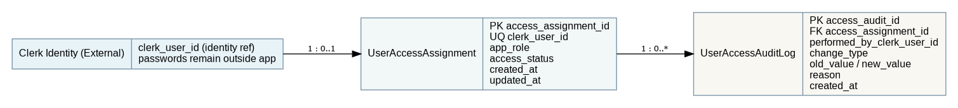
Figure 5.3: M7 User Access Assignment and Audit Log ERD Extension
Forecast versioning extends ForecastRun and introduces an append-only ForecastDecisionAuditLog. Historical runs and source snapshots are retained; version numbers are unique per learning centre and target semester. The existing coordinator ERD (Figure 5.2) remains the base design.
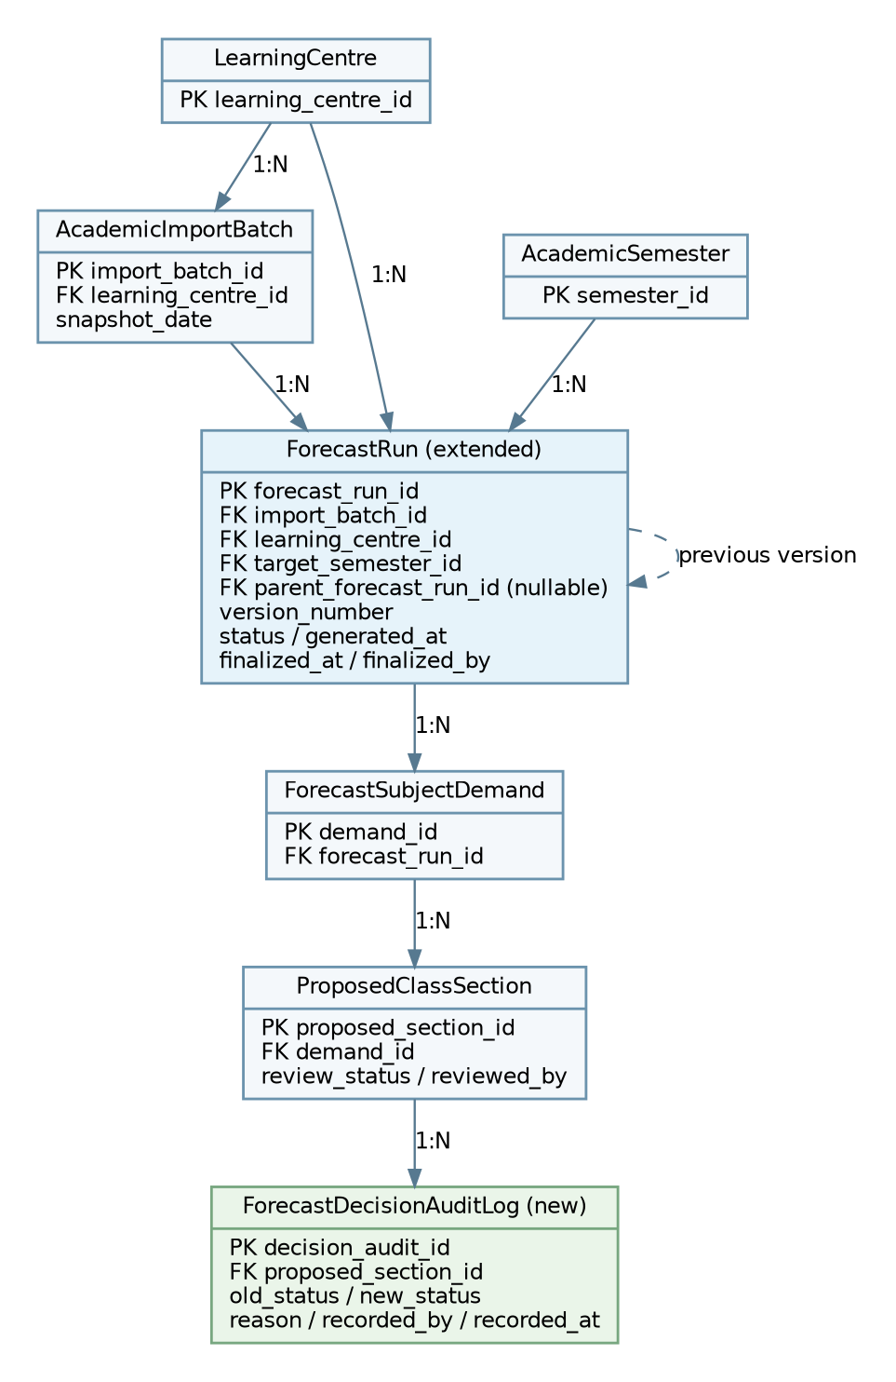
Figure 5.4: M6 Forecast Versioning and Decision Audit ERD Extension

6.0 Requirements Traceability Matrix

6.1 Functional Requirement Traceability
This matrix maps all 58 functional requirements to 23 use cases and the four development subsystems. Detailed test cases belong in the later System Testing Document. Existing requirement IDs are preserved; new forecast lifecycle requirements are FR-H10–FR-H14.
Requirement ID | Use Case(s) | Subsystem | Priority | Design / Verification Status
FR-A1 | UC1 | P004 (M0) | M | Pending VP design / planned test
FR-A2 | UC2 | P004 (M0) | M | Pending VP design / planned test
FR-A3 | UC3 | P001 | M | Pending VP design / planned test
FR-A4 | UC4 | P001 | M | Pending VP design / planned test
FR-A5 | UC5 | P001 | M | Pending VP design / planned test
FR-B1 | UC6 | P001 | M | Pending VP design / planned test
FR-B2 | UC6 | P001 | M | Pending VP design / planned test
FR-B3 | UC7 | P001 | M | Pending VP design / planned test
FR-B4 | UC6 | P001 | S | Pending VP design / planned test
FR-B5 | UC6 | P001 | M | Pending VP design / planned test
FR-B6 | UC7 | P001 | M | Pending VP design / planned test
FR-B7 | UC6 | P001 | M | Pending VP design / planned test
FR-C1 | UC8 | P002 | M | Pending VP design / planned test
FR-C2 | UC9 | P002 | M | Pending VP design / planned test
FR-C3 | UC10 | P002 | M | Pending VP design / planned test
FR-C4 | UC10 | P002 | M | Pending VP design / planned test
FR-C5 | UC9 | P002 | M | Pending VP design / planned test
FR-D1 | UC11 | P002 | M | Pending VP design / planned test
FR-D2 | UC11 | P002 | M | Pending VP design / planned test
FR-D3 | UC12 | P002 | M | Pending VP design / planned test
FR-D4 | UC12 | P002 | M | Pending VP design / planned test
FR-D5 | UC11 | P002 | S | Pending VP design / planned test
FR-D6 | UC11 | P002 | M | Pending VP design / planned test
FR-E1 | UC13 | P003 | M | Pending VP design / planned test
FR-E2 | UC14 | P003 | M | Pending VP design / planned test
FR-E3 | UC14 | P003 | M | Pending VP design / planned test
FR-E4 | UC14 | P003 | M | Pending VP design / planned test
FR-E5 | UC14 | P003 | M | Pending VP design / planned test
FR-E6 | UC14 | P003 | M | Pending VP design / planned test
FR-F1 | UC15 | P003 | M | Pending VP design / planned test
FR-F2 | UC15 | P003 | M | Pending VP design / planned test
FR-F3 | UC16 | P003 | M | Pending VP design / planned test
FR-F4 | UC16 | P003 | M | Pending VP design / planned test
FR-F5 | UC15 | P003 | M | Pending VP design / planned test
FR-G1 | UC17 | P003 (M5) | M | Pending VP design / planned test
FR-G2 | UC17 | P003 (M5) | M | Pending VP design / planned test
FR-G3 | UC18 | P003 (M5) | M | Pending VP design / planned test
FR-G4 | UC19 | P003 (M5) | M | Pending VP design / planned test
FR-H1 | UC20 | P004 (M6) | M | Pending VP design / planned test
FR-H2 | UC20 | P004 (M6) | M | Pending VP design / planned test
FR-H3 | UC20 | P004 (M6) | M | Pending VP design / planned test
FR-H4 | UC20 | P004 (M6) | M | Pending VP design / planned test
FR-H5 | UC20 | P004 (M6) | M | Pending VP design / planned test
FR-H6 | UC20 | P004 (M6) | M | Pending VP design / planned test
FR-H7 | UC20 | P004 (M6) | M | Pending VP design / planned test
FR-H8 | UC20 | P004 (M6) | M | Revised M6 design / planned test
FR-H9 | UC20 | P004 (M6) | M | Revised M6 design / planned test
FR-H10 | UC23 | P004 (M6) | M | New forecast-version design / planned test
FR-H11 | UC23 | P004 (M6) | M | New forecast-version design / planned test
FR-H12 | UC23 | P004 (M6) | M | New forecast-version design / planned test
FR-H13 | UC23 | P004 (M6) | M | New forecast-version design / planned test
FR-H14 | UC23 | P004 (M6) | M | New forecast-version design / planned test
FR-I1 | UC21 | P004 (M7) | M | Proposed M7 design / planned test
FR-I2 | UC22 | P004 (M7) | M | Proposed M7 design / planned test
FR-I3 | UC22 | P004 (M7) | M | Proposed M7 design / planned test
FR-I4 | UC22 | P004 (M7) | M | Proposed M7 design / planned test
FR-I5 | UC22 | P004 (M7) | M | Proposed M7 design / planned test
FR-I6 | UC21, UC22 | P004 (M7) | M | Proposed M7 design / planned test

Table 6.1: Functional Requirements Traceability Matrix

6.2 Visual Paradigm Diagram Register
Diagram | Expected Model | Status
Figure 2.1(a)–(c) | Three system use case views, UC01–UC20 (includes M0) | UC01–UC20 retain their original figure views; UC21–UC22 appear in Figure 2.17 and UC23 is shown in Figures 2.18–2.20.
Figure 2.2 | Domain model | Shared Subject and Curriculum model retained; coordinator and administrator extensions appear in Figures 5.2 and 5.3.
Figure 3.1 | UML Component Diagram — frontend/backend/external | Includes coordinator data provision and class forecasting, plus M7 administration services; student assessment removed.
Figure 4.1 | Complete package diagram — P001–P004 | P003 = M5; P004 = M0, M6 and M7. Forecast versioning extends M6 in Figure 4.15.
Figures 4.2–4.13 | Four subsystem package/class/sequence models (P004 covers M0/M6/M7) | P003 = M5; P004 = M0, M6 and M7. Package, class and sequence views cover all four subsystems.
Figure 5.1 | Logical database ERD | Figures 5.1–5.3 preserve academic, coordinator and administrator models; Figure 5.4 adds M6 forecast versioning and decision audit relationships.
Selected Figures 2.x | Activity and sequence diagrams for key use cases | UC20 covers initial data provision and forecasting; UC23 adds version history, refresh, draft reset and comparison activity/sequence diagrams.
Figure 2.17 | M7 System Administrator Use Case Diagram | UC01–UC20 retain their original figure views; UC21–UC22 appear in Figure 2.17 and UC23 is shown in Figures 2.18–2.20.
Figure 4.14 | M7 Administration Component/Sequence Overview | P004 additional M7 services, Clerk identity and app role/audit repositories.
Figure 5.3 | Administrator Authorization ERD Extension | UserAccessAssignment and UserAccessAuditLog linked to external Clerk identity.
Figures 2.18–2.20 | UC23 use case, activity and sequence diagrams | Coordinator refresh/reforecast, safe draft reset, historical comparison and immutable finalized runs.
Figure 4.15 | M6 Forecast Version Management classes | ForecastVersionService, CoordinatorDashboard, repository, validator and decision audit responsibilities.
Figure 5.4 | M6 Forecast Versioning ERD Extension | Existing ForecastRun extended with version lineage and status; new ForecastDecisionAuditLog stores decision changes.

Revised diagrams for the 2026 scope are included. Figures 2.18–2.20, 4.15 and 5.4 extend M6 forecast lifecycle and decision audit design; source models may be finalized in Visual Paradigm. Existing P001/P002 and M5 diagrams are retained.

Appendix A — Individual Use Case Diagram Checklist
This checklist tracks the dedicated use case diagrams for UC01–UC23. Grouped overview diagrams remain supplementary and do not replace the individual use case diagrams.
Current inventory: individual use case diagrams have been inserted for UC01–UC23. All 23 use cases have activity and sequence diagram subsections. The diagrams remain subject to final accuracy and legibility review.
UC | Use Case | Existing group diagram | Activity / Sequence | Dedicated diagram
UC01 | Register Account | Fig. 2.1(a) | Both present | Inserted (review)
UC02 | Login / Logout | Fig. 2.1(a) | Both present | Inserted (review)
UC03 | Manage Academic Profile | Fig. 2.1(a) | Both present | Inserted (review)
UC04 | Manage Academic Subject Records | Fig. 2.1(a) | Both present | Inserted (review)
UC05 | View Academic Progress | Fig. 2.1(a) | Both present | Inserted (review)
UC06 | Manage Curriculum and Prerequisites | Fig. 2.1(a) | Both present | Inserted (review)
UC07 | Manage Graduation Requirements | Fig. 2.1(a) | Both present | Inserted (review)
UC08 | Enter Semester Subject Offerings | Fig. 2.1(b) | Both present | Inserted (review)
UC09 | Check Subject Eligibility | Fig. 2.1(b) | Both present | Inserted (review)
UC10 | Manage Semester Subject Selection | Fig. 2.1(b) | Both present | Inserted (review)
UC11 | Generate Intelligent Subject Recommendations | Fig. 2.1(b) | Both present | Inserted (review)
UC12 | View Academic Bottlenecks and Alternative Recommendations | Fig. 2.1(b) | Both present | Inserted (review)
UC13 | Check Graduation Eligibility | Fig. 2.1(b) | Both present | Inserted (review)
UC14 | Generate Projected Academic Pathway | Fig. 2.1(b) | Both present | Inserted (review)
UC15 | Simulate Subject Choices in Interactive Pathway | Fig. 2.1(c) | Both present | Inserted (review)
UC16 | Compare and Reset Pathway Scenarios | Fig. 2.1(c) | Both present | Inserted (review)
UC17 | View Interactive Academic Pathway | Fig. 2.1(c) | Both present | Inserted (review)
UC18 | Explore Subject Dependencies | Fig. 2.1(c) | Both present | Inserted (review)
UC19 | View Projected Semester Roadmap | Fig. 2.1(c) | Both present | Inserted (review)
UC20 | Provide Academic Data and Generate Class Offering Forecast | Figs. 2.1(c), 2.18 | Both present | Inserted (review)
UC21 | View System Administration Dashboard | Fig. 2.17 | Both present | Inserted (review)
UC22 | Manage User Access and Roles | Fig. 2.17 | Both present | Inserted (review)
UC23 | Manage and Compare Forecast Versions | Fig. 2.18 | Both present | Inserted (review)
Notes for diagram review: Verify that every diagram uses its corresponding UC title, documented actors and interactions. Confirm image readability, UML notation and alignment with the use case specification before marking the review complete.

